HOW TO FLASH S60V5 MOBILE WITH CUSTOM FIRMWARE – DETAILED TUTORIAL
Download JAF
Download ROM at 4shared
http://www.4shared.com/rar/0ifzSHvv/C6_firmware_for_Nokia_5800_RM-.html
http://www.4shared.com/rar/0ifzSHvv/C6_firmware_for_Nokia_5800_RM-.html
Some days Ago We Start A Tutorials About Custom Firmware Flashing In Nokia Mobiles.Today I Going To Teach You How To Flash Your Mobile To Custom Firmware Using JAF.
I Explain Whole Tutorial In Deep, So Read Carefully And You Will Be Success Fully Flash Your Mobile To Custom Firmware.Where I Get Custom Firmware And Where To Extract It?We Will Upload Custom Firmwares Frequently To Help All Phones .If You Not Found Custom Firmware of Your Mobile Please Be Patient We Uploaded As Soon As Possible.
We Will Put Links Custom Firmware On Below This Article OR You Can Find It On Our Homepage.
After Download CFW(Custom Firmware) For Your Mobile From Here, You See A Folder Under It Called RM-XXX . Extract It To C: \ Program Files \ Nokia \ Phoenix \ Products \
So, It Will Look Like This For RM-428,
C: \ Program Files \ Nokia \ Phoenix \ Products \ RM-428
IF The Directory Not Exist Than Make a New With Name RM-XXX.Now Going To Tutorial About JAF :-
=> What Is JAF?
JAF is A Software For Flashing Mobile Phones And Its Very Easy For Flash Mobile To Custom Firmware Using JAF.
=> How To Install JAF?
First Download JAF Software From Here……. Download JAF
The JAF is a complex software and uses a hardware device actually to flash Nokia Phones known as Pkey dongle. We dont have it, so we use the pkey emulator to fool JAF thinking that we have the Hardware. It will be tagged as virus by most antivirus, but ignore it, its safe.
Unrar the files and install JAF to the default directory in program files. DO NOT CHANGE THE DIRECTORY or the pkey emulator will not work and you will have to reinstall. Do not run anything.
Copy the pkey file to \Program Files\ODEON\JAF and create a shortcut for the pkey file on desktopAfter deleting all other JAF shortcuts on the desktop. The location can be “Program files(x86)” for a 64-bit OS.
Run the pkey emulator link shortcut on the desktop. A windows with lots of emulation types open up, forget it all and press RUN. A red JAF splash screen will pop up followed by an error “ERROR:BOX DRIVER NOT INSTALLED”, click OK and JAF will open up.
Now, You will see 3 tabs, DCT4, BB5 and P-key. Our phone is BB5 type, so click on it.
There will be lots of check boxes, enable ‘Normal Mode’ and disable ‘CRT 308′.
Now enable ‘Manual Flash’ and ‘Dead USB’.
Finally after the above two steps, enable ‘Use INI’ and wait for 10 seconds to allow the phone selection box to open. Look at The Image Below…….
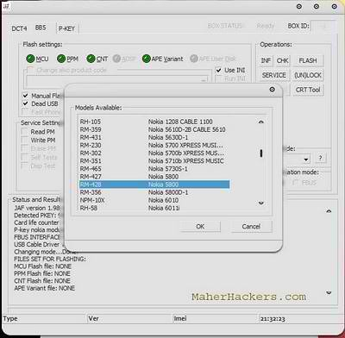
Click To Zoom

A ‘Select Phone Model’ box will open and look in the second column for Nokia 5800D-1 and make sure left is RM-356/RM-428 depending on your type and click ok. It Depend On Your Phone Model And Firmware.Check It Via Dialing *#0000# From Your Mobile.
After Selecting Your Phone’s Details You Will Show JAF Window Like Below,
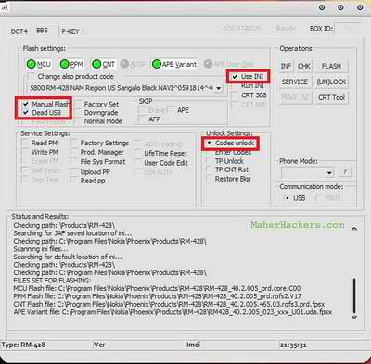
Click To Zoom

In the Box PHONE MODE select NORMAL.
Make sure that your phone has enough charge and will not switch off in the next 15mts. Switch the phone off, connect USB cable to pc and phone and leave it. After switching off, insert your memory card.
Now everything is done, click on the ‘FLASH’ button the top right corner of JAF window. A warning box will pop up, dont get scared, its just a general notification, so click ‘YES’.
Now it will tell “PRESS POWER ON NOW! Searching for phone…”
Now press the phone’s power button for 1 or 2 seconds to switch it on, don’t keep holding it. You will not get a vibration as usual and the screen will go white. Check on JAF now and it will say phone found and erasing and flashing will start shortly.
Flashing takes 1 minute and then JAF will say Done after pooling the fone. The phone will restart and PC will get 3 beep sounds.
You can now Remove usb cable and use your phone!!
View The Complete Tutorial In Video Below :
WARNING AND NOTES :-
* DO NOT ADD OR DELETE ANY FILES FROM THE FIRMWARE FOLDER U HAVE DOWNLOADED UNDER ANY CIRCUMSTANCES.
* Don’t EVER USE FOTA to update your phone or it will be DEAD! If in any case you want to update, you need to flash with original phone version before using FOTA
* ONCE YOU CLICK FLASH, DO NOT PULL THE USB CABLE, NOR LET POWER TO PC FAIL OR LET PHONE BATTERY RUN DOWN, YOU WILL BRICK YOUR PHONE!
If You Face Any Problem Or Get An Error Than Kindly Comment Here.I Will Surely Help Yo

Jaf 1.98.66 + Crack
Jaf 1.98.66 + Crack
1.Extract
2.install jaf suit
3.copy every file in x:\programs file\odeon\jaf\jaf usb driver
to x:\programs file\odeon\jaf\
4.change compatibility of JAF_Full_Emulator_2010.exe to Wind*ws Xp Sp3 on ][Wind*ws 7][
5.Then run the JAF_Full_Emulator_2010.exe and press run jaf 1.98.66 beta5
First time it will show an error Press run jaf 1.98.66 beta5 Again it will work
Don't close the JAF_Full_Emulator_2010.exe while using Jaf
Tested and working


