Objectives | No. of Days Taught | Percent | No. of Items | Item Placement
Explain how the organs of each organ system work together  S6LT-IIa-b-1 | 10 | 20 | 15 | 1-15
Explain how the different organ systems work together  S6LT-IIc-d-2 | 10 | 20 | 15 | 16-30
Determine the Distinguishing Characteristics of Vertebrates and Invertebrates  S6MT-IIe-f-3 | 10 | 20 | 15 | 31-45
Distinguish how spore-bearing and cone-bearing plants reproduce S6Mt-IIg-h-4 | 10 | 20 | 15 | 46-60
Discuss the interactions among living and non-living things in tropical and explain the need to protect and conserve rainforests, coral reefs and mangrove swamps.  S6LT-IIi-j-5 | 10 | 20 | 15 | 61-75
Total | 50 | 100 | 75

Republic of the Philippines
Region IV- A CALABARZON
Division of Cavite

SECOND PERIODICAL TEST IN SCIENCE VI
TABLE OF SPECIFICATION

PREPARED BY: ALONA CRISTOBAL REYES
Republic of the Philippines
Region IV- A CALABARZON
Division of Cavite

SECOND PERIODICAL TEST IN SCIENCE VI

NAME_________________________________________ SCORE___________

Direction: Choose and write the letter of the correct answer on the space provided.

1. Which of the statements correctly describe the general functions of
Skeletal system?

I. It gives shape to the body
II. It serves as framework of the body
III. It protects the internal organs of the body
IV. It converts energy, which enables the body to move

A. I, II, IV C. II, III, IV
B. I, II, III D. I, III, IV

2. It was Verna’s birthday party, she invited all of her classmates. During the game, Justine wants to get toys in the pabitin“. Which muscles help Justine to reach the prize?
I. arm muscle III. leg muscle
II. facial muscle IV. heart muscle
A. I and II C. I and III
B. II and III D. I, II, and III

3. Every morning, Jilliane joins zumba and jogs around in the park. After her activities, she sweats a lot. Why do you think so? Because of the _____
A. contraction of muscles in the dermis
B. relaxation of the muscles in the dermis
C. regulation of the body temperature
D. excessive movement of the body

4. Which could be the functions of the muscular system?

I. It gives shape in our body
II. It allows us to move
III. It supports and makes our skeleton in the hands and other body parts steady.
IV. It provides the structural framework for the body

A. I and II C. I, II,and III
B. II and III D. I, II, III and IV

5. Gina is ready for the school. She eats her breakfast at 6:00 o’clock in the morning and prepare herself for lunch. It takes her stomach 3-7 hours to be emptied. What is the best time for her to take her lunch? She will take her lunch at ______
A. 11:30 o’clock in the morning C. 12:30 o’clock in the afternoon
B. 12:00 o’clock noon D. 1:00 o’clock in the afternoon

6. How does digestion occur?
A. mouth ---- esophagus ---- stomach ---- small intestine ---- large intestine ---- rectum and anus
B. mouth ---- stomach ---- esophagus ---- small intestine ----- large intestine ----- anus and rectum
C. esophagus ---- mouth ---- large intestine ---- small intestine ---- anus and rectum
D. esophagus ----mouth----- small intestine ---- esophagus ---- anus and rectum ---- large intestine

7. Why is it important to promote healthful habit for our organs? To _____
A. have a happy personality
B. make our organs function properly
C. avoid death
D. keep our body away from diseases

8. How does the body use the energy released in its cells?
A. To rest the body
B. To lower body temperature
C. For making oxygen
D. For muscles to move

9. When you exhale, how does the diaphragm behave as you breath in?
A. relaxes C. sinks
B. contracts D. expands

10. Which of the following happens to air during the process of breathing?
A. air moves from area of higher pressure to an area of lesser pressure
B. air moves up and down
C. air gets warm
D. air gives off oxygen

11. When a small blood vessel in your hand is cut open, which plays an active
defense against possible diseases?
A. plasma C. red blood cells
B. platelets D. white blood cells

12. How does circulation take place? Trace the flow of blood from the heart to the
different parts of the body.
A. right atrium left ventricle lungs left atrium right ventricle body cells
B. right atrium right ventricle lungs left atrium right ventricle body cells
C. right atrium left atrium lungs left ventricle left atrium body cells
D. right ventricle right atrium lungs left ventricle left atrium body cells

13. If the cerebellum was damaged as a result of trauma, what effect would this person likely to experience?
A. rapid breathing
B. changes in body temperature
C. Trouble in maintaining balance
D. partial or incomplete memory loss
14. Which of the following statements are TRUE?
I. The brain is the center of nervous system.
II. The brainstem is the hind part of the brain
III. The largest part of the brain is cerebellum
IV. The spinal cord is the downward extension of the brain.
A. I and II C. I, II, and IV
B.II, III, and IV D. IV only

15. The craftsman quickly withdrew his hand when a needle pricked him. What part
of his nervous system worked?
A. cerebellum C. medulla
B. cerebrum D. spinal cord

16. Rico touched something very hot. He moved his hand away from the object when
he felt the hot sensation, Why? The _______
A. blood moves faster to his hand
B. nerve endings are very sensitive
C. message travels fast to his hand
D. message to and from the brain moves fast through the nerves

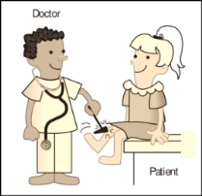
17. Striking the tendon on your knee stimulates a sensory neuron in your lower leg
that causes your knee to jerk. Why?
A. The sensory neuron transmits the nerve impulse to the neuron in the
spinal cord.
B. The nerve impulse travels directly to the brain. without passing the spinal
cord.
C. Motor neurons extending to the leg muscles transmit the nerve impulse
D. Nerves in the legs are functioning properly.
18. How does sensory neuron work? Sensory neuron ______
A. carries signal from the central nervous system to the outer parts of he body
B. carries signals from the outer parts of the body to the central nervous
system
C. connects various neurons within the brain and the spinal cord
D. delivers messages from the brain to the senses

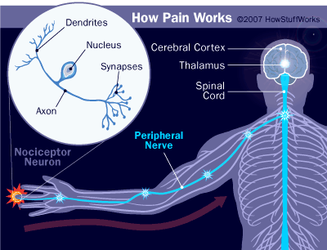
19. What is the usual path of message received by the body from the
environment?
A. brain → nerves → spinal cord → sense organ
B. sense organ → nerves → spinal cord → brain
C. spinal cord → sense organ → brain → nerves
D. nerves → sense organ → brain → spinal cord
20. .Rearrange the following lists to show how the order of events in the nervous system helps to initiate movement:
I -Message received at muscle fibers
II-Muscle contracts
III-Brain decides action
IV-Body or limb performs action
V-Message or impulse sent through nervous system
A. I,II,III.IV and V C. !,III,IV and II .
B. II,V,I,III and IV D. II,I,V,III and IV

21. How does the skin regulate the body temperature?
A. By retaining water
B. By producing vitamin C
C. By increasing sweat production
D. By regulating fat content in the skin

22. Which is the correct path that a nerve impulse will follow in a reflex arc?
A. Motor neuron—interneuron—sensory neuron
B. Interneuron—motor neuron---sensory neuron
C. Motor neuron—sensory neuron—interneuron
D. Sensory neuron—interneuron—motor neuron

23. How does the integumentary system work with the nervous system?
A. Integumentary system help the nervous system to produce blood
B. The skin protects the nerves
C. Nerves embedded in the skin are responsible for sensing the outside world
D. Nervous system help the skin to maintain its color
24. What happened to skin when a person gets cold or frightened?
A. Goose bumps develop
B. Your skin produces too much sweat
C. The nerve cells are frozen
D. The skin is contracted
25. The skin is one of the first defense mechanisms in your immune system, Why?
A. Tiny glands in the skin secrete oils that increase the function of the skin to
protect against microorganism.
B. The skin regulates the blood temperature
C. Tiny glands in the skin secrete water that increase the function of the skin
to protect against microorganism
D. The skin secret hormones to protect the immune system

26. Which of the following is the correct flow of the blood from the different parts of the body back to the heart?
- When the heart contracts, the right lower ventricle will pump the blood into the lungs, where the carbon dioxide is exchanged for oxygen.
- After the exchange, the blood containing fresh oxygen flows into the left upper atrium.
- When the heart contracts, the left lower ventricle will force the blood out to the body through a network of arteries.
- Oxygen-rich blood flows from the left upper atrium into the left lower ventricle
- The heart receives oxygen-deficient blood from the body into the right upper atrium

A. 2,1,4,3,5 C. 5,1,2,4,3
B. 1,3,2,5,4 D. 5,1,4,3,2

27. Which part of the heart pumps blood to the lungs?
A. Left ventricle C. Left atria
B. Right ventricle D. Right atria
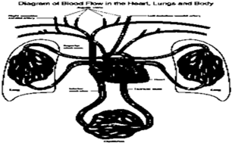
28. How does the blood from the lungs travel back into the heart?
A. lungs → pulmonary veins → left atrium → left ventricle
B. lungs → pulmonary arteries → left atrium → left ventricle
C. lungs → pulmonary arteries → left ventricle → left atrium
D. lungs → pulmonary → left ventricle → left atrium

29. How is respiratory system linked to the circulatory system?
A. The exchange of gasses happens in the capillaries of the alveoli found in lungs.
B. The oxygenated blood passes through the arteries.
C. The blood carries carbon dioxide from the lungs.
D. The blood is made in the lungs.

30. Which of the following shows what sensory neuron do? Sensory neuron-
A. carry signals from the central nervous system to the outer parts of he body
B. carry signals from the outer parts of the body to the central nervous system
C. connect various neurons within the brain and the spinal cord
D. deliver messages from the brain to the senses

31. Study the diagram below. Which groups of animals have both on land and water?

Water

Land
?

A. Amphibians C. Mammals
B. Fishes D. Reptiles

32. Which tells about the distinct characteristics of reptiles?
I. It has legs for crawling
II. are warm blooded animals
III. has gills and fins
IV. dry scaly skins
A. I and III C. II, and III
B. II and IV D. I and IV

33. How are the following animals grouped?
bat dolphin
whale penguin

A. Fishes C. Mammals
B. Amphibians D. Reptiles

34. Below is a list of groups of animals. Which one will best fill in the blank ?
Kiwi | Crocodile | Newt
Ostrich | Snake | Toad
peacock | ? | Salamander

A. Chicken C. seahorse
B. Iguana D. bat

35. Why are some worms harmful? They _______
A. grow very long
B. make children grow healthy
C. eat dead plants and animals
D. take nutrients from the bodies of other organisms

36. How do sponges get their food?
A. food is absorbed by suckers
B. They have big mouth to engulf food
C. Tentacles push the food into their bodies
D. The pores serve as entry and exit of food animals
37. How will you describe mollusks?
I. They have soft bodies and may be covered with hard shells
II. They are stationary
III. They are aquatic animals
IV. They live in bodies of other animals
A. I and II C. I and IV
B. II and III D. I and III

38. Animals acquire food in different ways. Which one tells how the cnidarians get their food?
A. Stinging cells on the tentacles capture prey
B. Food and water flow through the small opening
C. They have hooks and suckers on their heads
D. They live inside the bodies of other organisms

39. Four Animals were identified by one pet lover as vertebrate. Which of the
animals is he referring to?
A. sheep C. dog
B. lion D. tiger

40. Your uncle is a veterinarian and you asked him to help you on your assignment about vertebrates. These are the statements he said to you: an animal with backbone, live in water and move through swimming. What animal is he referring to?
A. snail C. snake
B. catfish D. starfish

41. You and your classmates went to Manila Ocean Park and saw different kinds of animals. One of your classmates said that the animals in one shelf have six legs, thorax and abdomen. Which animal is this ?
A. Earthworm C. scorpion
B. spider D. ant

42. Animals possess body parts which are distinct to them. Which characteristic best distinguishes birds from the other vertebrates? They_________

A. have bones C. are covered with feathers
B. lay eggs with shell D. take care of their young

43. Dog, cats and cow are examples of mammals. Which of the following is a characteristic of mammals only?
A. They have four legs.
B. They creep and live on land
C. They feed their young with milk
D. They have scales and live on water

44. Fishes are animals that can move easily in the water. What characteristic is shown in this situation? They have _________
A. streamline body
B. body covered with scales
C. gills and fins
D. long tail

45. Sponges and cnidarians are said to be sessile or stationary. What does this mean? They_____
A. are free living
B. do not move at all
C. move every now and then
D. have to get attached to something

46. Cypress and gingkoes are conifers. What do conifers use in order to reproduce?
A. seeds B. cones C. spores D. cells

47. What characteristics do mosses and ferns have in common?
A. They produce cones
B. They produce spores
C. They are flowering plants
D. They are non-flowering plants

48. What characteristic describes a non-flowering plant like fern and makes it different from flowering plant like gumamela? They are having_____
A. dark green leaves
B. naked cones
C. edible roots
D. spores

49. Why are seeds of conifers called “naked seeds”? The seeds are____
A. not enclosed within fruits
B. enclosed within fruits
C. within fruits
D. from cones.

50. In what way are ferns and mosses alike?
- They are flower-bearing
- They are spore-bearing
- They have vascular bundles
- They have roots, stems and leaves

51. Which of the following are cone-bearing plants?

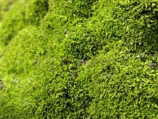
I.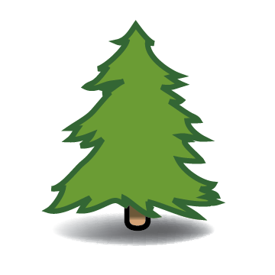 II. 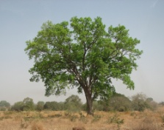 III. 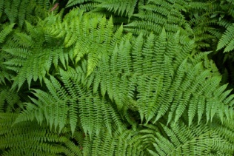 IV.
Pine Mahogany Fern Moss

A. I C. II, III & IV
B. I & II D. III & IV
.
52. Plants undergo process of reproduction. Which is the first step in the fertilization process of plants?
A. Pollination
B. The growth of fruit
C. A tube grows to the pistil
D. The sperm joins with the egg

53. Which part contains a material that a conifer uses to reproduce?
A. Bulbs C. Cones
B. Flowers D. Needles

54. Which is the primary pollinator of conifers?
- Birds
- Insects
- Water
- Wind

A. I and II C. I, II and IV
B. III and IV D. IV only

55. Which statement proves that pine trees are gymnosperms while mango trees are angiosperms? Pine trees _______; mango trees __________.
A. grow tall; grow short.
B. have needle-like leaves; have round leaves.
C. grow in cold climate; grow in tropical climate.
D. cone-bearing plants; flower-bearing plants.

56. Which of these statements describe the function of needle-like leaves of conifers?
- The evergreen needles can photosynthesize in winter.
- The waxy coating of the leaves dries up the water.
- The narrow needles protect the branches and reduce heavy snowfall.
- The leaves will grow into a mature conifer and produce more seeds

57. Seed plants have special structures on them where male and female cells join together through a process called _________.
- Fertilization C. embryo
- cone-bearing D. pollination

58. Which of the following characteristic is distinct among plants like pine trees and cycads?
- Produce seeds not enclosed in a fruit
- Produce seeds enclosed in a fruit
- Bear many colourful flowers
- Produce spores

59. Ferns, conifers and angiosperms have common characteristics. What are these?
- They can produce seeds
- They reproduce through spores
- They have fibro-vascular bundles
- They have the ability to bear flowers.

60. Which leaf has the presence of spores?
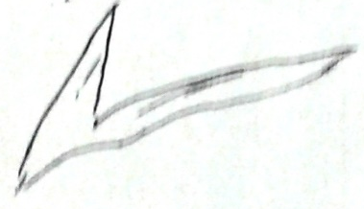
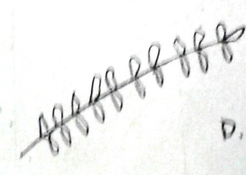
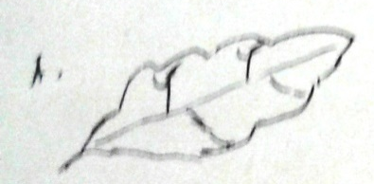
A C..

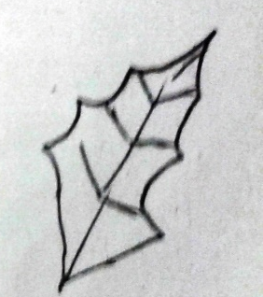
B. D.

61. Which food chain does occur in the forest ecosystem?
A. grass caterpillar chicken
B. corn mouse snake
C. grass wilderbeast lion
D. worm berries caterpillar raven

62. Ana will go to the forest. What are the living things she can find there?
A. cow, grass, mouse, soil
B. farmer, carabao, rat, trees
C. trees, fern, snail, mushroom
D. horse, goat, cow, water

63. How will you describe a tropical rainforest?
A. warm temperature
B. cold temperature
C. rare variety of reptiles or none at all
D. frozen ground

64. How do forests help in maintaining global climate?
A. Plants soak up large amounts of rainfall
B. Plants provide a habitat for plants and animals.
C. Plants provide materials for constructions and other needs of people.
D. Plants absorb carbon dioxide and release oxygen during photosynthesis.

65. What might happen if a tropical rainforest receives little rain for a long period of time?
A. Plants will wither which cause shortage of food to lower form of animals.
B. Increase population of both plants and animals
C. Abundance of oxygen
D. Flood might occur

66. In coral reef ecosystem, clown fishes, and sea anemones live together. Which type of relationship is shown?
A. commensalism C. parasitism
B. mutualism D. predation

67. Coral reefs are beneficial to marine life. In what way does it show in the following instances ?
I. provide rich sources of marine food
II. protect the coastal areas from strong waves
III. provide passage for strong currents to coastal areas
IV. serve as a breeding ground of fishes and other forms of marine life
A. I and II B. II and III C. I and IV D. III and IV

68. Coral reefs are important to man and other marine organisms How can we help protect them?
A. collect corals
B. clean coral reefs
C. prevent dynamite fishing
D. throw oil into waterways

69. Why are corals very important to marine life?.
A. They are the habitat of some marine animals.
B. They make the oceans and seas look blue.
C. They filter and purify the water.
D. They make the seawater salty.

70. Which of the following characterizes a tropical rainforest ecosystem?
I. It is located at the polar zones.
II. It has diverse plant and animal species
III. It is situated in tropical places.
IV. It caters to few plants and animals.
A. I and II B. II and III C. I and III D. III and IV

71. Mangrove swamps is one of important components of the ecosystem? Where do they usually found?
A. along arctic coastlines
B. along rocky coastlines
C. along temperate coastlines
D. long tropical and subtropical coastlines

72. You heard about a plan to convert the nearby mangrove swamp to commercial area. Your neighbor agrees with the plan because they believed that the mangrove swamp has no economic value. After researching you want to discuss the issue with your neighbor. Which statement could be possibly convey to your neighbor to not agree with the plan?
A. Mangrove swamps filter pollutants from water.
B. Mangrove swamps are beautiful ecosystems.
C. Mangroves swamps provide shelter for animals.
D. Mangrove swamps protect the coastal community from waves and provide food and business for people.

73. Which of the following is the role of crustaceans like crabs in the mangrove ecosystem?
A. They attach themselves to the roots of mangroves
B. They help break down leaf litter through grazing.
C. They serve as food of other animals.
D. They find food in the mud.

74. What is needed for the ecosystem to support the greatest variety of organisms over the longest period of time?
A. Variety of organism
B. Wide variety of animals
C. wide variety of bacteria
D. Wide variety of minerals

75. The fishermen in the barangay use dynamites in order to have a big catch. If this practice continues, what do you think will happen to the marine resources?
A. Fishes will multiply fast.
B. Marine life will increase.
C. Marine life will decrease.
D. The coral will multiply

Prepared by: ALONA CRISTOBAL REYES
Science Teacher

Noted by: LUCIA A. GARCIA
Principal I.

File Submitted by DepEd Club Member
-visit depedclub.com for more
Credit to the author of this file

Answer Key:

1. b
2. c
3. a
4. c
5. b
6. a
7. b
8. c
9. a
10. a
11. d
12. b
13. c
14. c
15. d
16. b
17. a
18. b
19. b
20. d
21. c
22. d
23. c
24. a
25. a
26. c
27. b
28. b
29. a
30. b
31. a
32. d
33. c
34. b
35. d
36. d
37. d
38. a
39. c
40. b
41. d
42. c
43. c
44. c
45. d
46. b
47. b
48. d
49. d
50. b
51. a
52. a
53. c
54. b
55. d
56. c
57. a
58. b
59. c
60. c
61. c
62. c
63. a
64. d
65. a
66. b
67. c
68. c
69. a
70. b
71. c
72. d
73. c
74. a
75. c

