LESSON NO. | COMPETENCY | CODE | NO. OF TEACHING DAYS | ITEM PERCENTAGE | NO. OF TEST ITEMS | ITEM DISTRIBUTIONS/PLACEMENTS
 |  |  |  |  |  | EASY | AVERAGE | DIFFICULT
1 | Identifies the notes and rests used in a particular song | MU6RH-Ia-1 | 2 | 17% | 5 | 1,2,3,4,5
2 | Differentiates among 2/4, ¾, and 4/4 time signatures | MU6RH-Ib-e-2 | 3 | 25% | 8 | 6,7,8,9,10, 11,12,13
3 | Differentiates among2/4, ¾, 4/4, and 6/8 time signatures | MU6RH-Ib-e-2 | 3 | 25% | 8 |  | 19,20,21,22,23,24,25,26
4 | Demonstrates the conducting gestures of 2/4, ¾, and 4/4 time signatures |  | 2 | 17% | 5 | 14,15,16,17,18
5 | Demonstrates the conducting gestures of 6/8 time signature |  | 1 | 8% | 2 |  |  | 29,30
6 | Identifies through conducting the relationship of the first and the last measure in an incomplete measure |  | 1 | 8% | 2 |  | 28 | 27
 | TOTAL |  | 12 | 100% | 30 | 18 | 9 | 3
Republic of the Philippines
DEPARTMENT OF EDUCATION
Region I
SCHOOLS DIVISION OFFICE I PANGASINAN
Binmaley Cluster II
BASING ELEMENTARY SCHOOL
S.Y. 2017-2018

TABLE OF SPECIFICATIONS
First Periodical Test in Music-6

Prepared by:

SEVERINO M. MANUEL
Teacher III

FIRST PERIODICAL TEST IN MUSIC – 6

I. Direction: Encircle the letter of the correct answer.

A. USE THIS MUSICAL SCORE TO ANSWER QUESTION 1 TO 5:

1. Name the rest used in the first measure of the song.
A. whole rest B. half rest C. quarter rest D. eighth rest

2. Name the first note used in the third measure of the song.
A. whole note B. half note C. quarter note D. eighth note

3. What musical note is used on the second beat of the fifth measure of the song?
A. quarter note B. eighth rest C. eighth note D. quarter rest

4. In the 15th measure of the song, name the note that has the corresponding lyrics “rin”.
A. dotted quarter note B. dotted quarter rest C. dotted half note D. dotted eighth note

5. In the 16th measure of the song, what notes made up the second beat of the measure?
A. a quarter note and an eighth note C. two eighth notes
B. two quarter notes D. one quarter note

6. In a 2/4 time signature, how many quarter notes or its equivalence maybe counted in a measure?
A. four B. three C. two D. one

7. In a 3/4 time signature, how many quarter notes or its equivalence maybe counted in a measure?
A. four B. three C. two D. one

8. In a 4/4 time signature, how many quarter notes or its equivalence maybe counted in a measure?
A. four B. three C. two D. one

9. In a time signature, how many beats are there in a measure?
A. three beats B. two beats C. one beat D. four beats

10. In a time signature, how many beats are there in a measure?
A. three beats B. two beats C. one beat D. four beats

11. In a time signature, how many beats are there in a measure?
A. three beats B. two beats C. one beat D. four beats
12. In , , and time signatures, a quarter note receives how many beat?

A. one beat B. two beats C. three beats D. four beats
13. In , , and time signatures, a quarter rest receives how many beat?

A. four beats B. two beats C. three beats D. one beat
14. Which of the following pictures shows/demonstrates time signature?
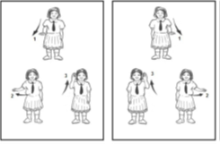
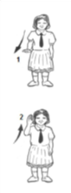
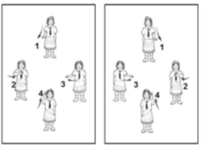
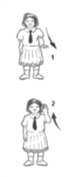

A. B. C.

15. Which of the following pictures shows/demonstrates time signature?

A. B. C.
16. Which of the following pictures shows/demonstrates time signature?

A. B. C.

17. What time signature is shown by this beat pattern:
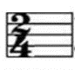
A. B. C. D.
18. What time signature is shown by this beat pattern:
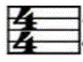
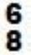
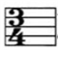
A. B. C. D.

In a time signature,
19. how many eighth notes or its equivalence are there in a measure?
A. four B. five C. six D. eight
20. how many beats does an eight note receive?
A. one beat B. two beats C. three beats D. four beats
21. how many beats does a dotted quarter note receive?
A. six beats B. five beats C. four beats D. three beats
22. how many beats does a quarter rest receive?
A. one beat B. two beats C. three beats D. five beats

23. Which group of measures below shows time signature ?

A. C.
B. D.
24. Which group of measures below shows time signature ?
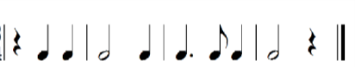
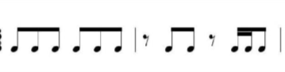

A. C.

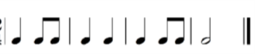
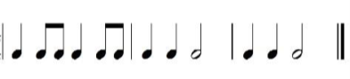
B. D.

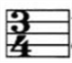
25. Which group of measures below shows time signature ?
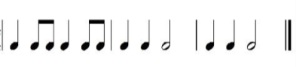
A C.

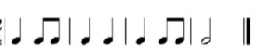
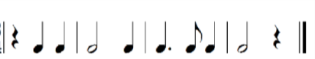
B. D.

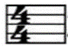
26. . Which group of measures below shows time signature ?
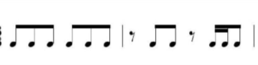
A. C.
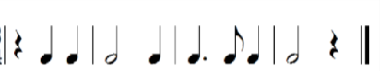
B. D.
27. The musical score, “Bahay Kubo” below is an example of a score with an incomplete beginning and ending measures
(broken measures). Where do we start singing the lyrics “Ba” of the first measure?

A. first beat B. second beat C. third beat D. halfway the first beat

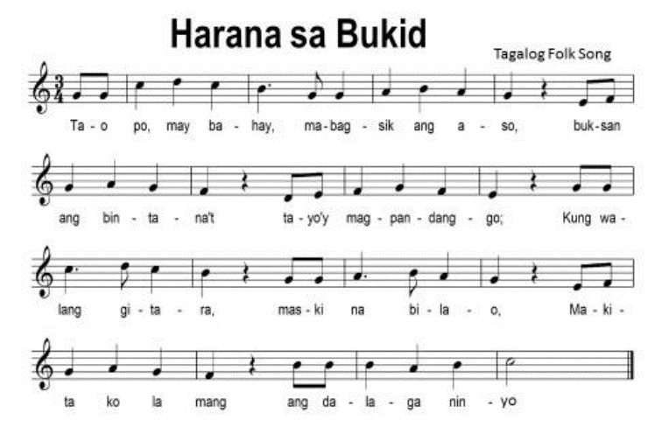
28. The musical composition, “Harana sa Bukid” below is an example of a score with complete measures. True or False?

A. True B. False

29 -30. Draw inside the box the beating pattern of the time signature . (2 points)

Key

1. B
2. B
3. D
4. A
5. C
6. C
7. B
8. A
9. D
10. B
11. A
12. A
13. D
14. B
15. C
16. B
17. B
18. A
19. C
20. A
21. D
22. B
23. D
24. D
25. B
26. A
27. C
28. B

29-30. (Other 6/8 beating patterns illustrated in some books maybe accepted)

Note: The improper use of the fraction bar in some items was just harnessed to hasten typing work.
Please explain to pupils.

