Department of Education
Region IV-A (CALABARZON)
City Schools Division of Dasmarinas
Cluster II of Dasmarinas
HUMAYAO ELEMENTARY SCHOOL

FOURTH PERIODIC TEST IN MAPEH 6
S.Y. 2017-2018
Name: __________________________________ Date: __________
Grade and Section: ____________________ Score: _________

GENERAL DIRECTIONS: Read each question then select the best answer from the given choices. Shade the letter which corresponds to the correct answer on the blank before the number.

1. It refers to the rate of speed in a musical composition.
a. Dynamics b. Pitch c. Tempo d. Speed
2. How can a joyful musical piece be played?
a. It should be played in a fast and lively tempo. c. It should be played slow.
b. It should be played soft. d. Played with only one instrument.
3. The song, Öb-La-Di, Ob-La-Da” has what kind of tempo?
a. a slow tempo c. a quick, lively tempo
b. moderately slow tempo d. a very fast tempo
4. It is a tempo change from a slow gradual change to a faster tempo.
a. Accelerando (accel.) c. Lento
b. Ritardando (rit.) d. Presto
5. This song demonstrates different kinds of tempo
a. Bahay Kubo c. ABC song
b. Leron Leron Sinta d. Pandangguhan
6. It refers to the structure of a musical composition.
a. Tempo b. Texture c. Dynamics d. Harmony
7. Singing “Sitsiritsit”with a piano accompaniment can be described as ____.
a. Monophonic b. Biphonic c. Homophonic d. Polyphonic
8. Humming is ___.
a. Monophonic b. Biphonic c. Homophonic d. Polyphonic
9. It contains two or more independent musical lines.
a. Monophonic b. Biphonic c. Homophonic d. Polyphonic
10. It is a single melodic sound with accompaniment.
a. Monophonic b. Biphonic c. Homophonic d. Polyphonic
11. Tonic has the Roman Numeral ____.
a. I b. II c. IV d. V
12. In the key of C, sol (G) is the _____ chord.
a. tonic b. sub-dominant c. dominant d. supertonic
13. In the key of C, sub-dominant’s second note is _____.
a. fa b. sol c. la d. ti
14. In the key of C, the third note in tonic chord is ____
a. fa b. sol c. la d. ti
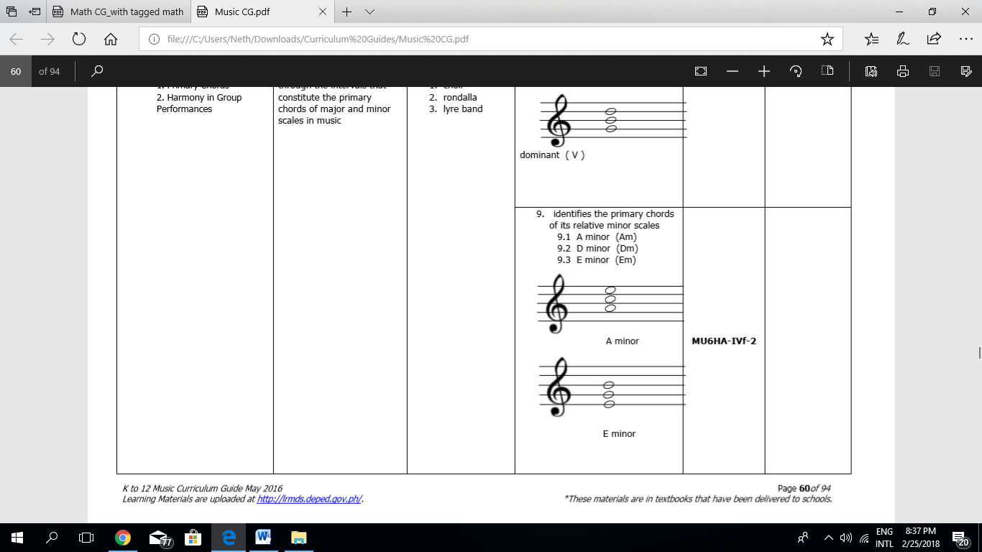
15. This chord is an ____.
a. A minor b. B minor c. D minor d. E. minor

16. This chord is an ____.
a. A minor b. B minor c. D minor d. E. minor

17. These chords create a feeling of happiness that greatly affects the mood of a person.
a. major chords b. super major chords c. minor chords d. sub-minor chords
18. These chords give the listeners a feeling of sadness.
a. major chords b. super major chords c. minor chords d. sub-minor chords
19. In the key of C, the following are the primary chords used in songs except ____.
a. B major b. C major c. F major d. G major
20. Which song in the Key of C major which has the primary chords C, F and G7?
a. Old Folks at Home b. Are You Sleeping c. You Are Mine d. Viva La Musica

ARTS
21. In sculpting, you can use any material we see around us as long as it is capable of being shaped in ____.
a. one dimension b. two dimensions c. three dimensions d. all of the above
22. In making a paper bag manually, this picture shows what direction?
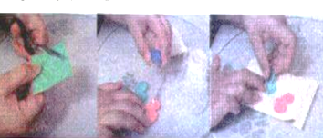
a. Punch the hole and attach the yarn.
b. Tuck in both sides following the fold.
c. Glue the edges, then flatten the paper.
d. Design the paper bag.

23. The software “blender” can be used to create digital sculpting. Which part can let you modify a function, an option or a value?
a. Editor b. Panels c. Regions d. Controls
24. ____ is a packaging software with unique set of tools for 3D packaging design made specifically for packaging artwork.
a. Studio b. Geomagic c. ZBrush d. Sculptris

25. The following is a digitally-enhanced product design for a paper bag except ____.
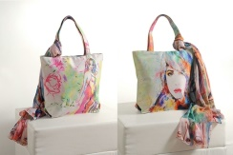

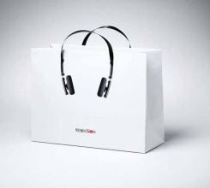
a. b. c. d.

26. It is an art production in which several materials are put together, to form a new work of art.
a. Collage b. Photopgraphy c. Sculpture d. Printmaking
27. Collage can be made of physical materials such as _____.
a. Used magazines b. Paper c. Photographs d. All of the above
28. It is an example of software that can be used to create electronic collage.
a. Studio b. Geomagic c. Picture Collage Maker d. Sculptris
29. One of the skills in making an electronic collage is ____.
a. arranging pictures b. adding borders c. both a and b d. a only
30. Which of the following you can do with an electronic collage which you cannot apply in a collage using only physical materials?
a. adding sound b. animating c. applying transitions d. all of the above

PHYSICAL EDUCATION
31. When you dance during special programs in school only, you ____.
a. don’t dance that much b. dance as a hobby c. dance everyday d. dance every minute
32. When your body move around a wide axis, which fitness is improved?
a. coordination b. flexibility c. balance d. endurance
33. Dancing is part of ______ in the Philippine Physical activity Pyramid which you can do during your free time.
a. Minimal activities c. Habitual activities
b. Recreational activities d. None of the above
34. Creative dances evolved from ____.
a. imitating the nature’s movements c. trading and marketing
b. making wars with enemies d. building homes and preparing food
35. The following are locomotor skills in dancing except _____.
a. walking b. running c. twisting d. hopping
36. We should observe safety precautions in hip hop dancing and one way is _____.
a. dancing immediately c. eating heavy meals then dance immediately
b. doing simple warm-up exercises d. taking a bat after dancing
37. It means move around a point.
a. circle b. twist c. straighten d. swing
38. Dancing develops your muscles and bones.
a. True b. False c. Maybe d. Both a and b
39. When dancing with your friends or classmates, you display ____.
a. joy of effort b. respect for others c. Both a and b d. None of these
40. The following are facts about dancing except ____.
a. It makes your brain work. c. It tones your muscles
b. It burns unwanted calories. d. It breaks your bones.
41. This type of dance translates feelings and emotions of human conditions, situations, or fantasies into movement and dramatic expressions.
a. Folk Dance b. Ballet c. Basic Dance Step d. Interpretative Dance
HEALTH VI
42. Consumer health helps you exercise consumer’s ______.
a. rights b. obligations c. time d. money
43. The following are components of consumer health.
a. health information b. health product c. health services d. all of the above
44. Bleaching soaps are examples of ____.
a. food b. medicines c. cleaning agents d. personal care
45. A ____ is a person who advises on matters of food and nutrition impacts on health.
a. dermatologist b. nutritionist c. ophthalmologist d. pharmacist
46. We can draw health information from _____.
a. scientists b. police officers c. fire men d. ministers
47. A _____ can diagnose and treat problems related to the eyes and vision.
a. dermatologist b. nutritionist c. ophthalmologist d. pharmacist
48. ______ drugs are medicines sold directly to a consumer without a prescription from a healthcare professional.
a. over-the-counter b. prescription c. illegal d. legal
Identify whether the following is a. over-the-counter medicines or b. prescription medicines
49. antacids
50. antibiotics

51. It is a pain reliever and fever reducer.
a. analgesics b. laxatives c. carbocisteine d. paracetamol
52. They are drugs used fot the treatment of major depressive disorder.
a. antibiotics b. antidepressants c. antihypertensives d. antihistamines
53. It’s a propaganda technique using big personalities such as experts and celebrities to endorse a product.
a. Testimonial b. Bandwagon c. Rewards d. Transfer
54. It is a technique used to stir the emotions of the audience to win their approval.
a. Testimonial b. Bandwagon c. Rewards d. Transfer
55. It used ordinary people or trying to sound ordinary to sell something.
a. Testimonial b. Bandwagon c. Glittering Generalities d. Plain Folk
56. It is a type of propaganda in which the customer gets another product or the same product twice for the purchase of the original product.
a. Testimonial b. Bandwagon c. Rewards d. Transfer
57. A wise consumer ____ of the products
a. read labels b. inspect the benefits c. both a and b d. b only
58. We should identify factual information from propaganda.
a. True b. False c. Maybe d. Both a and b
59. Reading product labels help consumers choose that will give the best value of ____.
a. money b. health c. both a and b d. a only
60. The best way to be protected from fraudulent products is to be ______ consumer.
a. informed b. misinformed c. frugal d. trusting

Department of Education
Region IV-A (CALABARZON)
City Schools Division of Dasmarinas
Cluster II of Dasmarinas
HUMAYAO ELEMENTARY SCHOOL

FOURTH PERIODIC TEST IN MAPEH 6
S.Y. 2017 – 2018

KEY TO CORRECTION

- C
- A
- C
- A
- D
- B
- C
- A
- D
- C
- A
- C
- C
- B
- A
- D
- A
- C
- A
- A
- C
- D
- D
- A
- D
- A
- D
- C
- C
- D
- A
- B
- B
- A
- C
- B
- A
- A
- C
- D
- D
- A
- D
- C
- B
- A
- C
- A
- A
- B
- D
- B
- A
- D
- D
- C
- C
- A
- C
- A

Department of Education
Region IV-A (CALABARZON)
City Schools Division of Dasmarinas
Cluster II of Dasmarinas
HUMAYAO ELEMENTARY SCHOOL

SECOND PERIODIC TEST IN MAPEH 6
S.Y. 2017 – 2018

TABLE OF SPECIFICATIONS

Contents/Objectives | Number of Days Taught | Percent  % | Number of Items | Item Placement
MUSIC  1. identifies the different tempo in a given song or music: -allegro -andante -ritardando -accelerando -largo -presto -vivace MU6TX-IVa-b1  2. distinguishes between ritardando and accelerando as used in a song MU6TX-IVa-b2  3. demonstrates the different kinds of tempo by following tempo marks in a familiar son  Ex: “Pandangguhan” MU6TX-IVa-b3  4. identifies aurally the texture of musical pieces MU6TX-IVc-d1  5. Identifies different textures  MU6TX-IVc-d2  6. distinguishes monophonic, homophonic, and polyphonic textures MU6TX-IVc-d3  7. applies primary chords (I, IV, V) as accompaniment to simple song  MU6TX-IVc-d4  8. identifies the intervals of the following major triads: MU6HA-IVe-1  9. identifies the primary chords of its relative minor MU6HA-IVf-2  10. distinguishes the sound of a major chord from a minor chord MU6HA-IVe-f3  11. uses the major triad as accompaniment to simple songs MU6HA-IVg-h4  ARTS  1. knows that design principles and elements relates to everyday objects. A6EL-IVa  2. appreciates the elements and principles applied in product design. A6PL-IVa  3. manifests understanding of concepts on the use of software (commands, menu, etc.)  A6PR-IVb  4. utilizes art skills in using new technologies (hardware and software) in package design.  A6PR-IVc  5. creates an actual 3-D digitally-enhanced product design for a paper bag. A6PR-IVd  6. realizes that art processes, elements and principles still apply even with the use of technologies.  7. appreciates the elements and principles applied in audio-video art.  A6PL-IVe  8. applies concepts on the use of the software (commands, menu, etc.) A6PR-IVf  9. utilizes art skills in using new technologies (hardware and software) A6PR-IVg  10. creates an audio-video art /animation promoting a product. A6PR-IVh  PE  34. describes the Philippines physical activity pyramid PE6PF-IVa-16  35. explains the indicators for fitness PE6PF-IVa-17  36. assesses regularly participation in physical activities based on the Philippines physical activity pyramid PE6PF-IVb-h-18  37. explains the nature/background of the dance PE6RD-IVb-1  38. describes the skills involved in the dance PE6RD-IVb-2  39. observes safety precautions PE6RD-IVb-h-3  40. executes the different skills involved in the dance PE6RD-IVc-h-4  41. recognizes the value of participation in physical activities PE6PF-IVb-h-19  42. displays joy of effort, respect for others during participation in physical activities PE6PF-IVb-h-20  43. explains health and skill related fitness components PE6PF-IVa-21  44. identifies areas for improvement PE6PF-IVb-h-22  HEALTH  1. explains the importance of consumer health H6CHIVa-13  2. enumerates the components of consumer health H6CHIVbc-14  3. describes the different components of consumer health H6CHIVcd-15  4. differentiates over- the- counter from prescription medicines H6CHIVcd-16  5. gives example of over the counter and prescription medicines H6CHIVe-17  6. explains the uses of some over the counter and prescription medicines H6CHIVf-18  7. identifies the common propaganda techniques used in advertising H6CHIVg-19  8. Identifies the common propaganda techniques used in advertising H6CHIVg-20  9. analyzes packaging and labels of health products H6CHIVh-21  10. practices good decision making skills in the selection of health products.  H6CHIVh-22  11. discusses ways to protect oneself from fraudulent health products H6CHIVij-23 | 2  1  1  1  1  1  1  1  1  1  1  1  1  1  1  1  1  1  1  1  1  1  1  1  1  1  1  1  1  1  1  1  1  1  2  1  1  1  1  1  1  1  1 | 4.44%  2.22%  2.22%  2.22%  2.22%  2.22%  2.22%  2.22%  2.22%  2.22%  2.22%  2.22%  2.22%  2.22%  2.22%  2.22%  2.22%  2.22%  2.22%  2.22%  2.22%  2.22%  2.22%  2.22%  2.22%  2.22%  2.22%  2.22%  2.22%  2.22%  2.22%  2.22%  2.22%  2.22%  4.44%  2.22%  2.22%  2.22%  2.22%  2.22%  2.22%  2.22%  2.22% | 2.7 = 3  1.3 = 1  1.3 = 1  1.3 = 1  1.3 = 2  1.3 = 2  1.3 = 2  1.3 = 2  1.3 = 2  1.3 = 2  1.3 = 2  1.3 = 1  1.3 = 1  1.3 = 1  1.3 = 1  1.3 = 1  1.3 = 1  1.3 = 1  1.3 = 1  1.3 = 1  1.3 = 1  1.3 = 1  1.3 = 1  1.3 = 1  1.3 = 1  1.3 = 1  1.3 = 1  1.3 = 1  1.3 = 1  1.3 = 1  1.3 = 1  1.3 = 1  1.3 = 1  1.3 = 2  2.7 = 3  1.3 = 1  1.3 = 2  1.3 = 2  1.3 = 2  1.3 = 2  1.3 = 2  1.3 = 1  1.3 = 1 | 1-3  4  5  6  7-8  9-10  11-12  13-14  15-16  17-18  19-20  21  22  23  24  25  26  27  28  29  30  31  32  33  34  35  35  37  38  39  40  41  42  43-44  45-47  48  49-50  51-52  53-54  55-56  57-58  59  60
TOTAL | 45 DAYS | 100% | 60 ITEMS
*Some are given extra items to complete the 60 item-exam.

Prepared by:
NENELETTE M. PASCUAL
Teacher II
Contents Checked:

ROSEMARIE A. CAMAY
Key Teacher, MAPEH

EDILYN C. DE LIMA
Teacher III/OIC

Contents Noted:

SUSANA B. HAYAG
Public Schools District Supervisor

Contents Checked/Verified:

JULIUS C. REYES
EPS, MAPEH

