ETO Siya mga bossing
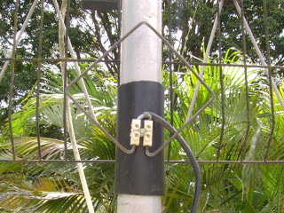

Mga gamit na kaiLangan

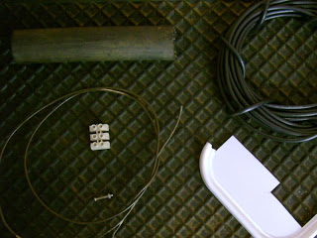
* 14,15 inch piece of iron wire. (Huwag gumamit ng tanso)
* A 2 piece connector block. (Used to extend electric cables)
* A small bolt and nut that fits through the whole of the “chocolate block.
* 32 feet of coax cable. (Don’t increasing the length of the cable, shortening it is okay thou)
* A piece of water pipe.
* A piece of plastic. (I used an ice-ream container)

Pagawa ng Signal Booster
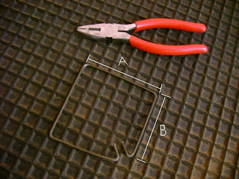

Straiten the wire with pliers and bend it exactly in the center at a 90 degree angle. Measure 3.54 inches from the bend on both sides and bend inwards at 90 degrees. Bend the edges of the wire inwards on both sides again at 90 degrees 3.14 inches away from the last bend.

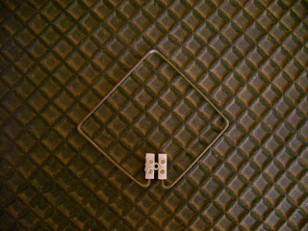
Insert the connector block to the ends of the wire and tighten it with a screw driver
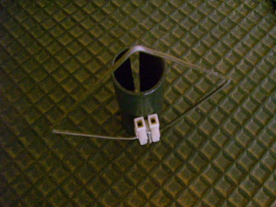
Saw one side of the pipe in half and make a whole on the other side in the center. The whole should just be big enough for the bolt to go through. After placing the bolt inside the whole, insert the “chocolate block” on top and tighten with the nut.

Connecting the coax cable ( Cable wire )

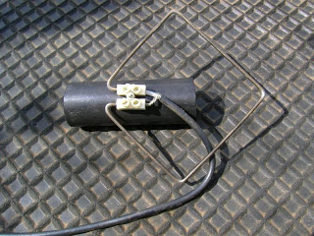
Strip the one end of the coax cable and separate the inner and outer wires. Connect the inner wires
to one side of the “chocolate block” and the outer wires to the other side.

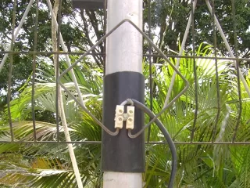
Place the GSM antenna on your TV antenna pole facing the same direction and lead the cable into the house.
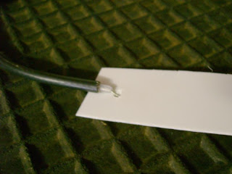
Strip the other end of the coax cable and separate the wires inside again. This time you need to cut away the outer wires since you won’t need them. Take the piece of plastic and cut it in the shape you desire. Make a small hole on one end and stick the inner wire of the coax cable through.
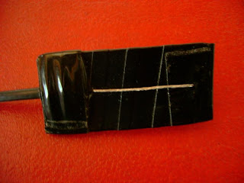
You can wrap the whole thing in tape like I did if you’d like.
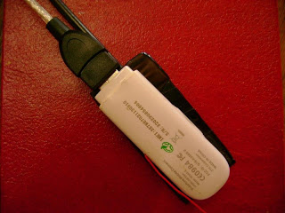
Last ilagay ang broadband sa naka wrap na tape

RESULT


