THANK YOU FOR ORDERING!
BELOW IS THE PROCESS ON HOW TO INSTALL

VIVA VIDEO PRO!


DOWNLOAD LINK: MEDIAFIRE
MEDIAFIRE PASSWORD: thursdaypayday

- Open the link on the browser then enter the password.
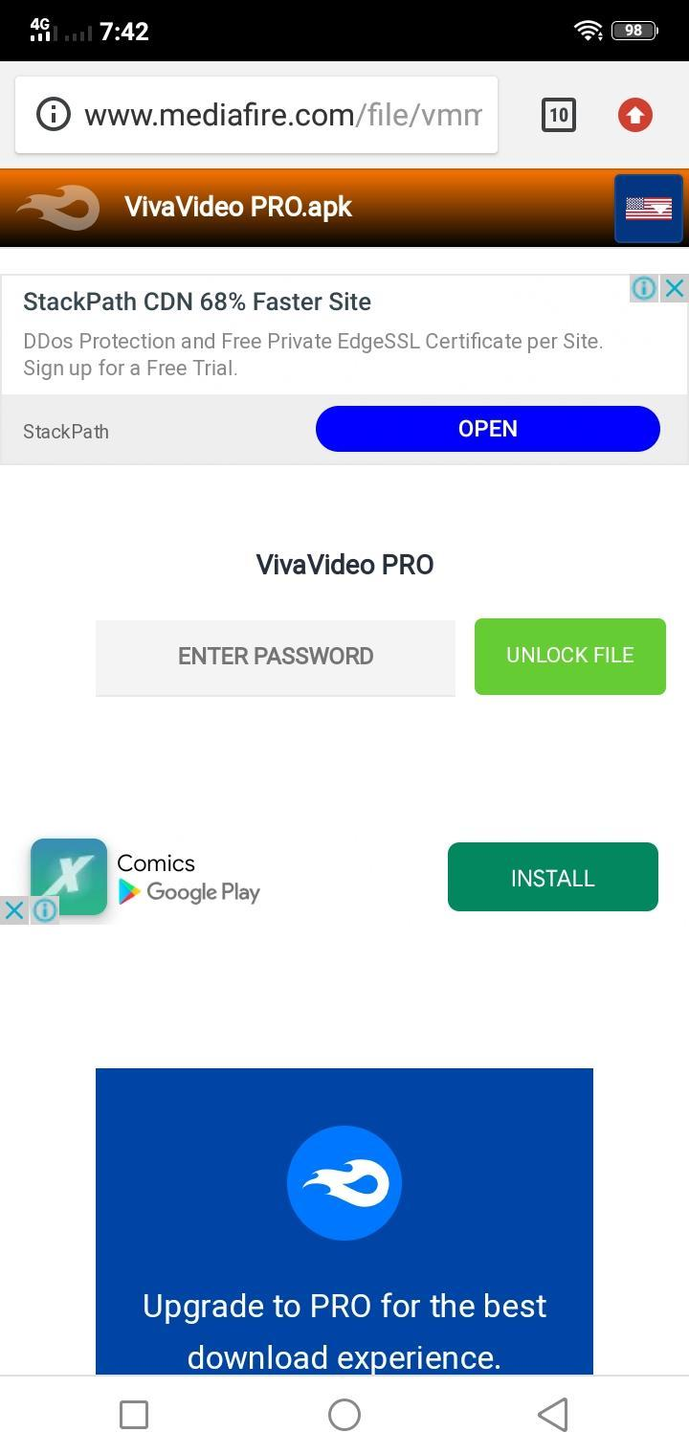

- Check the download on your notification
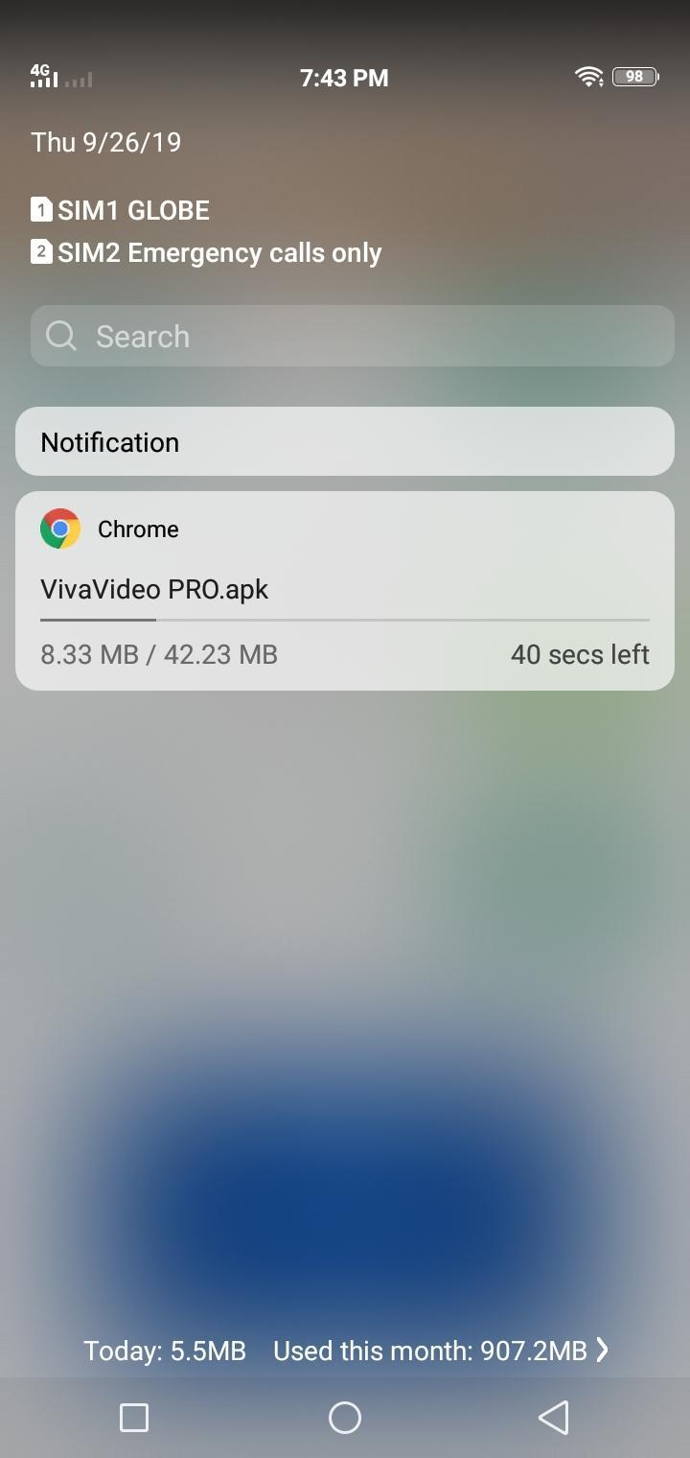

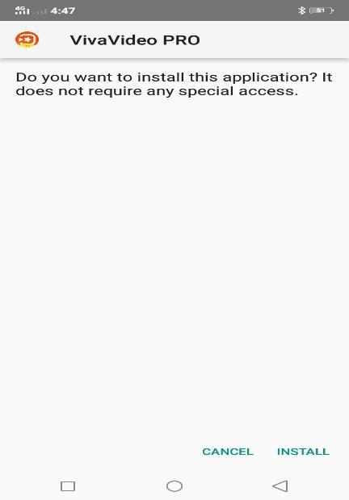
- Once the file has been downloaded from mediafire. Just open the file and click install.

- When this pops-up, just click settings then allow unknown apps to be installed.
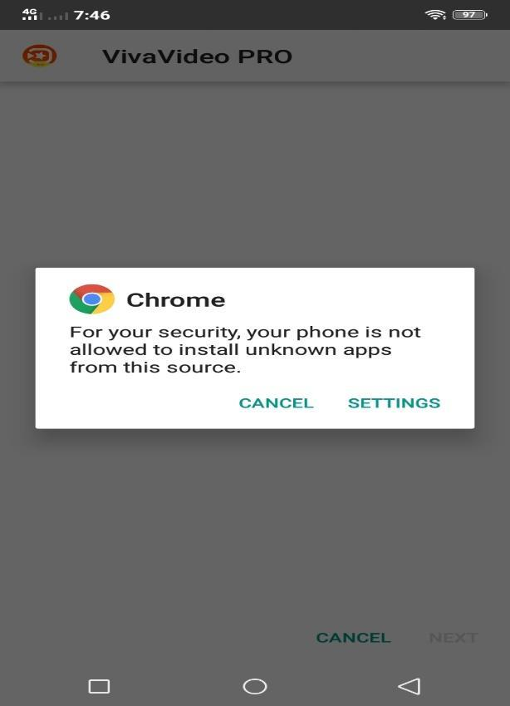
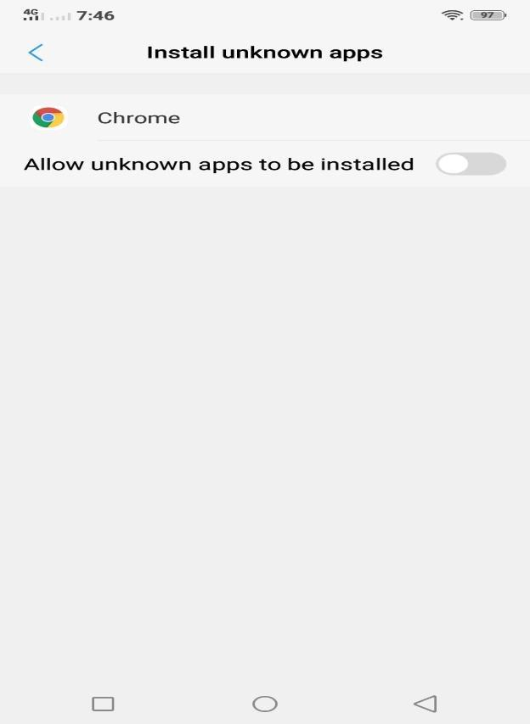

- Wait for it to be installed.
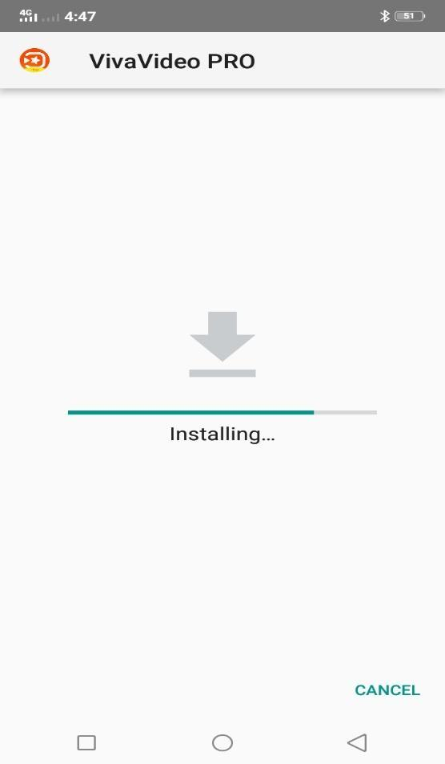

- Allow all requested permissions.
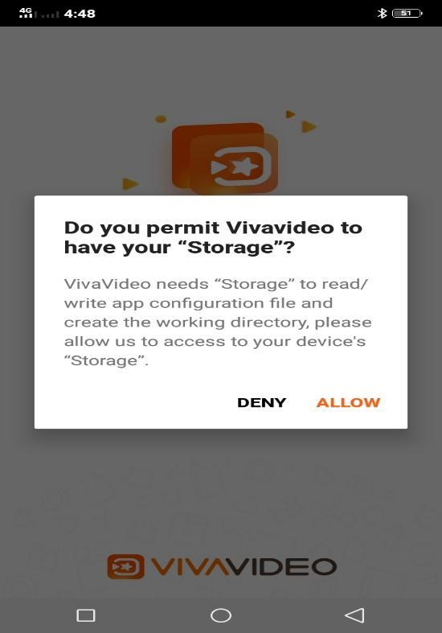

- There you go! You can start using the app with no ads and watermarks.



- Enjoy the following features and many more…
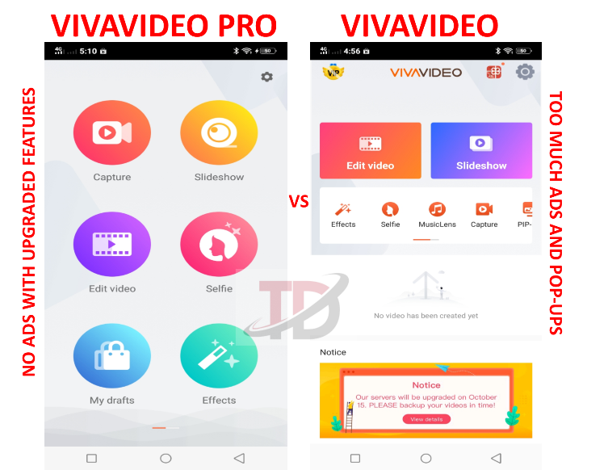

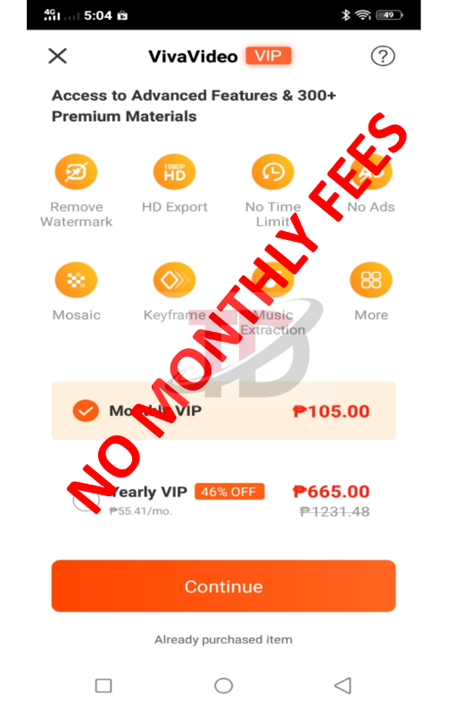

P.S. Please rate us five stars if you like our product.
Thank you!

