BAGO KA MAG INSTALL NG DRIVER DONWLOAD KA MUNA USBDEVIEW PA SEARCH NLNG SA GOOGLE ONCE DOWNLOADED RUN MO LNG USBDEVIEW THEN UNINSTALL ALL PRELOADER OR MTK65XX OR MTKXXXX NA MAKITA MO KUNG SAKALI..ONCE UNINSTALLED RESTART YOUR PC THEN FOLLOW THE SCREENSHOTS FOR INSTALLING THE RIGHT PRELOADER DRIVER

1.)Download mo muna to punta ka sa link sa baba copy paste mo sa address bar ng chrome or firefox or any internet browser ng pc http://www.4shared.com/zip/YYjIy3t8/usb_driver.html EXTRACT MO YUNG LAMAN NYAN SA DESKTOP NG PC MO usb driver name ng folder na yan pag inextract mo ha.
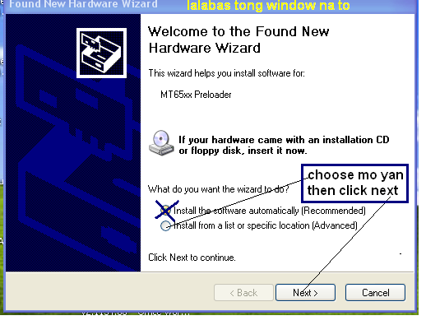
2. sundan mo screenshot para mainstall mo yung driver sa pc mo: ENABLE USB DEBUGGING SA PHONE MO GO TO SETTINGS NG FONE THEN APPLICATIONS >DEVELOPMENT THEN CHECK USB DEBUGGINGTURN OFF MO MUNA PHONE MO THEN CONNECT TO PC. THEN FOLLOW THIS SCREENSHOTS. MAY MAG POPOP UP SA PC MO NA FOUNG NEW DEVICE THEN LALABAS TO.

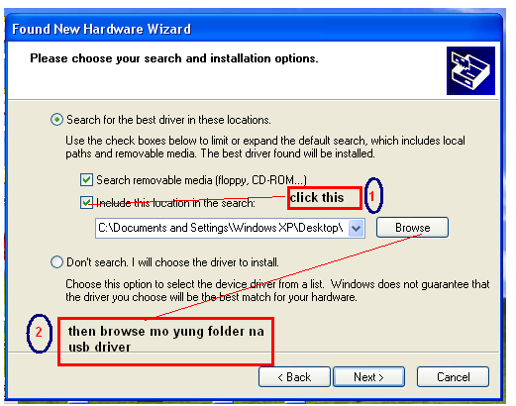

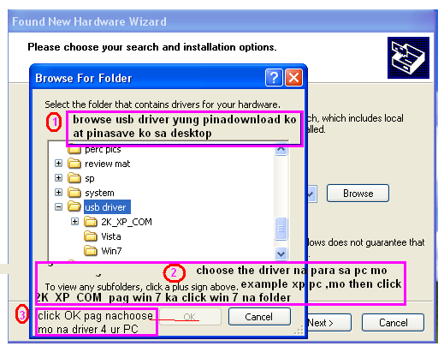
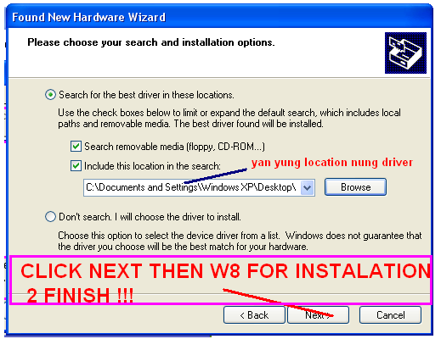

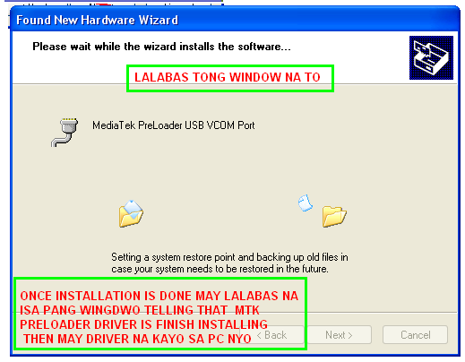
REBOOT YOUR PC CONGRATS INSTALLED NA PRELOADER DRIVER SA PC MO

