Rizal Technological University
College of Business and Entrepreneurial Technology

Information Technology II: Accounting information System

Submitted to:
Prof. Florencio A. Valdez

Submitted by:
Puig, Clarice
Balogbog, Christine
Dano, Rexienel
Fernandez, Katrina
Llape, Marie Joy
Sevilla, Crishelda

- Planning Phase

  - Statement of the objective

General Objective
The revenue cycle encompasses both the sale of goods or services to customers and collection of cash. This project will provide an improved system for the accuracy and efficiency of revenue transactions. This project will help the company carry out a smooth day to day transaction.

Specific Objective
- To bill products and services in a timely and accurate manner.
- To record and classify cash receipts promptly and accurately.

  - Scope

- Logical Scope

The activities covered by our project are billing of customers and collecting of cash.
Billing customers involves 2 tasks: invoicing and updating accounts receivable. Billing in restaurant starts with the copy of sales order approved and forwarded by the customer order department. The basic document created in here is sales invoice. The sales invoice notifies customer of the amount to be paid and where to send payment. Invoices may be sent/received in paper form or by EDI (electronic data interchange). The accounts receivable functions reports to the controller. This function performs 2 basic tasks: Debit customer accounts for the amount the customer is invoiced and credit customer accounts for the amount of customer payments. To maintain accounts receivable we use the balance forward method. The revenue cycle will be completed when cash is collected for the good and services sold. The cashier takes the remittances from the customer and deposits them in banks.

- Temporal Scope

Month | December |  |  | January |  |  |  | February
Week | 2nd | 3rd | 4th | 1st | 2nd | 3rd | 4th | 1st | 2nd | 3RD
PLANNING
Group discussion, researching and data gathering
Formulating objectives
Identifying scope
ANALYSIS
Determining input and output in the system
DESIGN
Conceptualization
Making input and output design
DEVELOPMENT
Making the prototype
Creating policies
Designing the data flow using context diagram
IMPLEMENTATION
Defining the process

  - Temporal Scope
- Project Team

- Project User

  - Financial Scope

Project Team | Monthly Salary | Duration (Months) | Amount
Project Manager | 85,000 | 3 | 255,000
System Analyst | 80,000 | 3 | 240,000
Software Engineer | 60,000 | 3 | 180,000
Database Engineer | 60,000 | 3 | 180,000
Software Developer | 75,000 | 3 | 225,000
System Administrator | 70,000 | 3 | 210,000
Hardware Engineer | 50,000 | 3 | 150,000
Total |  |  | 1,440,000
Software |  |  | 300,000
Hardware |  |  | 500,000
Personal
Training/Seminars |  |  | 100,000
Cash Reserves |  |  | 50,000
Total |  |  | 2,440,000

Cost | Benefits
Personal trainings and seminar | This is to train the employees who are going to use the system and familiarization of its function
Security and accessibility | The cost to incur is for safeguarding transactions, data, an only authorized persons are allowed to see these files to avoid theft, loss and fraud
Dry run and incidental expenditure to be incurred on the development stage | This is to ascertain that the system will work smoothly and as planned by conducting several tests runs

- Analysis Phase
INPUT | OUTPUT
- ORDER FORM | SALES ORDER
SOURCE: | PURPOSE:
WHO PREPARES?  Crew | To transcription of customer’s order to a formal and standardized format. Keeps record of description of product quantity and units, mode of payment place of delivery etc.
WHERE PREPARED? | USER:
FOH (Front Of House Staff) | General Manager
INPUT MEDIUM: | OUTPUT MEDIA:
Automated (Cashier – Dual Screen) | Softcopy (System File)
 | FREQUENCY OF OUTPUT:
 | This report is produce every transaction

INPUT | OUTPUT
- SALES ORDER | STATEMENT OF BILLING AND OFFICIAL RECEIPT
SOURCE: | PURPOSE:
WHO PREPARES?  Cashier | To keep record and to show the recent transaction , balance due, how much the bill is and any interest or other fees incurred and other key information  Official receipts allows for accurate tracking of sales and revenue. It is an evidence of the payment of customer
WHERE PREPARED? | USER:
FOH (Front Of House Staff) | Customer/General Manager
INPUT MEDIUM: | OUTPUT MEDIA:
Automated (Cashier – Dual Screen) | Hardcopy (billing) Softcopy (System File)
 | FREQUENCY OF OUTPUT:
 | This report is produce every transaction

INPUT | OUTPUT
- STATEMENT OF BILLING AND OFFCIAL RECEIPT | MONTHLY REVENUE REPORT
SOURCE: | PURPOSE:
WHO PREPARES?  Accounting Staff | To show the overall summary of all sales transaction of the business WOTHIN THE MONTH
WHERE PREPARED? | USER:
FOH (Front Of House Staff) | General Manager/Owner
INPUT MEDIUM: | OUTPUT MEDIA:
Automated (Spread sheet) | Softcopy (System File)
 | FREQUENCY OF OUTPUT:
 | This report is produce daily.

- Design Phase

SALES ORDER
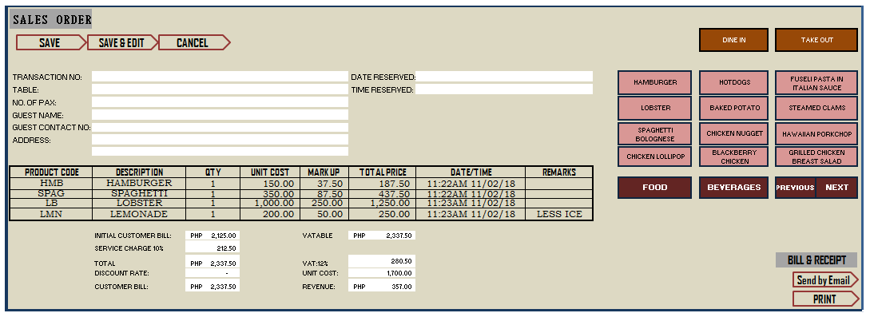

STATEMENT OF BILLING
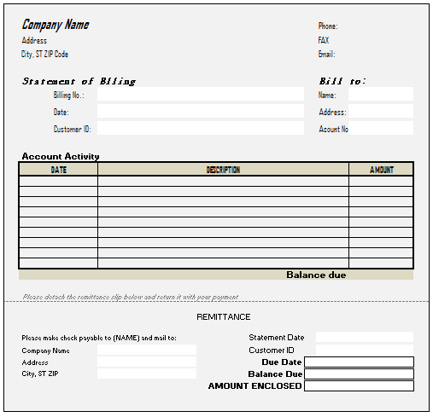

OFFICIAL RECEIPT

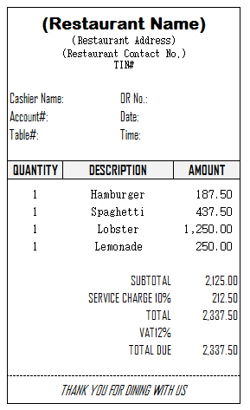

MONTHLY REVENUE REPORT

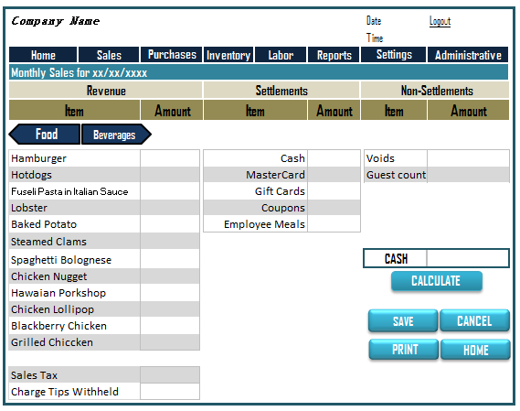

TRANSACTION FILE

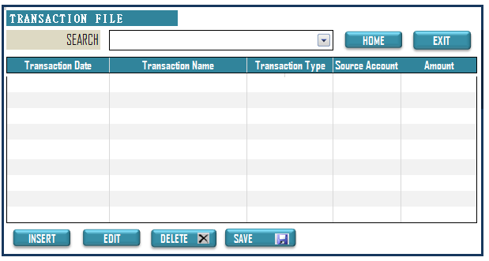
CUSTOMER MASTER FILE
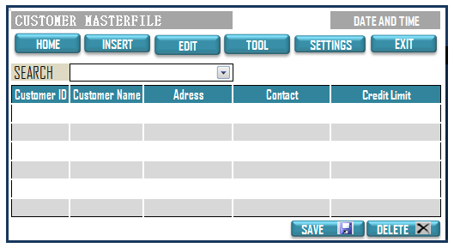

ACCOUNTS RECEIVABLE MASTER FILE

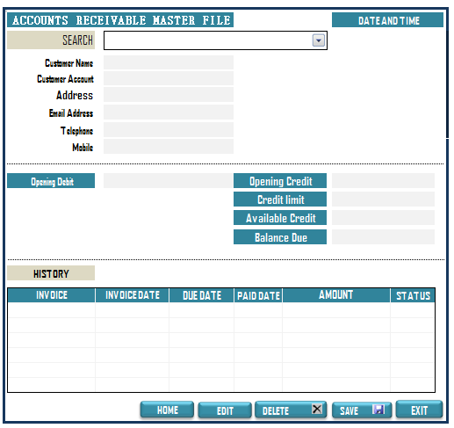

- DEVELOPMENT PHASE
Policies
- Existing customers would be classified into two. The excellent payee, average payee and poor payee which would be based on their past transactions with the company. Their standing would be used to determine their credit limit.

Excellent----------------------------------------------UNLIMITED
Average----------------------------------------------500,000
Poor----------------------------------------------------125,000

- For new customers, their credit standing would be based upon their credit card limit, income and other possible and related sources.

- Customer’s accounts would be written off after 3 attempts of collection through mail for three consecutive months.

- All perfected sales should be supported by a receipt.

Context Diagram
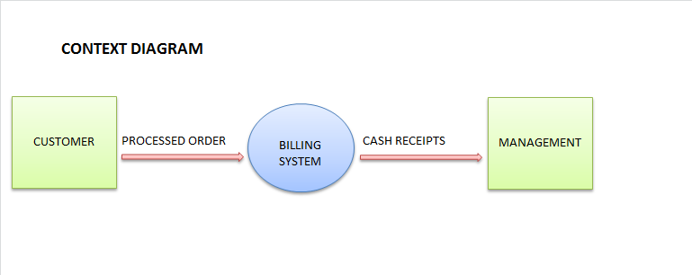

Data Flow Diagram


