What you need?
HTTP Injector
SSH Account
Proxy Server/Remote Proxy
So let's start downloading HTTP injector, you can download it on the play store, but here I have a link.
http://www.datafilehost.com/d/4b97777b
Creating SSH Account
Next step create account, where you can create a SSH account. Choose wisely for the countries. Here are some free SSH sites.

4g.diginet.net
akashiro.co.id
arema-nia.com
best-ssh.me
bestvpnssh.com
bolehcopas.com
boostvpn.us
brssh.com
campssh.com
ciscossh.com
cloudssh.net
cloudssh.us
connortoth.com
contassh.com
create.sshgoogle.com
createssh.com
criarssh.com
cyberssh.com
darkssh.com
datassh.com
dewassh.net
dimas.id
dynamicssh.com
fastproxyservers.org/socks5-servers.html
fastssh.com
flashssh.com
flyssh.com
free.easypro.xyz
free-proxy-list.net
free-ssh.xyz
freevpn.us
fullssh.com
gatherproxy.com
globalssh.net
goodssh.com
goossh.com
greenssh.com
ifmvpn.us
interssh.com
jarumssh.com
Jetssh.com
kopissh.com
lastssh.com
list.proxylistplus.com/Fresh-HTTP-Proxy-List-1
lowframe.com
monthlyssh.com
myproxy.id/squid-proxy
mytunneling.com
neossh.com
nordvpn.com/free-proxy-list/
portssh.com
premiumproxy.net
premproxy.com/list
proxyfish.com/proxies
proxyhttp.net
proxynova.com
proxyserverlist24.top/2017/12/31-12-17-fast-proxy-server-list-fast.html
redskinbro.com/?do=ssh-redskinbro
roketssh.com
rumahssh.net
securedssh.net
servervpn.net
skyssh.com
sockslist.net
socks-proxy.net
speedssh.com
spotssh.com
spys.one/en
squidssh.com
ssh.funkysst.com
sshagan.net
sshdropbear.com
sshdropbear.net
ssh-fast.net
sshfast.us
sshfunkysst.net
sshgoogle.com
sshinjector.net
sshkit.com
sshmu.us
sshngebut.xyz
sshocean.com
sshservers.com
sshudp.com
ssh-vip.me
sshweb.net
sshwus.com
stunnel.site
tcpvpn.com
trialssh.net
vpnjantit.com
vpnsplit.com
vpnssh.net
vpnsshfree.com
vpnudp.com
wussh.us

Here is the example after you create an account.
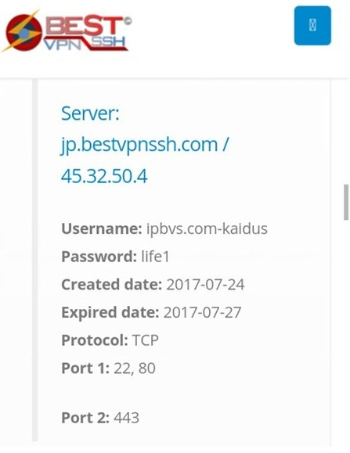
Finding Remote Proxy
Most free SSH account providers also have proxy servers, try looking around their site for pages named “squid”, or “proxy” and here are some sites where you can find or hunt remote proxy.
fastssh.com
free-proxy-list.net
httptunnel.ge
gatherproxy.com
proxydb.net
hidemyass.com
spys.ru
sslproxies.org
tcpvpn.com
torvpn.com
Dito niyo naman pwedeng itest ang RP dapat all green lahat para mas swabe ang speed:
www.httptunnel.ge/proxychecker.aspx
Example:
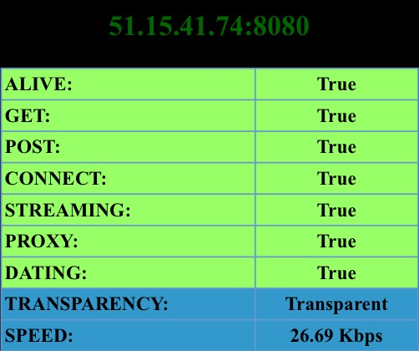
Dito niyo naman malalaman ang country ng server niyo:
http://www.hcidata.info/host2ip.cgi
For ping test [The lower the "ms" the better] If gusto mo lang ng low ping config:
ping.eu/ping/
Low "PING" example:
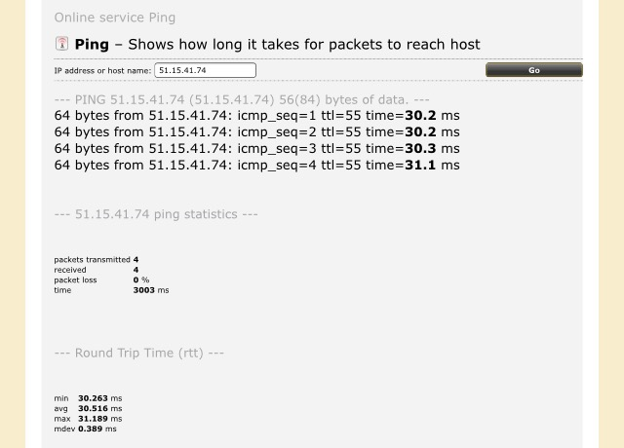
NOTE: Dapat kung ano ang server ng ssh mo, dapat ganon din ang sa remote proxy mo para to the go agad! XD
After creating your account and finding remote proxy, open your HTTP injector, you first see the remote proxy. Put the remote proxy, just like this.
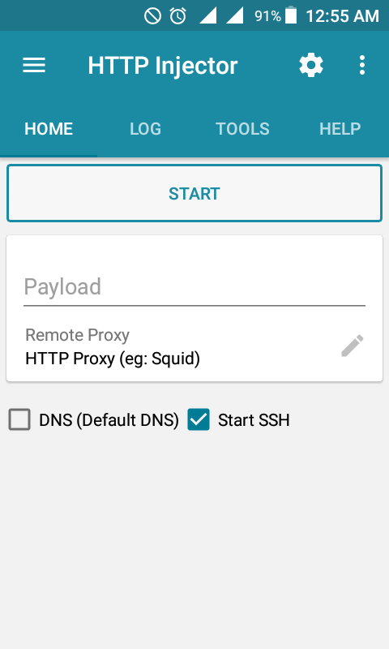
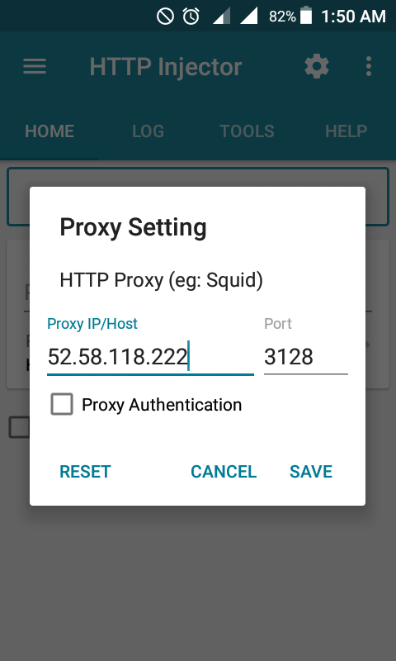
Putting SSH Account
Then, when you done putting the remote proxy, on the left hand corner click SSH settings, where you're going to put your SSH Account. Different SSH Port 22/80/109/110/443.
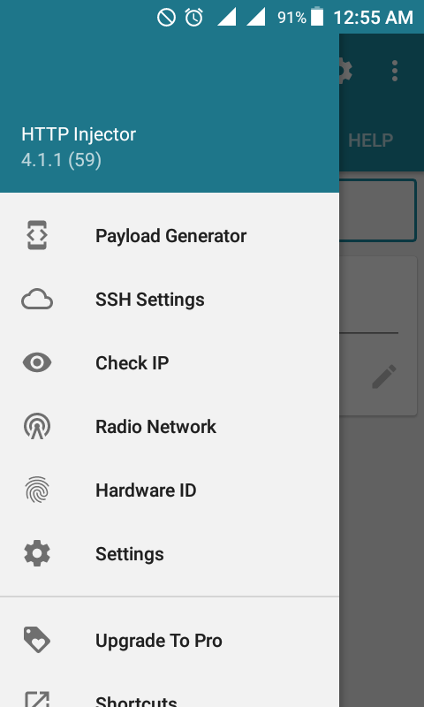
Different Ways On Payload
When you done putting your SSH Account click the Payload Generator. In generating a payload this step comes with trial and error, where your going to succeed or not.
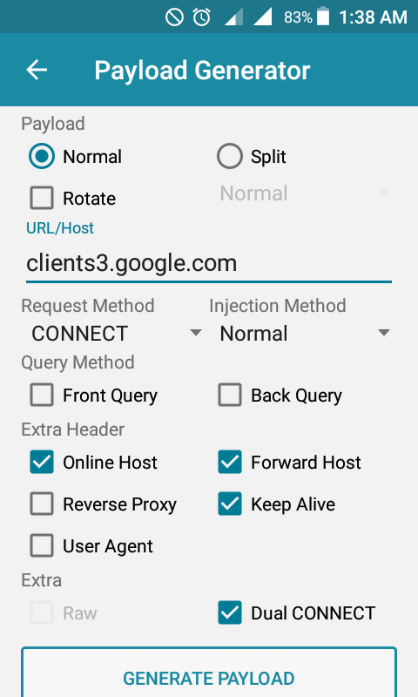
Here are some payloads and formats. Url/Host are the free site(e.g. bug sites) to browse.
Url/Host
google.az
clients3.google.com
pack.google.com
relay.google.com
29domains.com
Format
•√ Normal-√ Online Host-√ Keep Alive-√ Dual Connect
•√ Normal-√ Dual Connect
•√ Normal-√ Put-√ Back Inject-√ Dual Connect
•√ Split-√ Post-√ Front Inject-√ Online Host-√ Keep Alive-√ Dual Connect
•√ Split-√ Instant Split-√ Get-√ Back Inject-√ Online Host-√ Keep Alive-√ Dual connect
Saving your File
Then click Generate, don't forget to CLICK DNS and start your http Injector, if it connects try and save your configured ehi server by clicking on the top right corner and click export file.
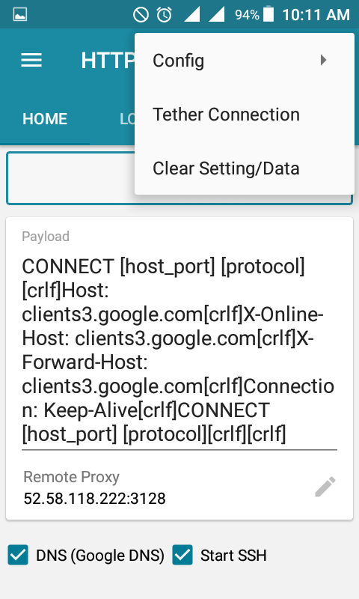

- Note may nilagay akong Tips sa baba sa pag-gegenerate ng Payload ng Globe / TM

HTTP INJECTOR PAYLOAD GENERATOR SETTINGS:
PAYLOAD:
- × Normal
- √ Split
- √ Delay Split
- × Rotate
URL / HOST:
- WWW.NOCHE.COM.PH or anything what you want to put here like WWW.KAPATID.COM or anything what you like to put here.
REQUEST METHOD:
- GET
INJECTION METHOD:
- Back Inject
QUERY METHOD:
- × Front Query
- × Back Query
EXTRA HEADER:
- √ KEEP ALIVE
- × REVERSE PROXY
- √ ONLINE HOST
- √ FORWARD HOST
- × USER AGENT
EXTRA:
- × Raw
- √ Dual CONNECT

- CLICK Generate Payload.
HTTP INJECTOR PAYLOAD GENERATOR SETTINGS IMAGE:
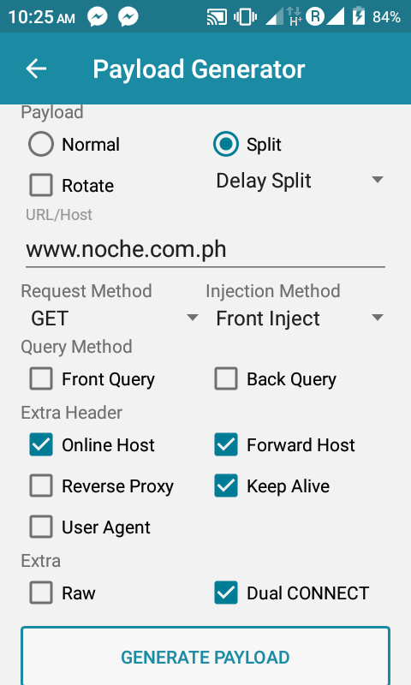

•Split/instant split
•Front inject
•Patch/propatch
•Keep alive
URL/Host example:
Single payload:
ASP.NET
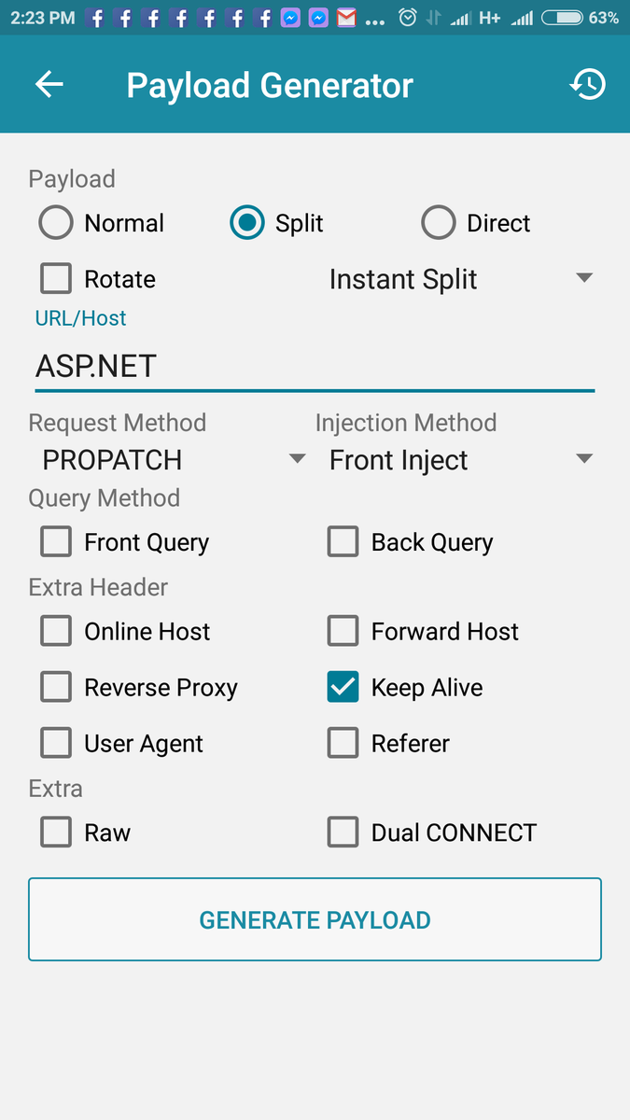
Multi-payload [Use Rotate]:
ASP.NET;VB.NET
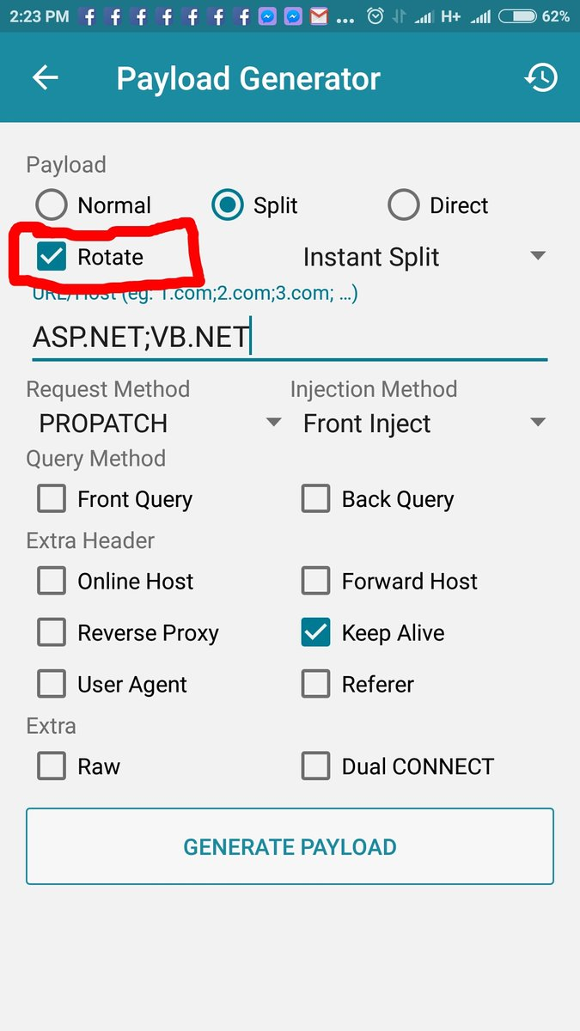
Multipayloads are always separated with this “;”

For configuring "NO LOAD":
Always use "Back query" [Open for Smart]
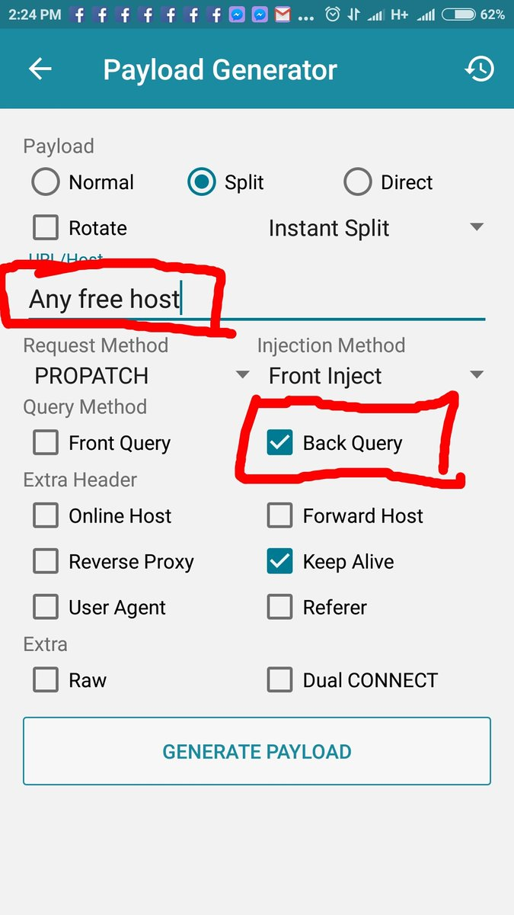

Host / Domain: ssl.gstatic.com
method: connect
Injection: Back injection
e check nyo ang Dual connect
check X-ONLINE-HOST
Check Keep alive
and click Generate
tignan nyo ang sample sa baba
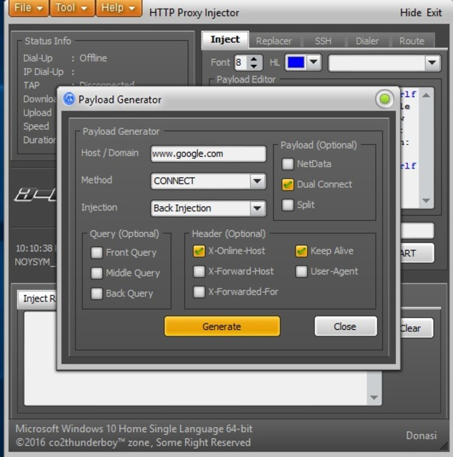
Name it with your desired name and you can secure it so as to use it alone by locking it, and to lock your ehi server tick all the lock configuration.
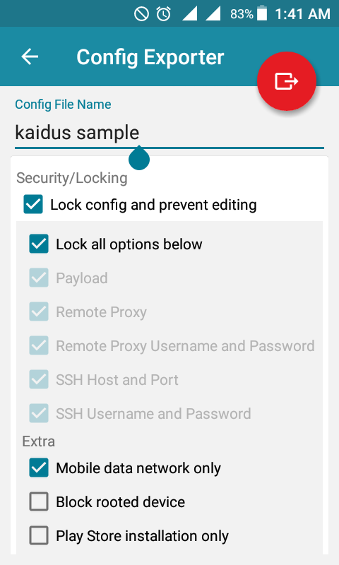
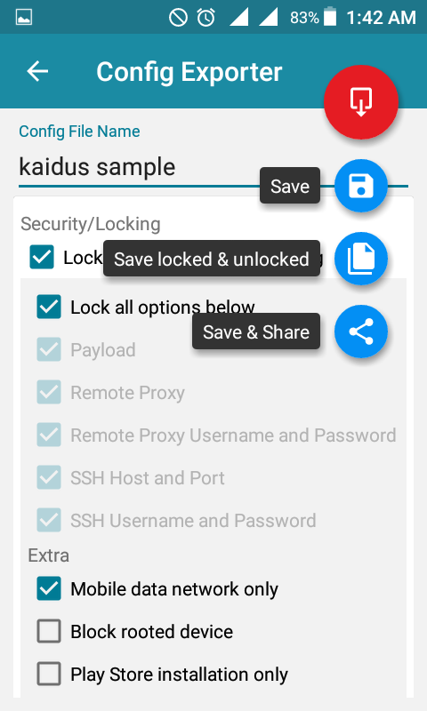
That's all, it was easy right? Go and make your ehi now.

