- Start screen
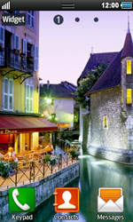
- select settings
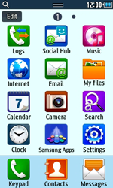
- select connectivity
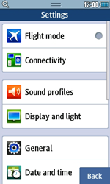
- select network
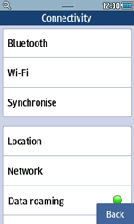
- select connections
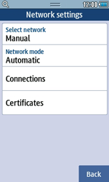
- select yes
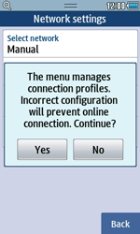
- select create
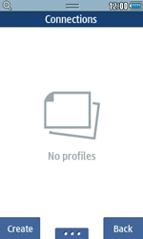
- under set name, enter myglobeconnect
under access name, enter www.globe.com.ph
under auth. type, select normal
leave user id and password .
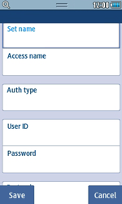
- scroll down
under protocol, select HTTP
under home url, enter http://www.globe.com.ph/globe.asp
under proxy address, enter 203.177.42.214:80
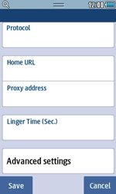
- select save
- return to the main menu
- select internet
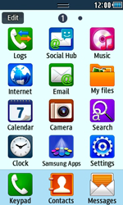
- select the menu icon and then internet settings
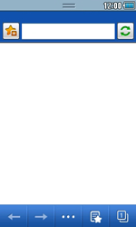
- select internet profiles
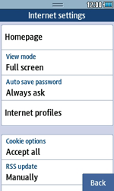
- select myglobeconnect and then set


