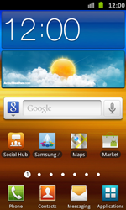

- Start screen.
- Choose Applications.
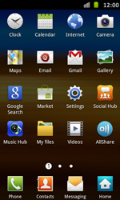

- Choose Settings.
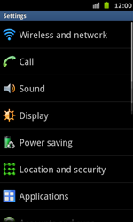

- Choose Wireless and network.
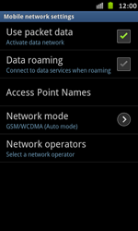

- Choose Use packet data, and tick this option.

- Choose Access Point Names.


- Remove all current APN settings: choose the APN, choose the menu key, and choose Delete APN.
- Choose the menu key, and choose New APN.
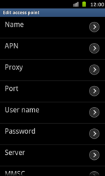

- Under Name, enter myglobeconnect
- Under APN, enter www.globe.com.ph

- Under Proxy, enter 203.177.42.214
- Under Port, enter 8080
- Under Server, enter http://www.globe.com.ph/globe.asp

- Under User name, enter nothing.
- Under Password, enter nothing.
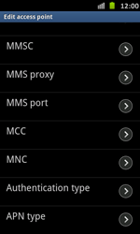

- Scroll down.
- Under MCC, enter 515
- Under MNC, enter 02
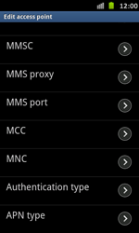

- Under Authentication type, choose PAP.
- Under APN type, choose Internet.
- Choose the menu key.
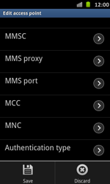

- Choose Save.


- Choose myglobeconnect, and tick this option.
- Return to the Start screen.

