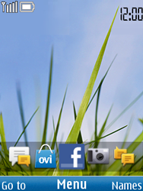
- Start screen.
- Choose Menu.
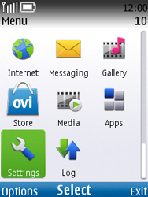
- Choose Settings, and then Select.
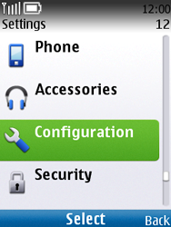
- Scroll down.
- Choose Configuration, and then Select.
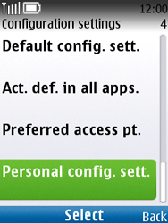
- Choose Personal config. sett., and then Select.
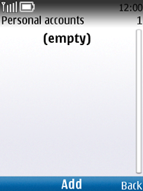
- If this screen appears, choose Add.
- If this screen does not appear, choose Options, Add new, and then Select.
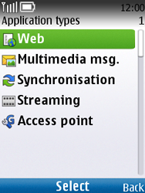
- Choose Web, and then Select.
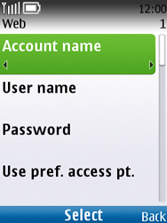
- Choose Account name, Select, enter myglobeconnect, and choose OK.
- Choose User name, Select, enter nothing, and choose OK.
- Choose Password, Select, enter nothing, and choose OK.
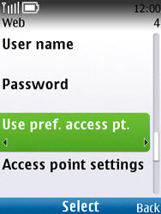
- Choose Use pref. access pt., Select, No, and then Select.
- Choose Access point settings, and then Select.
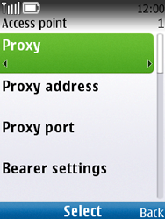
- Choose Proxy, Select, enable, and then Select.
- Under Proxy address, enter 203.177.42.214
- Under Proxt port, enter 8080
- Choose Bearer settings, and then Select.
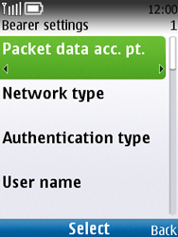
- Choose Packet data acc. pt., Select, enter myglobeconnect, and then OK.
- Choose Authentication type, Select, Normal, and then Select.
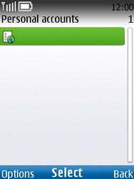
- Choose MMS, Options, Activate, and then Select.
- Return to the Start screen.
- Start screen.
- Switch off the Nokia C2-01 and restart it in order to activate the settings.
- You can now start using the internet.

