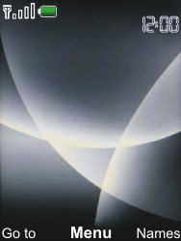

- Start screen.
- Choose Menu.
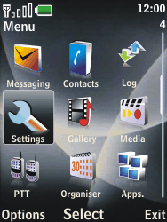

- Choose Settings, and then Select.
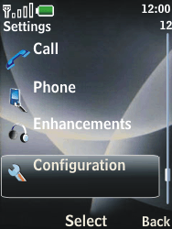

- Choose Configuration, and then Select.
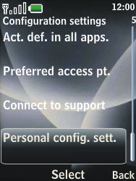

- Choose Personal config. sett., and then Select.
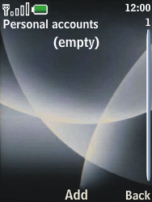

- If this screen appears, choose Add.
- If this screen does not appear, choose Options, Add new, and then Select.
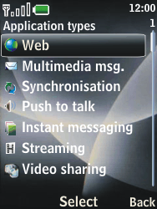

- Choose Web, and then Select.
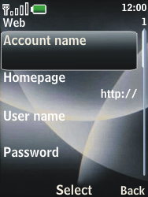

- Choose Account name, Select, enter myglobeconnect, and choose OK.
- Choose Homepage, Select, enter http://www.globe.com.ph/globe.asp
, and choose OK.
- Choose User name, Select, enter nothing, and choose OK.
- Choose Password, Select, enter nothing, and choose OK.
- Scroll down.
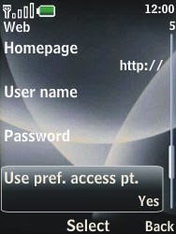

- Choose Use pref. access pt., Select, yes, and then
- Under proxy, enter 203.177.42.214
- Under port, enter 8080
- Then Select ok
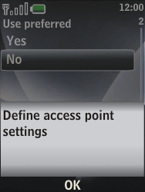

- Choose OK.
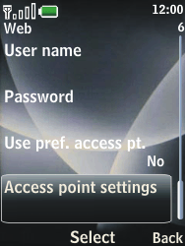

- Choose Access point settings, and then Select.
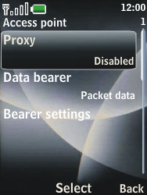

- Choose Proxy, Select, Enable, and then Select.
- Choose Data bearer, Select, Packet data, and then Select.
- Choose Bearer settings, and then Select.
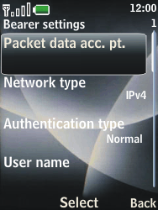

- Choose Packet data acc. pt., Select, enter www.globe.com.ph, and choose OK.
- Choose Authentication type, Select, Normal, and then Select.
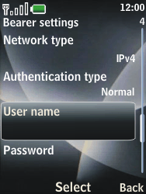

- Choose User name, Select, enter nothing, and choose OK.
- Choose Password, Select, enter nothing, and choose OK.
- Choose Back three times
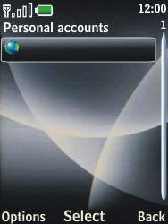

- Choose myglobeconnect, and then Options.
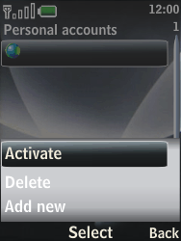

- Choose Activate, and then Select.
- Return to the Start screen.

- Start screen.
- Switch off the Nokia 3120 classic and restart it in order to activate the settings.
- You can now start using the internet.

