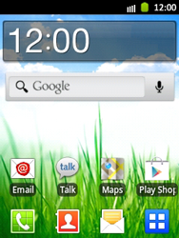

- Start screen.
- Go to the Main menu.
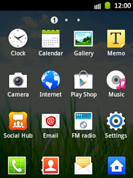

- Choose Settings.

- Choose Settings.
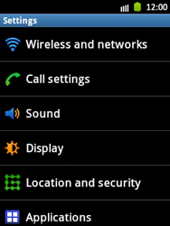

- Choose Wireless and networks.
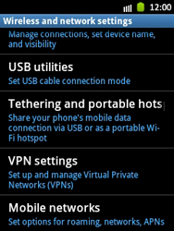

- Scroll down.
- Choose Mobile networks.
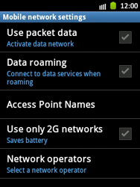

- Choose Use packet data, and tick this option.
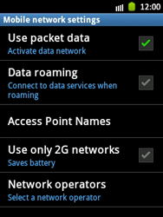

- Choose Acces Point Names.
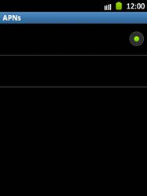

- Remove all current APN settings choose the APN, choose the menu key, and choose Delete APN.
- Choose the menu key, and choose New APN.
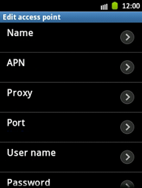

- Under Name, enter myglobeconnect
- Under APN, enter www.globe.com.ph
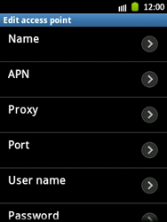

- Under Proxy, enter 203.177.42.214
- Under Port, enter 8080
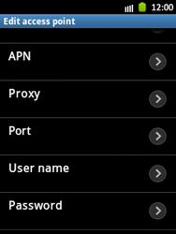

- Under User name, enter nothing.
- Under Password, enter nothing.
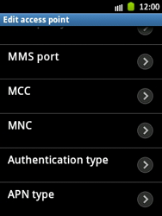

- Scroll down.
- Under Server, enter http://www.globe.com.ph/globe.asp
- Under MCC, enter 515
- Under MNC, enter 02
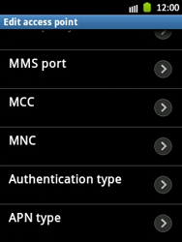

- Choose Authentication type, and then PAP.
- Choose APN type, and then internet.
- Choose the menu key.
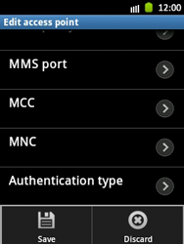

- Choose Save.
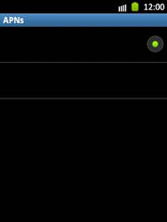

- Choose Proximus Internet, and tick this option.
- Return to the Start screen.

- Start screen.
- Go to the Main menu.

