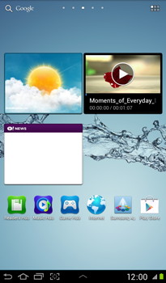

- Start screen.
- Go to the Main menu.
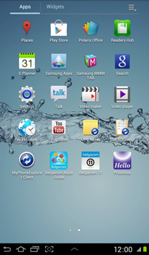

- Choose Settings.
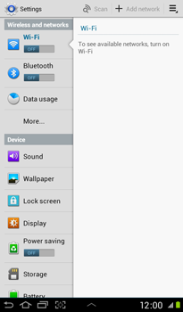

- Choose More…
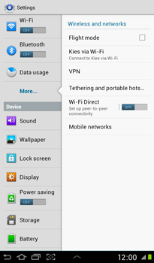

- Choose Mobile networks.
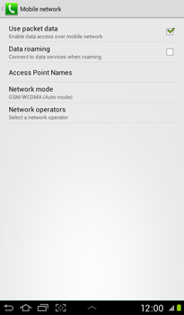

- Choose Use packet data, and tick this option
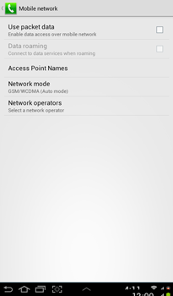

- Choose Access Point Names.
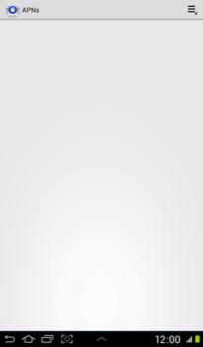

- Remove all current APN settings: Choose the APN, choose the menu symbol, and choose Delete APN.
- Choose the menu symbol, and choose New APN.
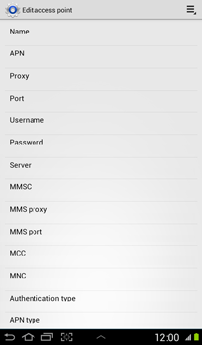

- Under Name, enter myglobeconnect
- Under APN, enter www.globe.com.ph
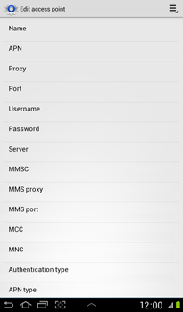

- Under Proxy, enter 203.177.42.214
- Under Port, enter 8080
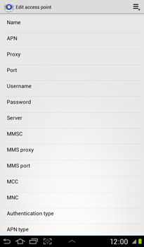

- Under Username, enter nothing.
- Under Password, enter nothing.
- Under Server, enter http://www.globe.com.ph/globe.asp
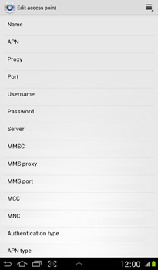

- Under MCC, enter 515
- Under MNC, enter 02
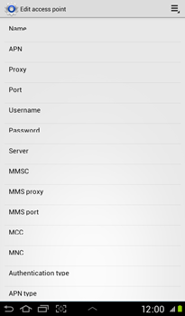

- Under Authentication type, choose PAP.
- Under APN type, choose Internet.
- Choose the menu symbol.
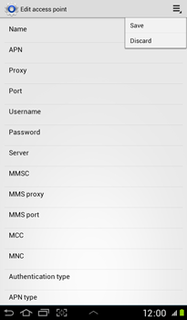

- Choose Save.
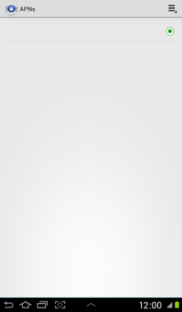

- Choose myglobeconnect, and tick this option.
- Return to the Start screen.

