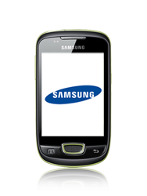

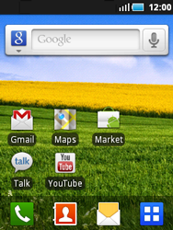

- Start screen.
- Choose the menu symbol.
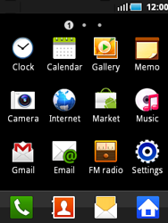

- Choose *Settings*.
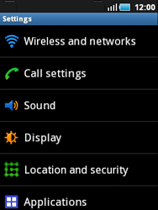

- Choose *Wireless and networks*.
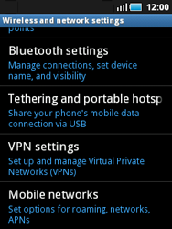

- Scroll down.
- Choose *Mobile networks*.
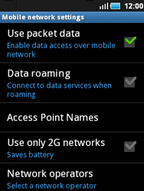

- Choose *Use packet data*, and check this option.
- Choose *Access Point Names*.
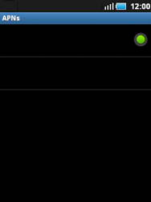

- Remove all current APN settings by choosing the APN, choosing the menu key, and choosing Delete APN.
- Choose the menu key, and choose New APN.
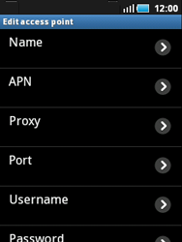

- Under Name, enter myglobeconnect
- Under APN, enter www.globe.com.ph
- Under Proxy, 203.177.42.214
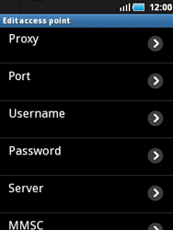

- Under Port, enter 80
- Under Username, enter nothing.
- Under Password, enter nothing.
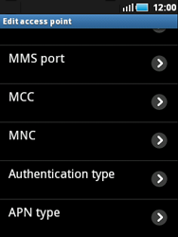

- Scroll down.
- Under MCC, enter 515
- Under MNC, enter 02
- Choose Authentication type, and then PAP.
- Choose APN type, and then internet.
- Choose the menu key
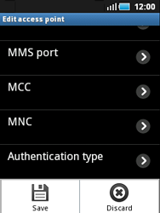

- Choose *Save*.
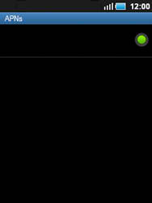

- Choose myglobeconnect and check this option.
- Return to the Main menu.
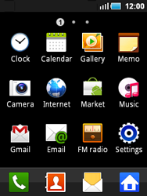

- Choose Internet.


- Choose the menu key, choose More, scroll down, and choose Settings.
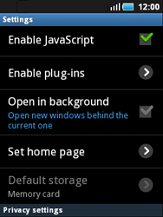

- Scroll down.
- Choose Set home page.
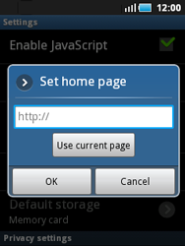

- Enter http://www.globe.com.ph/globe.asp
and choose OK.
- Return to the Start screen.

- Start screen.
- Switch off the Samsung Galaxy Mini and restart it in order to activate the settings.
- You can now start using the internet.

