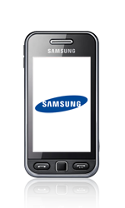

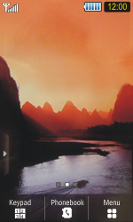

- Start screen.
- Select Menu.

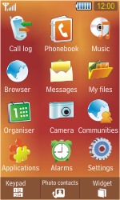

- Select Browser.
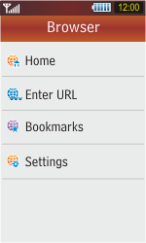

- Select Settings.
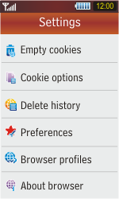

- Select Browser profiles.
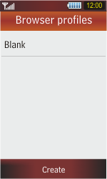

- Select Create.
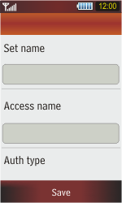

- Under Set name, enter myglobeconnect
- Under Access name, enter www.globe.com.ph
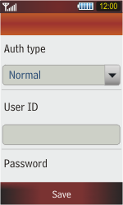

- Under Auth type, select Normal.
- Under User ID, enter nothing.
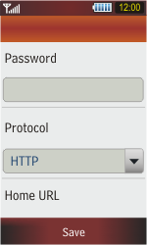

- Under Password, enter nothing.
- Under Protocol, select HTTP.
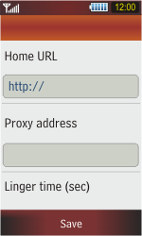

- Under Home URL, enter http://www.globe.com.ph/globe.asp
.
- Select Save.
- Under proxy address, enter 203.177.42.214:80
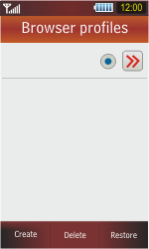

- Select the O symbol next to myglobeconnect
- Return to the Start screen.

- Start screen.
- Switch off the Samsung Star and restart it in order to activate the settings.
- You can now start using the internet.

