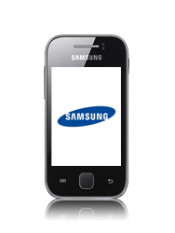

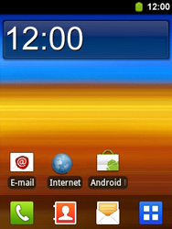

- Start screen.
- Go to the Main menu.
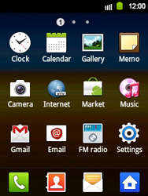

- Choose Settings.
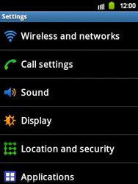

- Choose Wireless and networks.
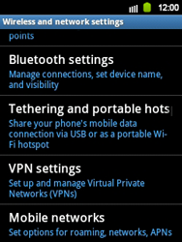

- Choose Mobile networks.
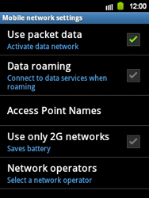

- Choose Use packet data, and tick this option.
- Choose Access Point Names.
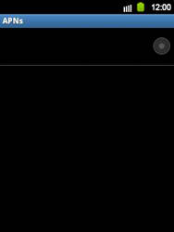

- Remove all current APN settings by choosing the APN, choosing the menu key, and choosing Delete APN.
- Choose the menu key, and choose New APN.
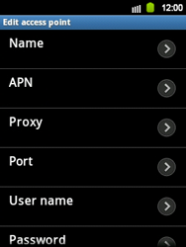

- Under Name, enter myglobe connect
- Under APN, enter www.globe.com.ph
- Under Proxy, 203.177.42.214
- Under Port, 8080
- Under Username, enter nothing.
- Under Password, enter nothing.
- Under Server, enter http://www.globe.com.ph/globe.asp
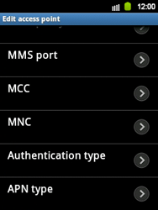

- Scroll down.
- Under MCC, enter 515
- Under MNC, enter 02
- Choose Authentication type, and then PAP.
- Choose APN type, and then internet.
- Choose the menu key.
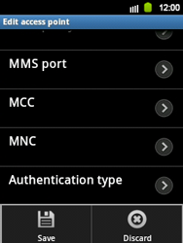

- Choose Save.

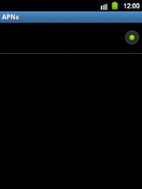

- Choose myglobe connect, and tick this option.
- Return to the Main menu.

- Choose Internet.


- Choose the menu key, choose More, and then Settings.
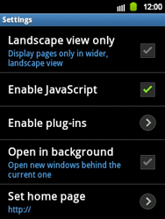

- Scroll down.
- Choose Set home page.
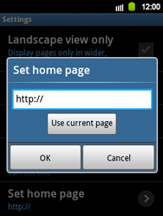

- Enter http://www.globe.com.ph/globe.asp
and choose OK.
- Return to the Start screen.

- Start screen.
- Switch off the Samsung Galaxy Y and restart it in order to activate the settings.
- You can now start using the internet.

