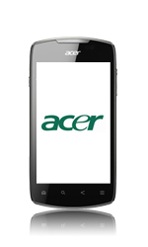
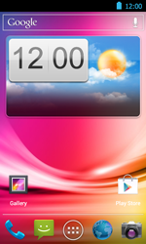
- Go to the Start screen.
- Choose the menu symbol
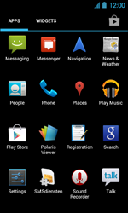
- Choose Settings.
v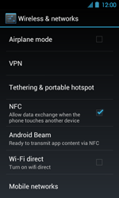
- Choose Mobile networks.
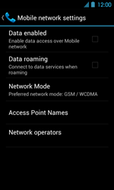
- Choose Data enabled, and tick this option
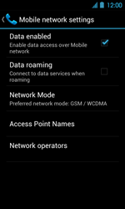
- Choose Access Point Names.
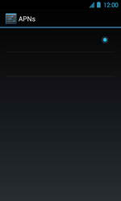
- Remove all current APN settings Choose the APN, choose the menu key, and choose Delete APN.
v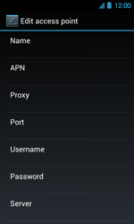
- Under Name, enter myglobeconnect
- Under APN, enter www.globe.com.ph
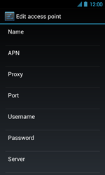
- Under Proxy, enter 203.177.42.214
- Under Port, enter 8080
- Under Username, enter nothing.
- Under Password, enter nothing.
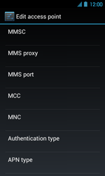
- Scroll down.
- Under MCC, enter 515
- Under MNC, enter 02
- Under Authentification type, choose PAP.
- Under APN type, choose internet.
- Choose the menu key.
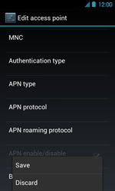
- Choose Save.
- Choose myglobeconnect and tick this option.
- Return to the Main menu.
- Choose the menu symbol.
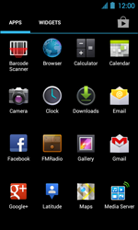
- Choose Browser.
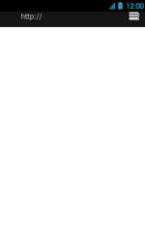
- Choose the menu key.
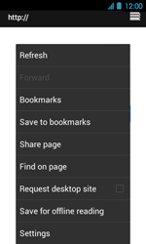
- Choose Settings.
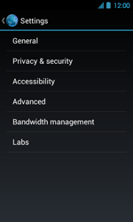
- Choose General.
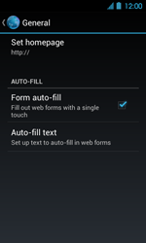
- Choose Set homepage.
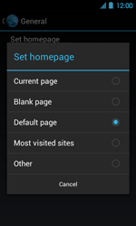
- Choose Other.
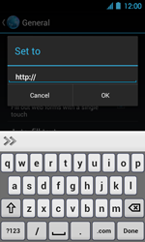
- Enter http://www.globe.com.ph/globe.asp and choose OK
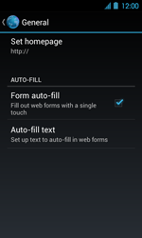
- The homepage has been saved.
- Return to the Start screen.
- Start screen.
- Switch off the Acer Liquid Glow and restart it in order to activate the settings.
- You can now start using the internet.

