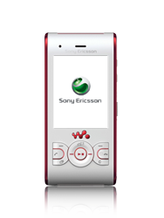

- Start screen.
- Choose Menu.

- Choose Internet, and then Select.
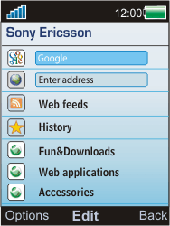
- Choose Options.
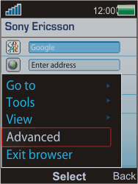
- Choose Advanced, and then Select.
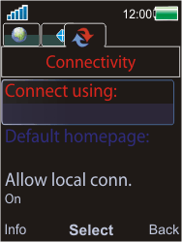
- Choose Connect using, and then Select.
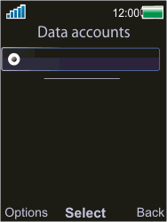
- Choose Options, Create new, and then Select.
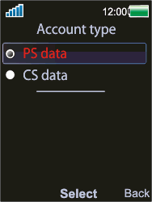
- Choose PS data, and then Select.
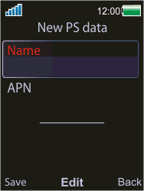
- Choose Name, Edit, enter myglobeconnectand choose OK.
- Choose APN, Edit, enter www.globe.com.ph, and choose OK.
- Choose Save.
- Choose myglobeconnect and then Options.
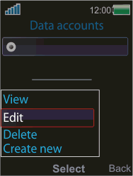
- Choose Edit, and then Select.
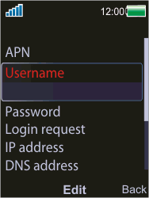
- Choose Username, Edit, enter nothing, and chooseOK.
- Choose Password, Edit, enter nothing, and chooseOK.
- Scroll down.
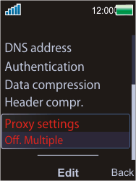
- Choose Proxy settings, and then Edit.
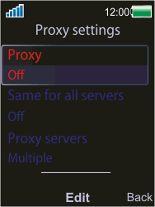
- Choose Proxy, Edit, On and then under proxy enter 203.177.42.214 while under port enter 80
- Choose Back twice.
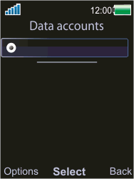
- Choose myglobeconnect, and then Select.
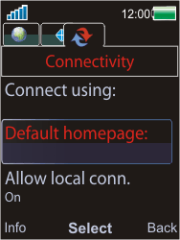
- Choose Default homepage, and then Select.
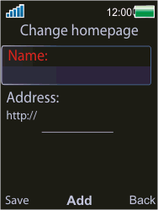
- Choose Name, Edit, enter myglobeconnect, and choose OK.
- Choose Address, Edit, enter http://www.globe.com.ph/globe.asp , and choose OK.
- Choose Save.
- Return to the Start screen.
- Start screen.
- Switch off the Sony Ericsson W595 and restart it in order to activate the settings.
- You can now start using the internet

