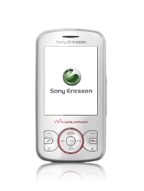
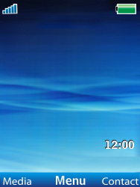
- Start screen.
- Choose Menu.
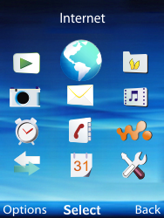
- Choose Internet, and then Select.
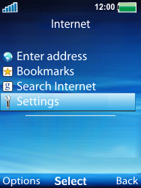
- Choose Settings, and then Select.
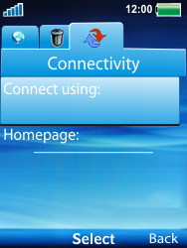
- Choose the Connectivity tab.
- Choose Connect using, and then Select.
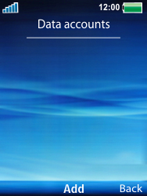
- Choose Add.
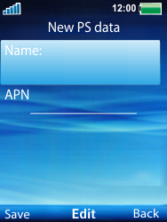
- Choose Name, Edit, enter myglobeconnect and choose OK.
- Choose APN, Edit, enter www.globe.com.ph and choose OK.
- Choose Save.
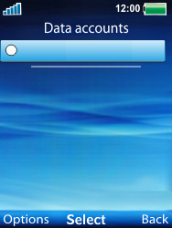
- Choose myglobeconnect Options, and then Edit.
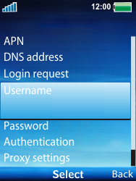
- Choose Username, Edit, enter nothing, and chooseOK.
- Choose Password, Edit, enter nothing, and chooseOK.
- Choose Proxy settings, and then Select.
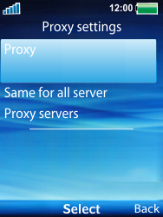
- Choose Proxy, Select, on, and then under proxy enter 203.177.42.214 while under port enter 80
- Choose Back twice
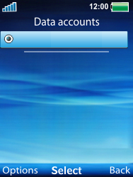
- Choose myglobeconnect, and then Select.
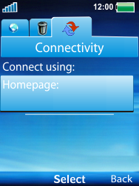
- Choose Homepage, and then Select.
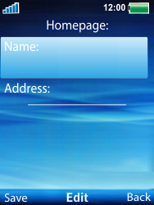
- Choose Name, Edit, enter myglobeconnect, and choose OK.
- Choose Address, Edit, enter http://www.globe.com.ph/globe.asp and choose OK.
- Choose Save.
- Return to the Start screen.
- Start screen.
- Switch off the Sony Ericsson Spiro and restart it in order to activate the settings.
- You can now start using the internet.

