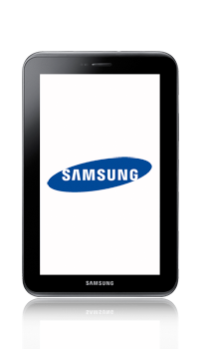
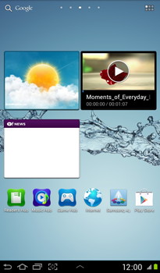
- Start screen.
- Go to the Main menu.
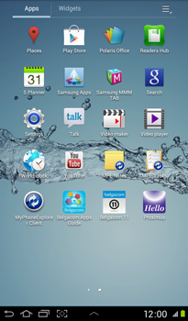
- Choose Settings.
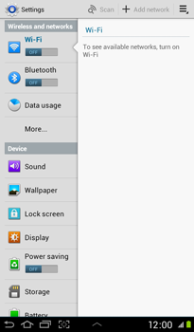
- Choose More…
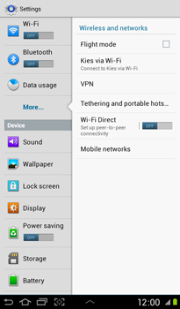
- Choose Mobile networks.
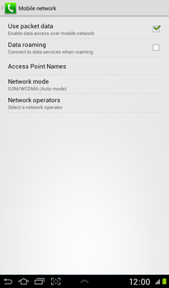
- Choose Use packet data, and tick this option.
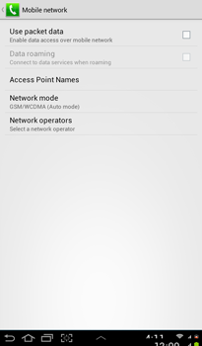
- Choose Access Point Names.
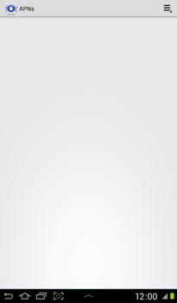
- Remove all current APN settings: Choose the APN, choose the menu symbol, and choose Delete APN.
- Choose the menu symbol, and choose New APN.
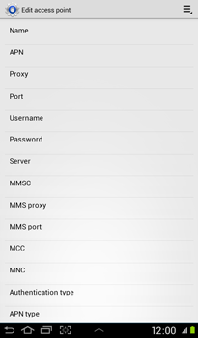
- Under Name, enter myglobeconnect
- Under APN, enter www.globe.com.ph
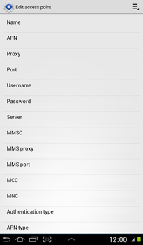
- Under Proxy, enter 203.177.42.214
- Under Port, enter 8080
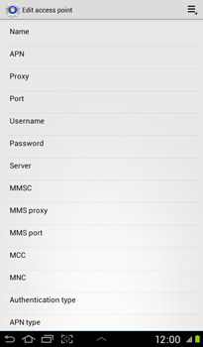
- Under Username, enter nothing.
- Under Password, enter nothing.
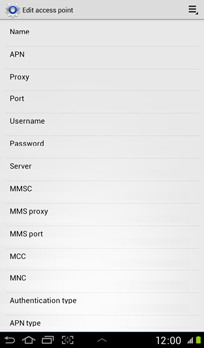
- Under MCC, enter 515
- Under MNC, enter 02
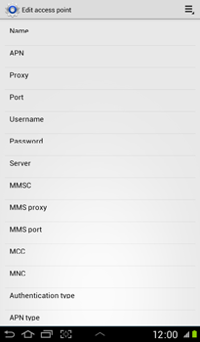
- Under Authentication type, choose PAP.
- Under APN type, choose Internet.
- Choose the menu symbol.
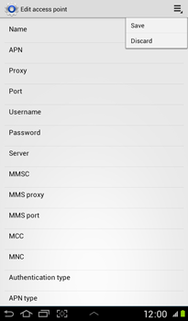
- Choose Save.
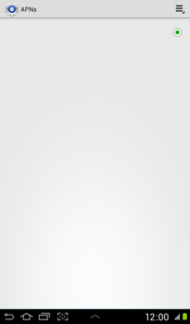
- Choose myglobeconnect, and tick this option.
- Return to the Start screen.
- Start screen.
- Go to the Main menu.
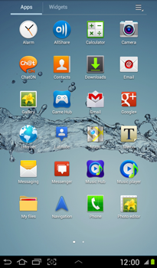
- Choose Internet.
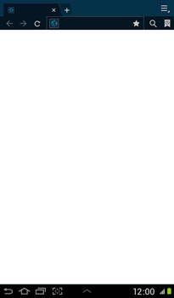
- Choose the menu symbol, and choose Settings
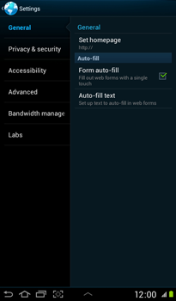
- Choose General.
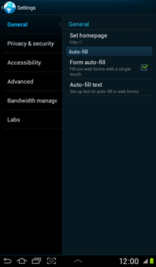
- Choose Set homepage.
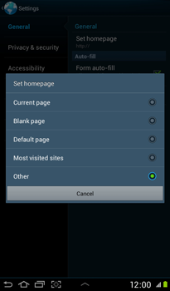
- Choose Other, and tick this option.
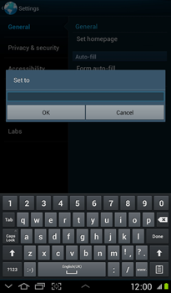
- Enter http://www.globe.com.ph/globe.asp and choose OK.
- Return to the Start screen.
- Start screen.
- Switch off the Samsung Tab 2 and restart it in order to activate the settings.
- You can now start using the internet.

