
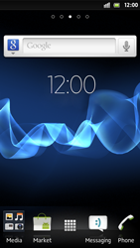
- Start screen.
- Go to the Main menu.
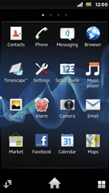
- Choose Settings.
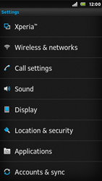
- Choose Wireless & networks.
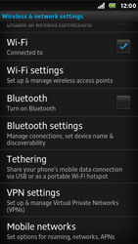
- Scroll down.
- Choose Mobile networks.
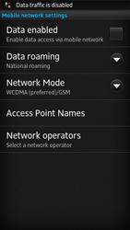
- Choose Data enabled, and tick this option.
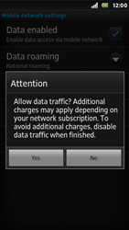
- Choose Yes.
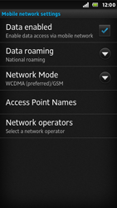
- Choose Access Point Names
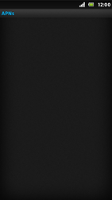
- Remove all current APN settings choose the APN, choose the menu key, and choose Delete APN.
- Choose the menu key, and choose New APN.
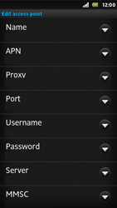
- Under Name, enter myglobeconnect
- Under APN, enter www.globe.com.ph
- Under Proxy, enter 203.177.42.214
- Under Port, enter 8080
- Under Username, enter nothing.
- Under Password, enter nothing.
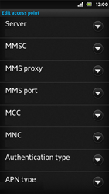
- Scroll down.
- Under MCC, enter 515
- Under MNC, enter 02
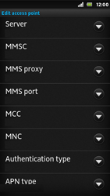
- Under Authentication type, choose PAP.
- Under APN type, enter default. (Note: in lower case)
- Choose the menu key.
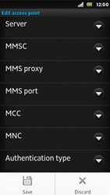
- Choose Save.
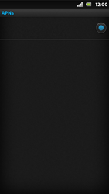
- Choose myglobeconnect and tick this option.
- Return to the Start screen
- Start screen.
- Go to the Main menu.
- Choose Browser.
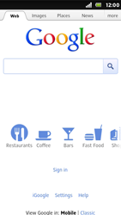
- Choose the menu key, choose More, and thenSettings.
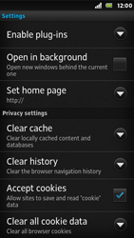
- Scroll down.
- Choose Set home page.
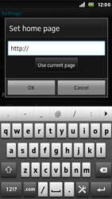
- Enter http://www.globe.com.ph/globe.asp , and choose OK.
- Return to the Start screen.
- Start screen.
- Switch off the Sony Xperia U and restart it in order to activate the settings.
- You can now start using the internet.

