
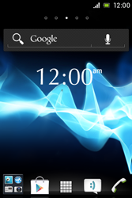
- Start screen.
- Go to the Main menu.
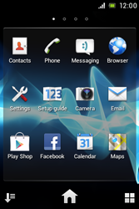
- Choose Settings.
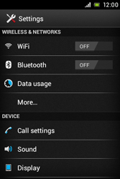
- Go to More…
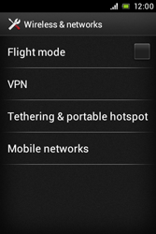
- Choose Mobile networks.
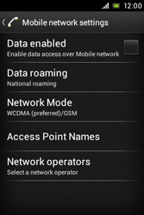
- Choose Data enabled, and tick this option.
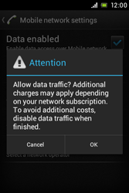
- If this screen appears, choose OK.
- If this screen does not appear, go to the next step.
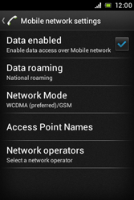
- Choose Access Point Names.
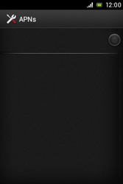
- Remove all current APN settings Choose the APN, choose the menu key, and choose Delete APN.
- Choose the menu key, and choose New APN.
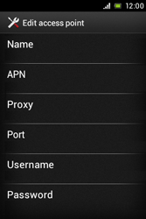
- Under Name, enter myglobeconnect
- Under APN, enter www.globe.com.ph
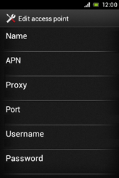
- Under Proxy, enter 203.177.42.214
- Under Port, enter 8080
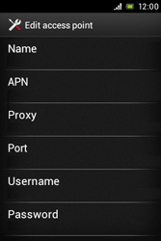
- Under Username, enter nothing.
- Under Password, enter nothing.
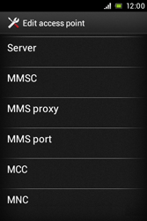
- Scroll down.
- Under MCC, enter 515
- Under MNC, enter 02
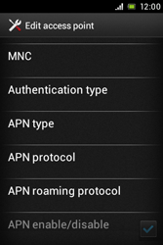
- Scroll down.
- Under Authentication type, choose PAP.
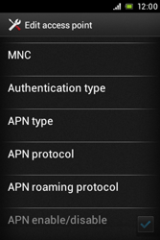
- Under APN type, enter default. (Note: in lower case)
- Choose the menu key
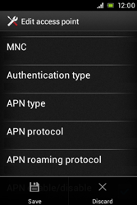
- Choose Save.
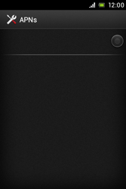
- Choose myglobeconnect and tick this option.
- Return to the Start screen.
- Start screen.
- Go to the Main menu.
- Choose Browser.

- Choose the menu key, and choose Settings
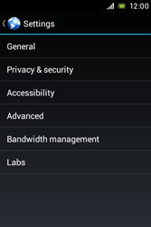
- Choose General.
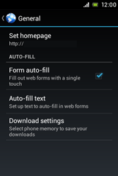
- Choose Set homepage.
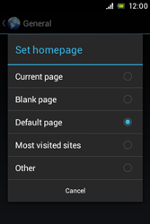
- Choose Other.
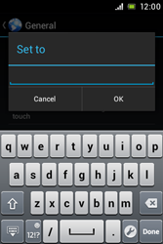
- Enter http://www.globe.com.ph/globe.asp , and choose OK.
- Return to the Start screen.
- Start screen.
- Switch off the Sony Xperia Miro and restart it in order to activate the settings.
- You can now start using the internet.

