
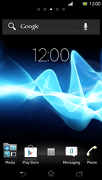
- Go to the Start screen.
- Go to the Main menu.
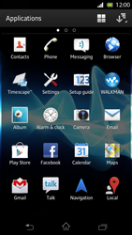
- Choose Settings
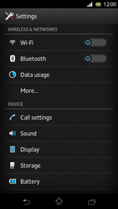
- Choose More…
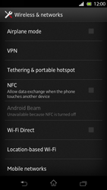
- Choose Mobile networks.
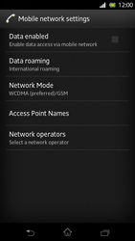
- Choose Data enabled, and tick this option.
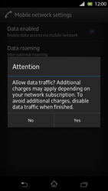
- If this screen appears, choose Yes.
- If this screen does not appear, go to the next step.
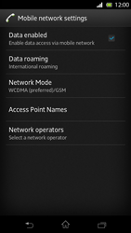
- Choose Access Point Names.
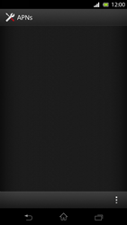
- Remove all current APN settings Choose the APN, choose the menu key, and choose Delete APN
- Choose the menu key, and choose New APN.
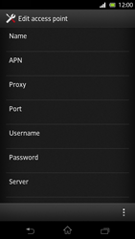
- Under Name, enter myglobeconnect
- Under Proxy, enter 203.177.42.214
- Under Port, enter 8080
- Under Username, enter nothing.
- Under Password, enter nothing.
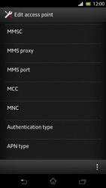
- Scroll down.
- Under MCC, enter 515
- Under MNC, enter 02
- Under Authentication type, choose PAP.
- Under APN-type, enter default. (Note: in lower case)
- Choose the menu icon.
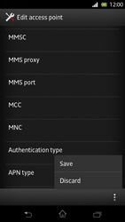
- Choose Save.
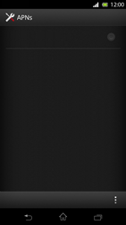
- Choose myglobeconnect and tick this option.
- Return to the Start screen
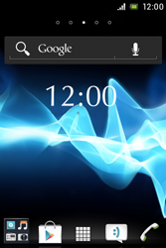
- Go to the Main menu.
- Choose Browser.
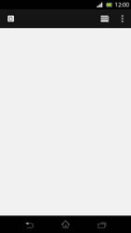
- Choose the menu key, and choose Settings.
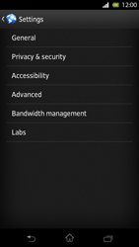
- Choose General.
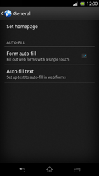
- Choose Set homepage.
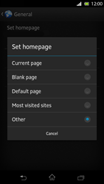
- Choose Other, and tick this option.
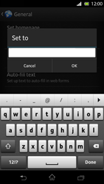
- Enter http://www.globe.com.ph/globe.asp and choose OK.
- Return to the Start screen.
- Start screen.
- Switch off the Sony Xperia T and restart it in order to activate the settings.
- You can now start using the internet.

