
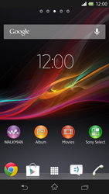
- Go to the Start screen.
- Choose the menu symbol.
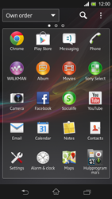
- Choose Settings.
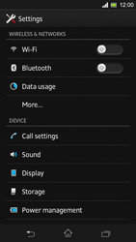
- Choose More…
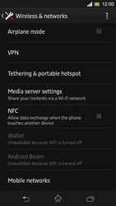
- Scroll down.
- Choose Mobile networks.
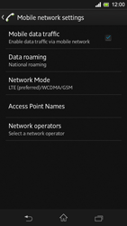
- Tick Mobile data traffic if this option is not ticked.
- If Mobile data traffic is ticked, skip the next step
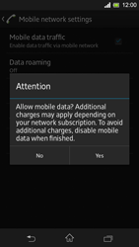
- If this screen appears, choose Yes.
- If this screen does not appear, go to the next step.
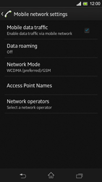
- Choose Access Point Names.
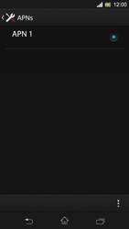
- Choose the options symbol.
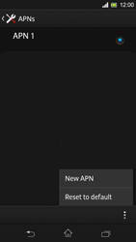
- Choose New APN.
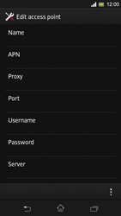
- Under Name, enter myglobeconnect
- Under APN, enter www.globe.com.ph
- Under Proxy, enter 203.177.42.214
- Under Port, enter 8080
- Under server, enter http://www.globe.com.ph/globe.asp
- Under Username, enter nothing.
- Under Password, enter nothing.
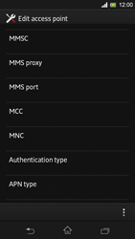
- Scroll down.
- Under MCC, enter 515
- Under MNC, enter 02
- Under Authentication type, tick PAP.
- Under APN type, enter default. (Note: in lower case)
- Choose the options symbol.
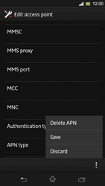
- Choose Save.
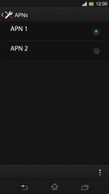
- Tick myglobeconnect
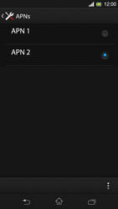
- The Sony Xperia SP has been configured for mobile internet.
- Return to the Start screen.
- Start screen.
- Switch off the Sony Xperia SP and restart it in order to activate the settings.
- You can now start using the internet.

