
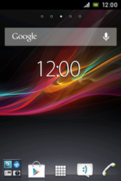
- Go to the Start screen.
- Choose the menu symbol.
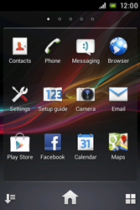
- Choose Settings.
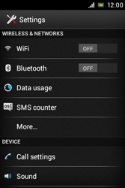
- Choose More…
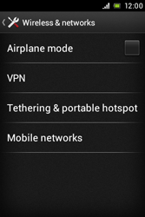
- Choose Mobile networks.
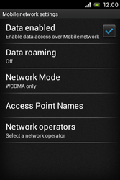
- Tick Data enabled.
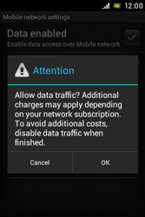
- If this screen appears, choose OK.
- If this screen does not appear, go to the next step.
- Choose Access Point Names.
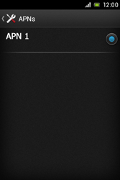
- Press the menu key.
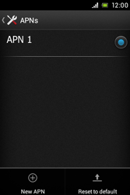
- Choose New APN.
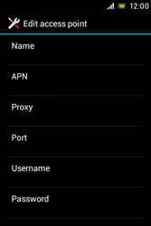
- Under Name, enter myglobeconnect
- Under APN, enter www.globe.com.ph
- Under Proxy, enter 203.177.42.214
- Under Port, enter 8080
- Under Username, enter nothing.
- Under Password, enter nothing.
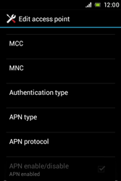
- Scroll down.
- Under MCC, enter 515
- Under MNC, enter 02
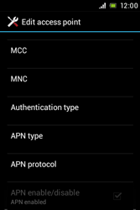
- Under Authentication type, choose PAP.
- Under APN type, enter default. (Note: in lower case)
- Press the menu key.
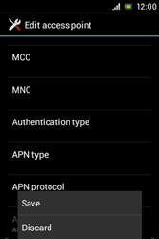
- Choose Save.
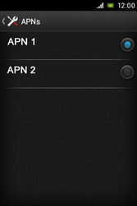
- Tick myglobeconnect
- Return to the Start screen.
- Choose the menu symbol.
- Choose Browser.

- Press the menu key.
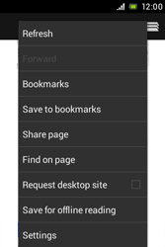
- Choose Settings.
v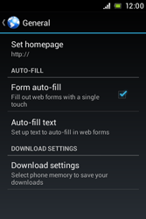
- Choose Set homepage.
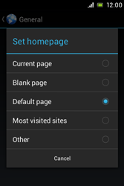
- Tick Other.
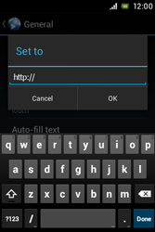
- Enter http://www.globe.com.ph/globe.asp and choose OK.
- Return to the Start screen.
- Start screen.
- Switch off the Sony Xperia E and restart it in order to activate the settings.
- You can now start using the internet.

