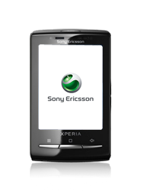
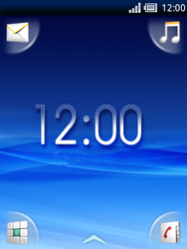
- Start screen.
- Choose the arrow symbol.
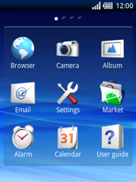
- Choose Settings.
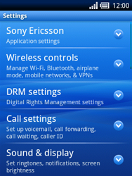
- Choose Wireless controls.
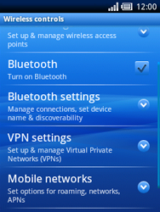
- Choose Mobile networks.
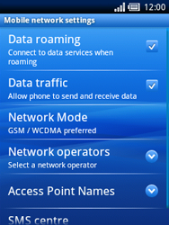
- Choose Data traffic, and check this option.
- Choose Access Point Names

- Remove all current APN settings by choosing the APN, choosing the menu key, and choosing Delete APN.
- Choose the menu key, and choose New APN.
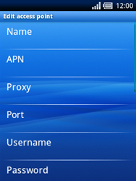
- Choose Name, enter myglobeconnect chooseDone, and then OK.
- Choose APN, enter www.globe.com.ph chooseDone, and then OK.
- Choose Proxy, enter 203.177.42.214 choose Done, and then OK.
- Choose Port, enter 8080 choose Done, and thenOK.
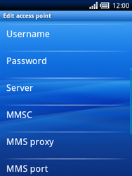
- Choose Username, enter nothing, choose Done, and then OK.
- Choose Password, enter nothing, choose Done, and then OK.
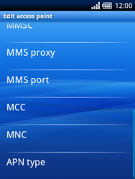
- Scroll down.
- Choose MCC, enter 515 choose Done, and then OK.
- Choose MNC, enter 02 choose Done, and then OK.
- Choose APN type, enter default, choose Done, and then OK. (Note: in lower case)
- Choose the menu key.
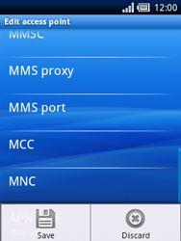
- Choose Save.
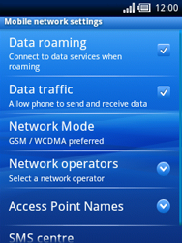
- Choose Access Point Names.
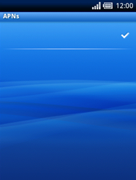
- Choose myglobeconnect and check this option.
- Press the Back key three times.
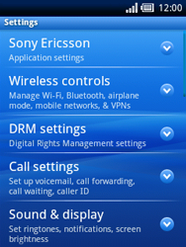
- Choose Sony Ericsson.
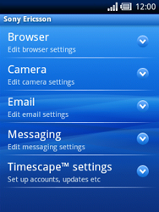
- Choose Browser.
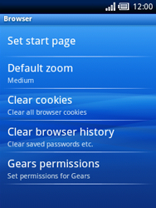
- Choose Set start page.
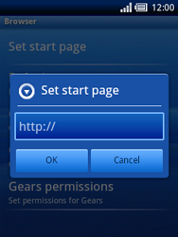
- Enter http://www.globe.com.ph/globe.asp choose Done, and then OK.
- Return to the Start screen.
- Start screen.
- Switch off the Sony Ericsson Xperia X10 Mini and restart it in order to activate the settings.
- You can now start using the internet.

