
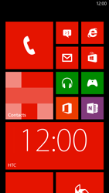
- Go to the Start screen.
- Scroll to the right.
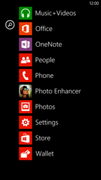
- Scroll down.
- Choose Settings.
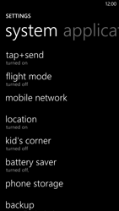
- Scroll down.
- Choose mobile network.
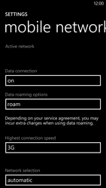
- Under Data connection, choose the text box.
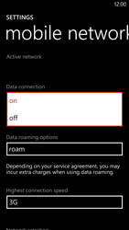
- Choose on.
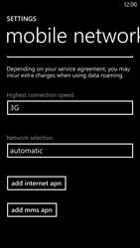
- Scroll down.
- Choose add internet apn.
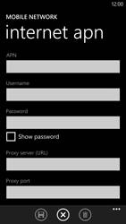
- Under APN, enter www.globe.com.ph
- Under Username, enter nothing.
- Under Password, enter nothing.
- Under Proxy server (URL), 203.177.42.214
- Under Proxy port, enter 8080
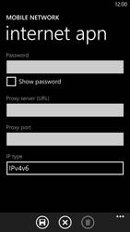
- Choose the save symbol.
- Return to the Start screen.
- Start screen.
- Switch off the HTC Windows Phone 8X and restart it in order to activate the settings.
- You can now start using the internet

