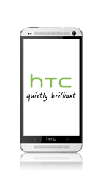
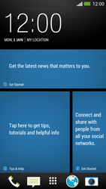
- Go to the Start screen.
- Choose the menu symbol.
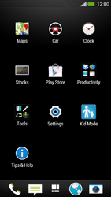
- Scroll down.
- Choose Settings.
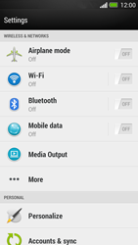
- Enable Mobile data.
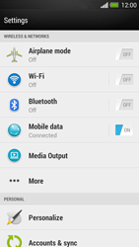
- Choose Mobile data.
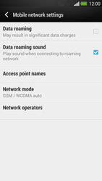
- Choose Access point names.
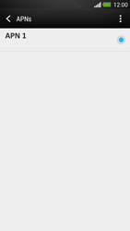
- Choose the options symbol.
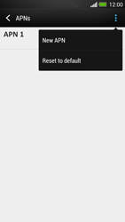
- Choose New APN.
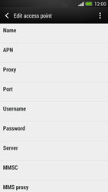
- Under Name, enter myglobeconnect
- Under APN, enter www.globe.com.ph
- Under Proxy, 203.177.042.214
- Under Port, enter 8080
- Under Username, enter nothing.
- Under Password, enter nothing.
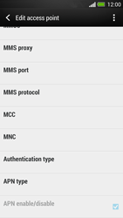
- Scroll down.
- Under MCC, enter 515
- Under MNC, enter 02
- Under Authentication type, choose PAP.
- Under APN type, enter default. (Note: in lower case)
- Choose the options symbol.
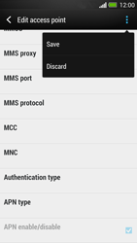
- Choose Save.
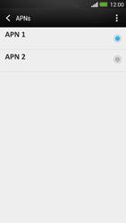
- Tick myglobeconnect
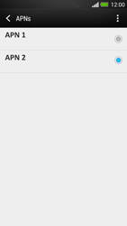
- Return to the Start screen.
- Choose the internet symbol.

- Choose the options symbol.
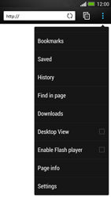
- Scroll down.
- Choose Settings.
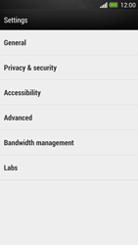
- Choose General.
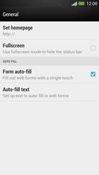
- Choose Set homepage.
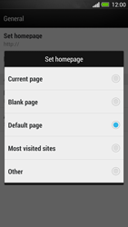
- Tick Other.
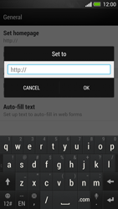
- Enter http://www.globe.com.ph/globe.asp and choose OK.
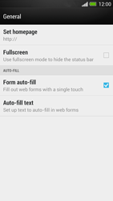
- The homepage has been set.
- Return to the Start screen.
- Start screen.
- Switch off the HTC One and restart it in order to activate the settings.
- You can now start using the internet.

