
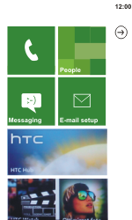
- Start screen.
- Choose the arrow symbol.
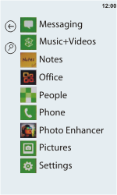
- Scroll down.
- Choose Settings.
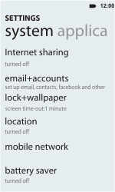
- Scroll down.
- Choose mobile network.
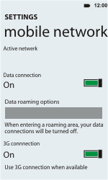
- Choose Data connection, and enable this option.
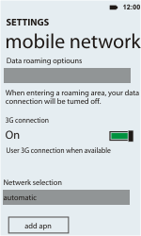
- Scroll down.
- Choose add apn.
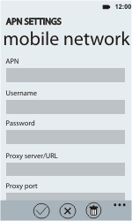
- Under APN, enter www.globe.com.ph
- Under Username, enter nothing.
- Under Password, enter nothing.
- Under Proxy server/URL, enter 203.177.42.214
- Under Proxy port, enter 8080
- Choose the tick symbol.
- Return to the Start screen.
- Start screen.
- Switch off the HTC Radar and restart it in order to activate the settings.
- You can now start using the internet.

