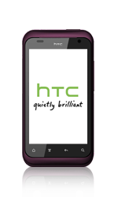
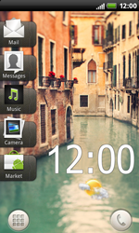
- Start the screen
- Go to menu.
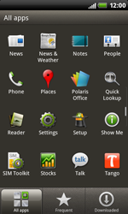
- Scroll down
- Choose Settings.
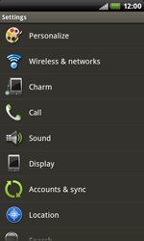
- choose Wireless & networks.
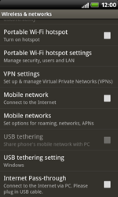
- Scroll navigation key
- choose Mobile network
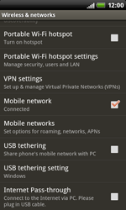
- choose Mobile networks.
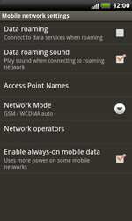
- choose Access Point Names.
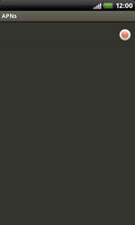
- choose more and choose *New APN*.
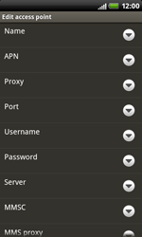
- under Name, enter myglobeconnect
- under APN, enter www.globe.com.ph
- under Proxy enter 203.177.042.214
- under Port, enter 8080
- under Username, enter nothing
- under Password, enter nothing
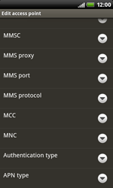
- Scroll navigation key
- under *MCC*, enter 515
- under *MNC*, enter 02
- under Authentication type,choose PAP.
- Under APN type, key in default
- Choose menu and Save.
- choose myglobeconnnect and tick the field
- go to menu
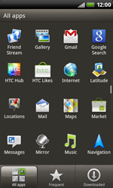
- next Internet
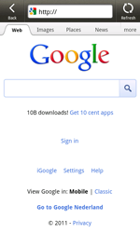
- choose More and choose Settings.
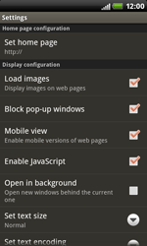
- chooseSet home page.
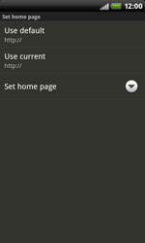
- choose Set home page.
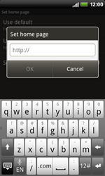
- enter http://www.globe.com.ph/globe.asp and OK.
- Start screen.
- Switch off the HTC Rhyme and restart it in order to activate the settings.
- You can now start using the internet.

