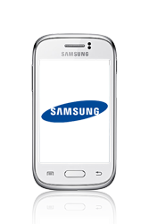
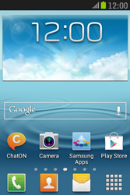
- Go to the Start screen.
- Choose the menu symbol.
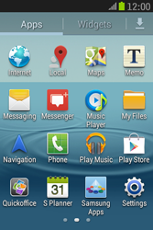
- Scroll to the right.
- Choose Settings.
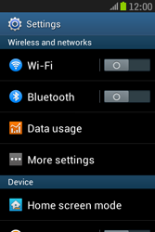
- Choose More settings.
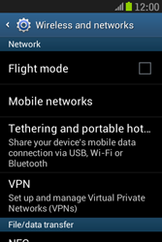
- Choose Mobile networks.
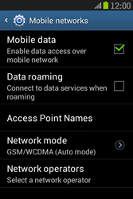
- Tick Mobile data if this option is not ticked.
- If Mobile data is ticked, skip the next step.
- Choose Access Point Names.
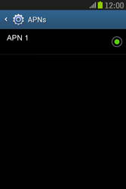
- Press the menu key.
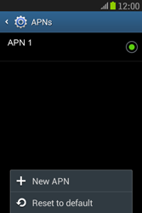
- Choose New APN.
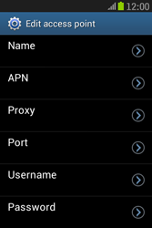
- Under Name, enter myglobeconnect
- Under APN, enter www.globe.com.ph
- Under Proxy, 203.177.42.214
- Under Port, enter 8080
- Under Username, enter nothing.
- Under Password, enter nothing.
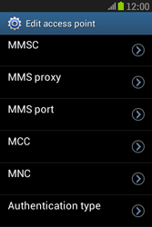
- Scroll down.
- Under MCC, enter 515
- Under MNC, enter 02
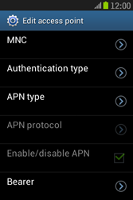
- Scroll down.
- Under Authentication type, choose PAP.
- Choose APN type.
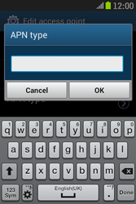
- If this screen appears, enter default, and choose OK. (Note: in lower case).
- If this screen does not appear, tick Internet.
- Press the menu key.
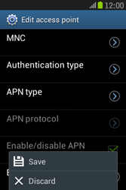
- Choose Save.
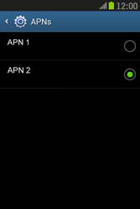
- Tick myglobeconnect
- Return to the Start screen.
- Choose the menu symbol.
- Scroll to the right.
- Choose Internet.

- Press the menu key.
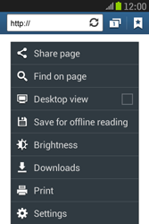
- Choose Settings.
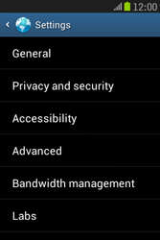
- Choose General.
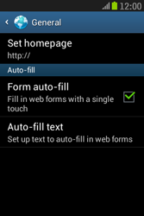
- Choose Set homepage.
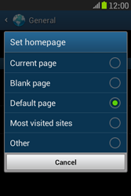
- Tick an option, in this case Other.
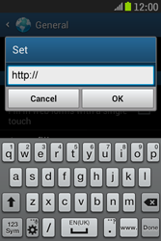
- Enter http://www.globe.com.ph/globe.asp and choose OK.
- The Samsung Galaxy Young has been configured for mobile internet.
- Return to the Start screen.
- Start screen.
- Switch off the Samsung Galaxy Young and restart it in order to activate the settings.
- You can now start using the internet.

