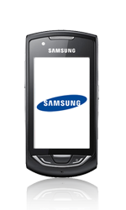
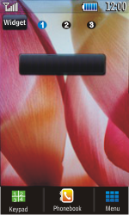
- Start screen.
- Select Menu.
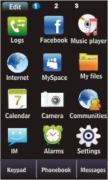
- Select Internet.
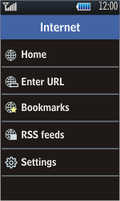
- Select Settings.
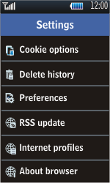
- Scroll down.
- Select Internet profiles.
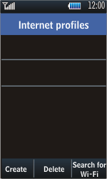
- Select Create.
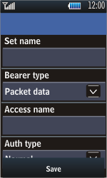
- Under Set name, enter myglobeconnect
- Under Bearer type, select Packet data.
- Under Access name, enter www.globe.com.ph
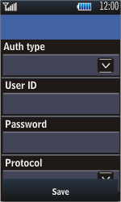
- Under Auth type, select Normal.
- Under User ID, enter nothing.
- Under Password, enter nothing.
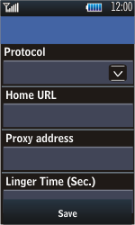
- Under Protocol, select HTTP.
- Under Home URL, enter http://www.globe.com.ph/globe.asp
- Under Proxy address, enter 203.177.42.214:80
- Selecteer Save.
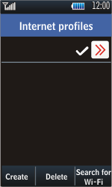
- Select myglobeconnect to check it.
- Return to the Start screen.
- Start screen.
- Switch off the Samsung Monte and restart it in order to activate the settings.
- You can now start using the internet.
-

