1. Please go to menu->“Setting” ->"Wireless & networks”
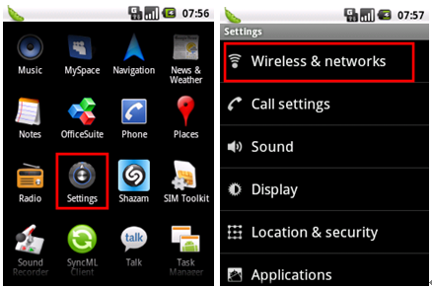
2. Select “Mobile networks”->"GSM/UMTS Options”
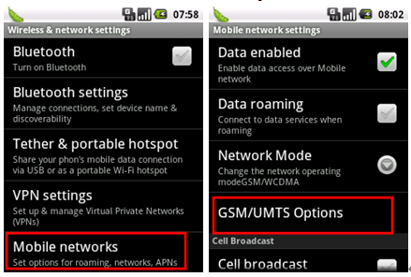
3. Press “Access Point Names”->you can select a corresponding APN or press “Menu” key ◊ ->Create a “New APN”.
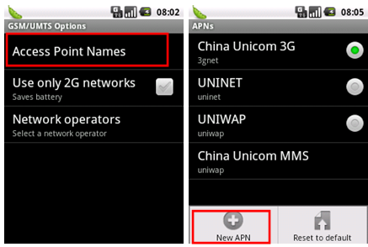
4. Please input the data according to local network parameter.
Connection name: myglobeconnect
APN: www.globe.com.ph
PROXY: 203.177.42.214
PORT: 8080
SERVER: http://www.globe.com.ph/globe.asp
MCC: 515
MNC: 02
AUTHENTICATION TYPE: PAP
APN TYPE: internet
APN PROTOCOL : IPv4
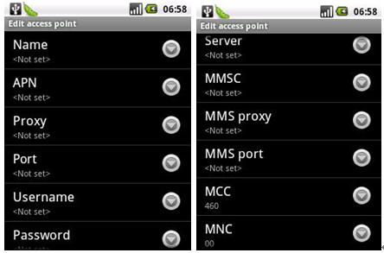
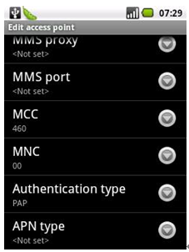
After the above steps are done, you can access Internet.

