- Please go to menu-> “Settings”-> "Wireless & networks”
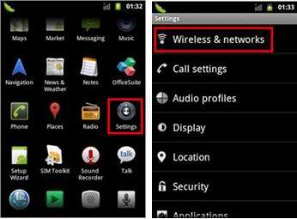
2． Select “Mobile networks” -> “Network settings” -> “Access Point Names” ->you can select a corresponding APN or press “Menu” key-> Create a “New APN”.
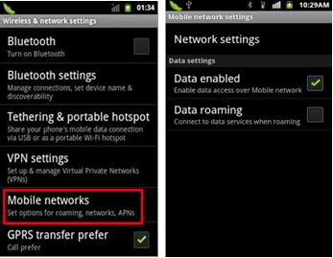
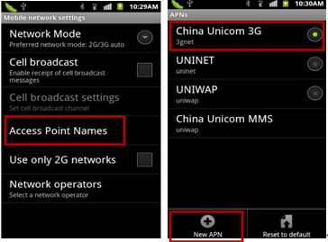
3. Please input the data according to local network parameters.
Connection name: myglobeconnect
APN: www.globe.com.ph
PROXY: 203.177.42.214
PORT: 8080
SERVER: http://www.globe.com.ph/globe.asp
MCC: 515
MNC: 02
AUTHENTICATION TYPE: PAP
APN TYPE: internet
APN PROTOCOL : IPv4
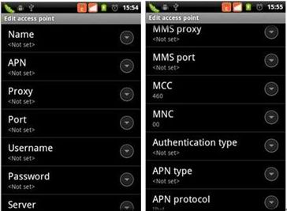
4. Please make sure “Disable data” is deactivated by going to menu -> “Battery Saver” ->”Settings” -> Deactivate “Disable data”.
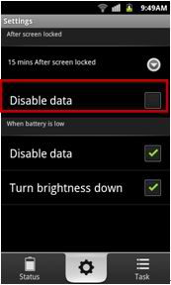
5. After the above steps are done, please go to menu-> “Settings”-> "Wireless & networks” -> “Mobile networks” ->activate “Data enabled”, then you can access Internet.


