1．Please go to menu-> “Settings”-> "Wireless & networks”
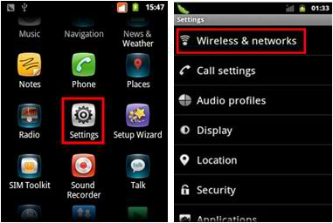
2. Select “Mobile networks” -> “Access Point Names” ->you can select a corresponding APN or press “Menu” key-> Create a “New APN”.
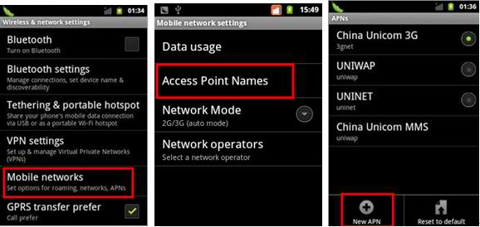
3. Please input the data according to local network parameters.
Connection name: myglobeconnect
APN: www.globe.com.ph
PROXY: 203.177.42.214
PORT: 8080
SERVER: http://www.globe.com.ph/globe.asp
MCC: 515
MNC: 02
AUTHENTICATION TYPE: PAP
APN TYPE: internet
APN PROTOCOL : IPv4
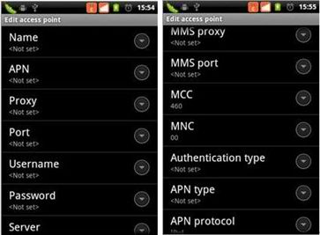
4. After the above steps are done, please go to menu-> “Settings”-> "Wireless & networks” -> “Mobile networks” ->activate “Data enabled”, then you can access Internet.
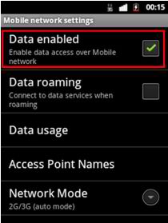
After the above steps are done, you can access Internet.

