ONE TOUCH 918

1．Please go to menu-> “Setting”-> "Wireless & networks”
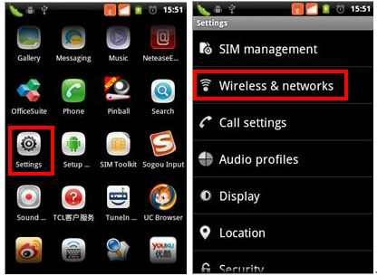
2. Select “Mobile networks” -> “Access Point Names” ->you can select a corresponding APN or press “Menu” key-> Create a “New APN”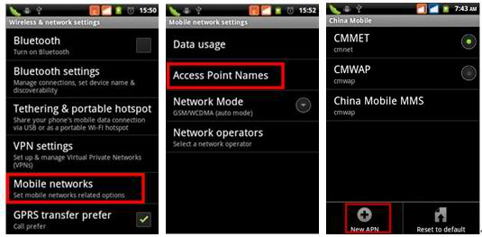
3. Please input the data according to local network parameter.

Connection name: myglobeconnect
APN: www.globe.com.ph
PROXY: 203.177.42.214
PORT: 8080
SERVER: http://www.globe.com.ph/globe.asp
MCC: 515
MNC: 02
AUTHENTICATION TYPE: PAP
APN TYPE: internet
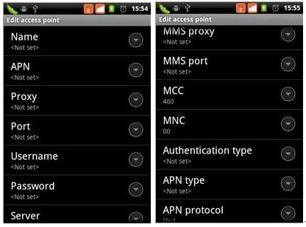
4. After above parameters have been entered and saved, please go to “Menu” key on home screen -> “Settings”-> “SIM management” -> “Data connection” -> Select your operator. 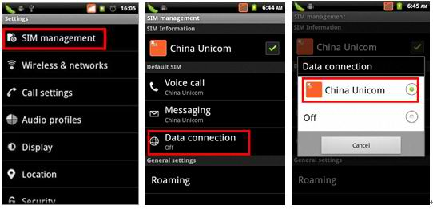 (example lang yan, pero choose GLOBE)
After the above steps are done, you can access Internet.

