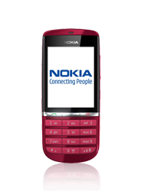
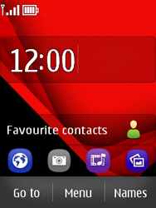
- Start screen.
- Choose Menu.
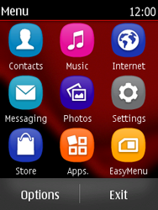
- Choose Settings.
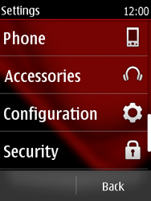
- Scroll down.
- Choose Configuration.
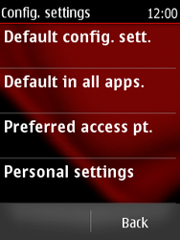
- Choose Personal settings.
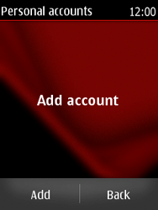
- If this screen appears, choose Add.
- If this screen does not appear, choose Options, and then Add new.
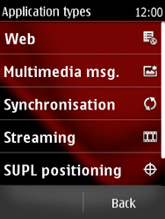
- Choose Web.
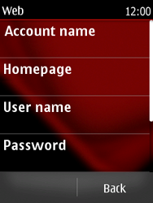
- Choose Account name, enter myglobeconnect and choose OK.
- Choose Homepage, enter http://www.globe.com.ph/globe.asp and choose OK.
- Choose User name, enter nothing, and choose OK.
- Choose Password, enter nothing, choose OK, re-enter nothing, and choose OK.
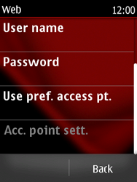
- Choose Use pref. access pt., and then yes
- Under proxy type 203.177.042.214
- Under port type 8080
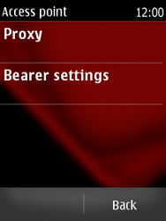
- Choose Bearer settings.
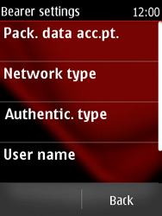
- Choose Pack. data acc.pt., enter www.globe.com.ph and choose OK.
- Choose Authentic. type, and then Normal.
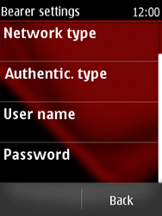
- Choose User name, enter nothing, and choose OK.
- Choose Password, enter nothing, choose OK, re-enter nothing, and choose OK.
- Choose Back three times.
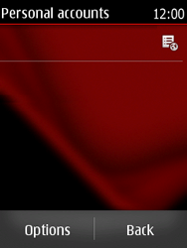
- Choose myglobeconnect for a second, until a popup window is displayed.
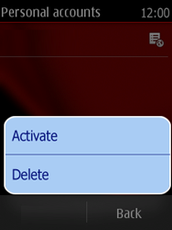
- Choose Activate.
- Return to the Start screen.
- Start screen.
- Switch off the Nokia Asha 300 and restart it in order to activate the settings.
- You can now start using the internet.

