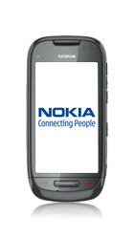
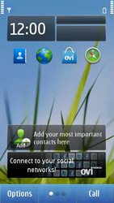
- Start screen.
- Go to the Main menu.
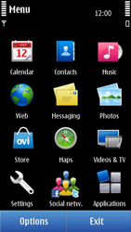
- Choose Settings.
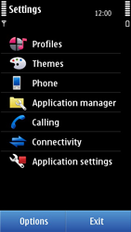
- Choose Connecttivity.
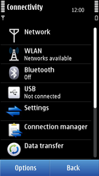
- Choose Settings.
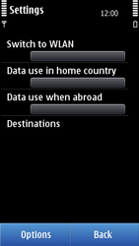
- Choose Destinations.
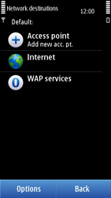
- Choose Internet.
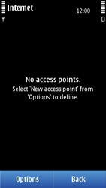
- Choose Options, and then New access point.
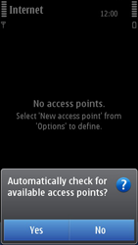
- Choose No.
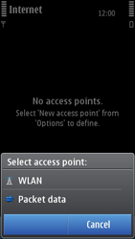
- Choose Packet data.
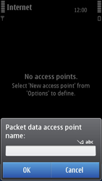
- Enter myglobeconnect, and choose OK.
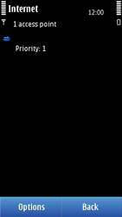
- If myglobeconnect, has Priority 1, skip the next step.
- If not, go to the next step.
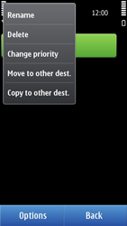
- Choose myglobeconnect, for a second, until a popup window is displayed.
- Choose Change priority, and choose the highest position.
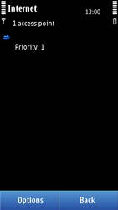
- Choose myglobeconnect,
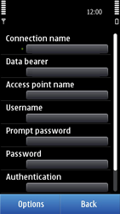
- Choose Connection name, enter myglobeconnect, and choose OK.
- Choose Acces point name, enter www.globe.com.ph, and choose OK.
- Choose Username, enter nothing, and choose OK.
- Under Prompt password, choose No.
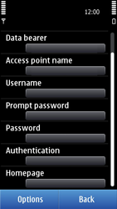
- Choose Password, enter nothing in en kies OK.
- Under Authentication, choose Normal.
- Choose Homepage, enter http://www.globe.com.ph/globe.asp and choose OK.
- Choose options and type under proxy 203.177.042.214 and port 8080
- Return to the Main menu.
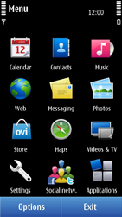
- Choose Web.
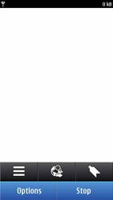
- Choose Options, and then Settings
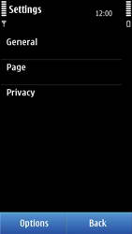
- Choose General
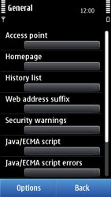
- Choose Acces point, Internet, and then OK.
- Choose Homepage, User defined, enter http://www.globe.com.ph/globe.asp and choose OK.
- Return to the Start screen.
- Start screen.
- Switch off the Nokia C7 and restart it in order to activate the settings.
- You can now start using the internet.

