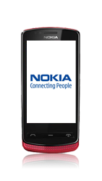
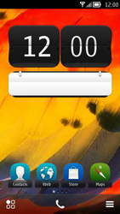
- Start screen.
- Go to the Main menu.
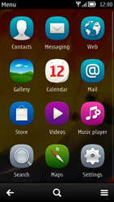
- Choose Settings.
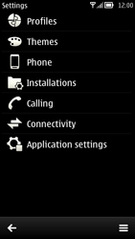
- Choose Connectivity.
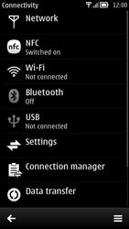
- Choose Settings.
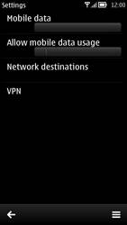
- Under Allow mobile data usage, choose Home country/region.
- Choose Network destinations.
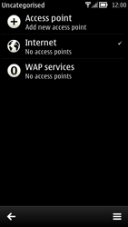
- Choose Internet.
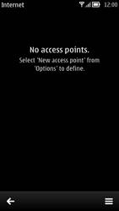
- Choose the menu symbol, and choose New access point.
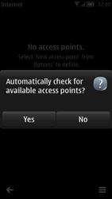
- Choose No.
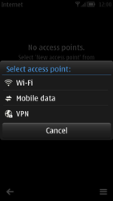
- Choose Mobile data.
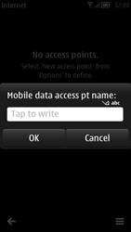
- Enter myglobeconnect and choose OK.
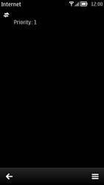
- Choose myglobeconnect
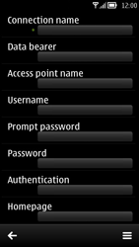
- Choose Connection name, enter myglobeconnect, and choose OK.
- Choose Access point name, enter www.globe.com.ph and choose OK.
- Under proxy type 203.177.042.214
- Under port type 80
- Choose Username, enter nothing, and choose OK.
- Under Prompt password, choose No.
- Choose Password, enter nothing, and choose OK.
- Under Authentication, choose PAP.
- To return, choose the arrow symbol.
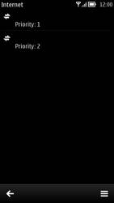
- If myglobeconnect has Priority 1, skip this step and the next.
- If not, choose myglobeconnect for a second, until a popup window is displayed. Choose Change priority, choose the highest position, and go to the next step.
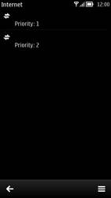
- Choose the highest position, and choose OK.
- Return to the Main menu.
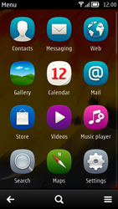
- Choose Web.
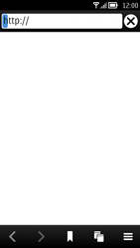
- Choose the menu symbol, and choose Settings.
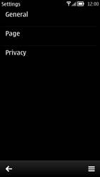
- Choose General.
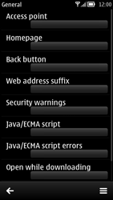
- Choose Access point
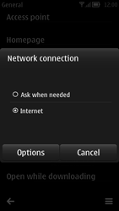
- Choose Internet, and tick this option.
- Choose Options, and then Select access point.
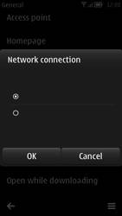
- Choose myglobeconnect and tick this option.
- Choose OK.
- Choose Homepage, and then User defined.
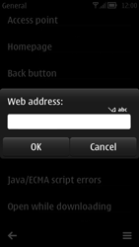
- Enter http://www.globe.com.ph/globe.asp and choose OK.
- Return to the Start screen.
- Start screen.
- Switch off the Nokia 700 and restart it in order to activate the settings.
- You can now start using the internet.

