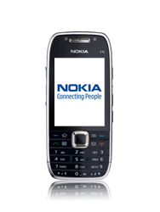
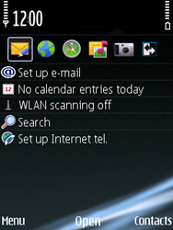
- Start screen.
- Choose Menu
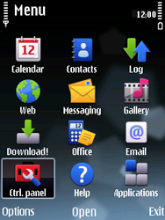
- Choose Ctrl.panel, and then Open.
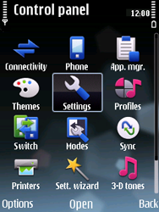
- Choose Settings, and then Open.
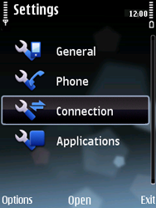
- Choose Connection, and then Open.
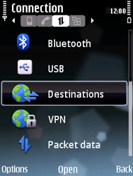
- Choose Destinations, and then Open.
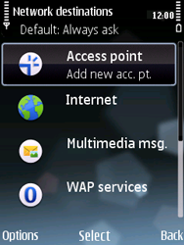
- Choose Access point, and then Select.
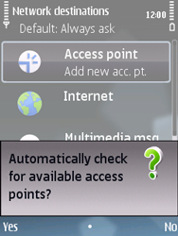
- If this screen appears, choose No.
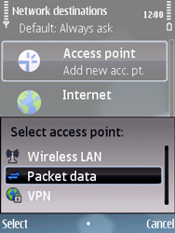
- Choose Packet data, and then Select.
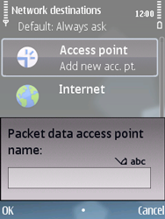
- Enter www.globe.com.ph and choose OK.
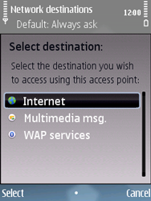
- Choose Internet, and then Select.
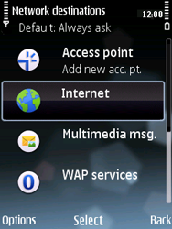
- Choose Internet, and then Open.
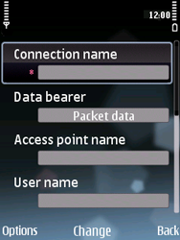
- Choose Connection name, Change, enter myglobeconnect, and choose OK.
- Choose Data bearer, Change, Packet data, and then OK.
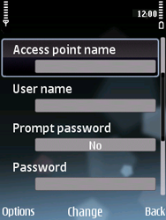
- Choose Access point name, Change, enter www.globe.com.ph, and choose OK.
- Choose User name, Change, enter nothing, and choose OK.
- Choose Prompt password, Change, No, and thenOK.
- Choose options , advanced settings.
- Under proxy type 203.177.42.214
- Under port type 8080
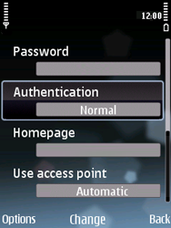
- Choose Authentication, Change, Normal, and thenOK.
- Choose Homepage, Change, enter http://www.globe.com.ph/globe.asp and choose OK.
- Choose Use access point, Change, Automatic, and then OK.
- Return to the Start screen.
- Start screen.
- Choose Menu.
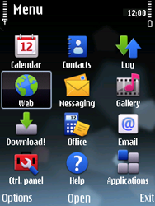
- Choose Web, and then Open.
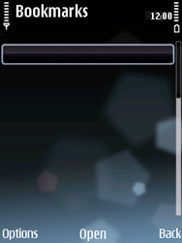
- Choose Options, Settings, and then Select.
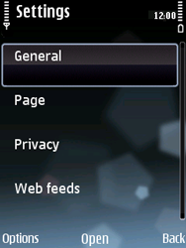
- Choose General, and then Open.
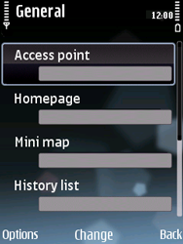
- Choose Access point, and then Change.
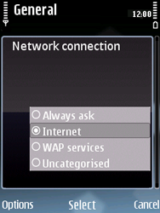
- Choose Internet, and then Select.
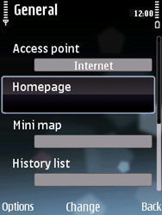
- Choose Homepage, and then Change.
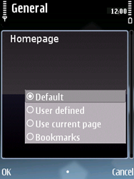
- Choose Default, and then OK.
- Return to the Start screen.
- Start screen.
- Switch off the Nokia E75 and restart it in order to activate the settings.
- You can now start using the internet.

