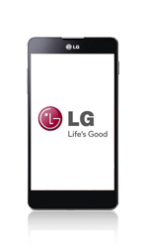
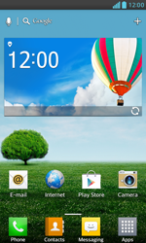
- Go to the Start screen.
- Choose Apps.
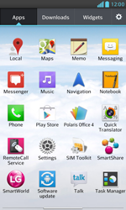
- Scroll to the right.
- Choose Settings.
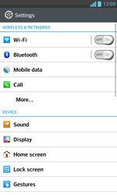
- Choose More…

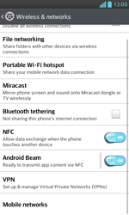
- Scroll down.
- Choose Mobile networks.
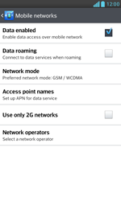
- Tick Data enabled if this option is not ticked.
- If Data enabled is ticked, skip the next step.
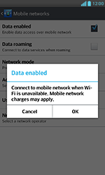
- Choose OK.
- Choose Access point names.
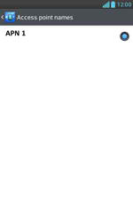
- Press the menu key.
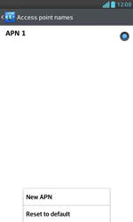
- Choose New APN.
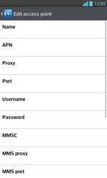
- Under Name, enter myglobeconnect
- Under APN, enter www.globe.com.ph
- Under Proxy, 203.177.042.214
- Under Port, 8080
- Under Username, enter nothing.
- Under Password, enter nothing.
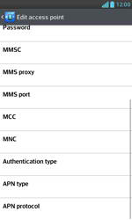
- Scroll down.
- Under MCC, enter 515
- Under MNC, enter 02
- Under Authentication type, tick PAP.
- Under APN type, enter default. (Note: in lower case)
- Press the menu key.
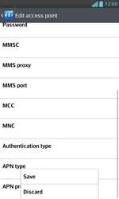
- Choose Save.
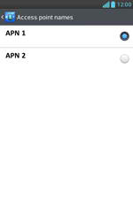
- Tick myglobeconnect
- Return to the Start screen.
- Choose Apps.
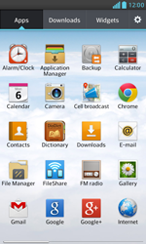
- Choose Internet.
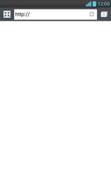
- Press the menu key.
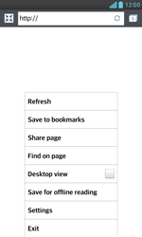
- Choose Settings.
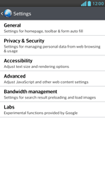
- Choose General.
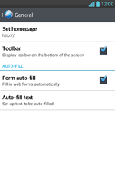
- Choose Set homepage.
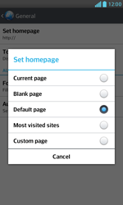
- Tick Custom page.
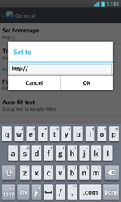
- Enter http://www.globe.com.ph/globe.asp and choose OK.
- The LG Optimus G has been configured for mobile internet.
- Return to the Start screen.
- Start screen.
- Switch off the LG Optimus G and restart it in order to activate the settings.
- You can now start using the internet.

