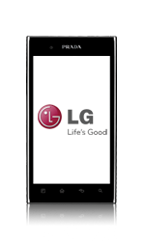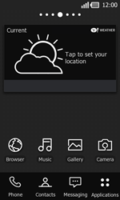
- Start screen.
- Choose Applications.
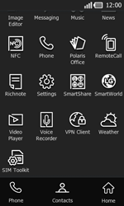
- Scroll down.
- Choose Settings.
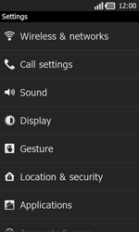
- Choose Wireless & networks.
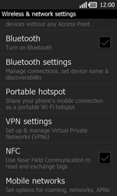
- Scroll down.
- Choose Mobile networks.
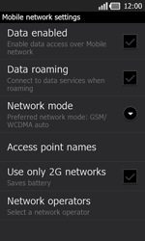
- Choose Data enabled, and tick this option.
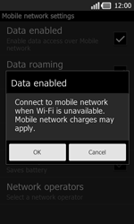
- Choose OK.
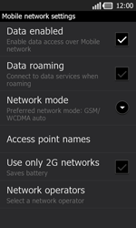
- Choose Access point names.
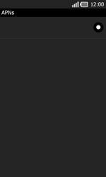
- Remove all current APN settings by choosing the APN, choosing the menu key, and choosing Delete APN.
- Choose the menu key, and choose New APN.
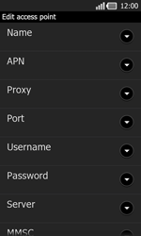
Under Name, enter myglobeconnect 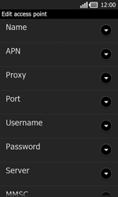
- Under Username, enter nothing.
- Under Password, enter nothing.
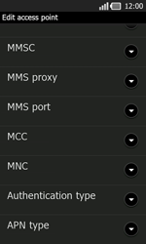
- Scroll down.
- Under MCC, enter 515
- Under MNC, enter 02

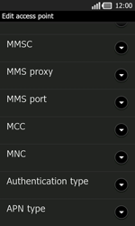
- Under Authentication type, choose PAP.
- Under APN type, enter default. (Note: in lower case)
- Choose the menu key.
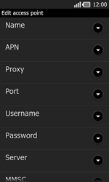
- Under Proxy, 203.177.042.214
- PORT: 8080
- Under server type, http://www.globe.com.ph/globe.asp
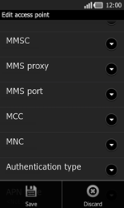
- Choose Save.
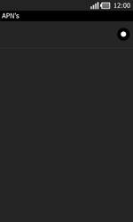
- Choose myglobeconnnect and tick this option.
- Return to the Main menu.
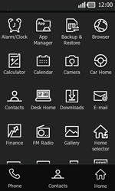
- Choose Browser.
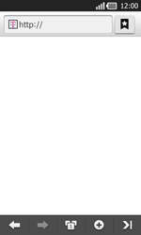
- Choose the menu key, choose More, and thenOptions.
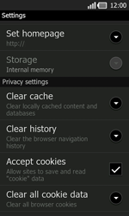
- Scroll down.
- Choose Set homepage.
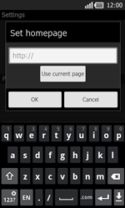
- Enter http://www.globe.com.ph/globe.asp
- Start screen.
- Switch off the PRADA phone by LG and restart it in order to activate the settings.
- You can now start using the internet.

