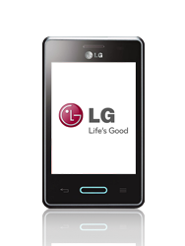
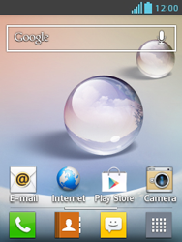
- Go to the Start screen.
- Choose the menu symbol.
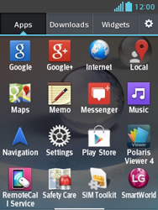
- Scroll to the right.
- Choose Settings.
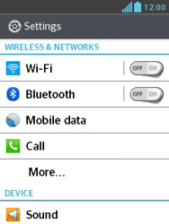
- Choose More…
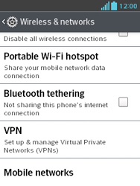
- Scroll down.
- Choose Mobile networks.
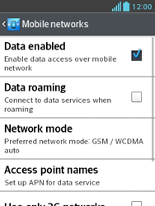
- Tick Data enabled if this option is not ticked.
- If Data enabled is ticked, skip the next step.
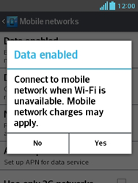
- If this screen appears, choose Yes.
- If this screen does not appear, go to the next step.
- Choose Access point names.
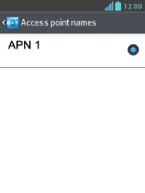
- Press the menu key.
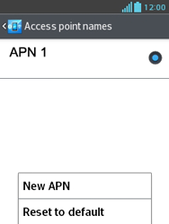
- Choose New APN.
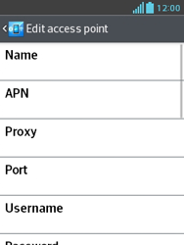
- Under Name, enter myglobeconnect
- Under APN, enter www.globe.com.ph
- Under Proxy, 203.177.042.214
- PORT: 8080

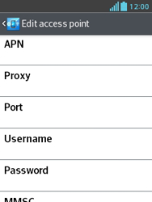
- Scroll down.
- Under Username, enter nothing.
- Under Password, enter nothing.
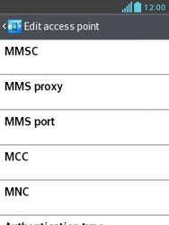
- Scroll down.
- Under MCC, enter 515
- Under MNC, enter 02
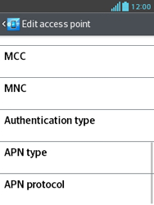
- Scroll down.
- Under Authentication type, choose PAP.
- Under APN type, enter default. (Note: in lower case)
- Press the menu key
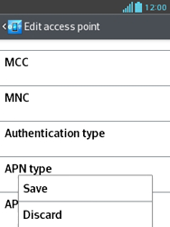
- Choose Save.
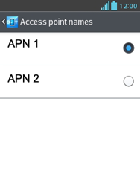
- Tick myglobeconnect
- Return to the Start screen.
- Choose the menu symbol.
- Scroll to the right.
- Choose Internet.
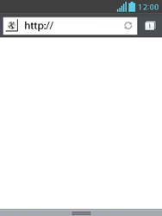
- Press the menu key.
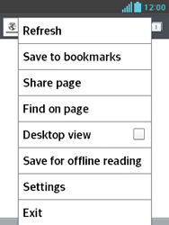
- Choose Settings.
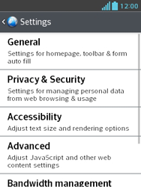
- Choose General.
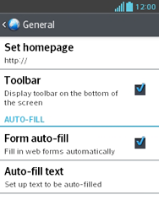
- Choose Set homepage.
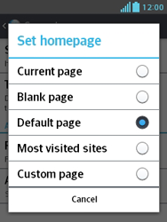
- Choose Custom page.
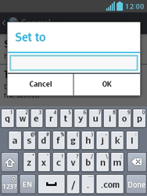
- Enter http://www.globe.com.ph/globe.asp, and choose OK.
- Mobile internet has been configured.
- Return to the Start screen.
- Start screen.
- Switch off the LG Optimus L3 II and restart it in order to activate the settings.
- You can now start using the internet.

