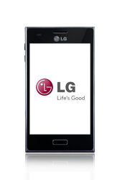
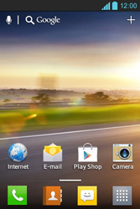
- Start screen.
- Go to the Main menu.
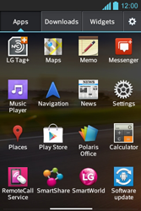
- Scroll to the right.
- Choose Settings.
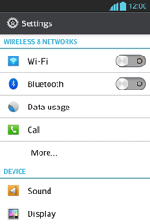
- Choose More…
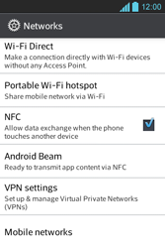
- Scroll down.
- Choose Mobile networks.
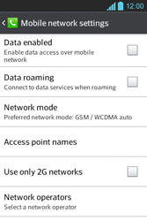
- Choose Data enabled, and tick this option.
- If prompted, choose OK.
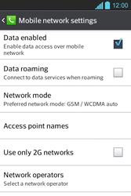
- Choose Access point names.
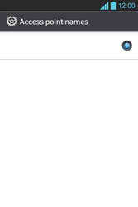
- Remove all current APN settings, choose the menu key, and choose Delete APN.
- Choose the menu key, and choose New APN.
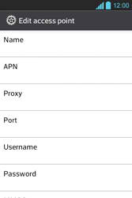
- Under Name, enter myglobeconnect.
- Under APN, enter www.globe.com.ph
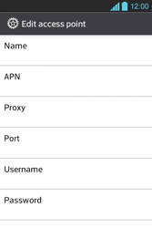
- Under Proxy, 203.177.042.214
- Under Port, 8089
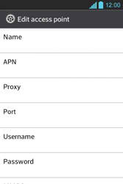
- Under Username, enter nothing.
- Under Password, enter nothing.
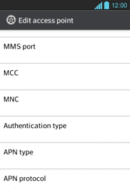
- Scroll down.
- Under MCC, enter 515
- Under MNC, enter 02
- Under Authentication type, choose PAP.
- Under APN type, enter default. (Note: in lower case)
- Choose the menu key.
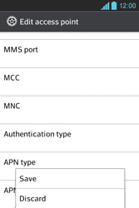
- Choose Save.
- Choose myglobe connect and tick this option.
- Return to the Start screen.
- Start screen.
- Go to the Main menu.
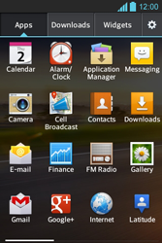
- Choose Internet.

- Choose the menu key, and choose Settings.
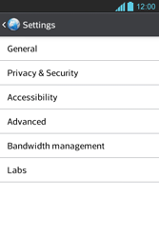
- Choose General.
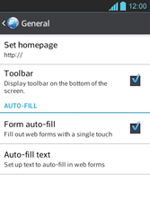
- Choose Set homepage.
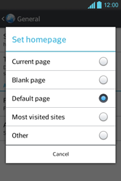
- Choose Other, and tick this option.
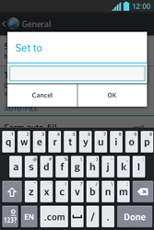
- Enter http://www.globe.com.ph/globe.asp and choose OK.
- Return to the Start screen.
- Start screen.
- Switch off the LG Optimus L5 and restart it in order to activate the settings.
- You can now start using the internet.

