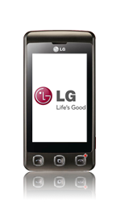
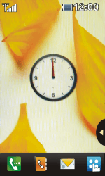
- Start screen.
- Go to the Main menu.
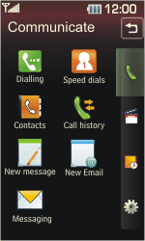
- Select the Settings tab.
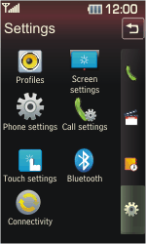
- Select Connectivity.
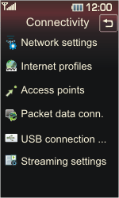
- Select Access points.
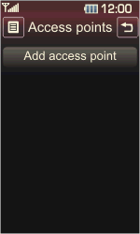
- Select Add access point.
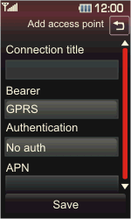
- Under Connection title, enter myglobeconnect
- Under Bearer, select GPRS.
- Under APN, enter www.globe.com.ph
- Select Save.
- Select Internet profiles.
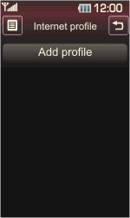
- Select Add profile.
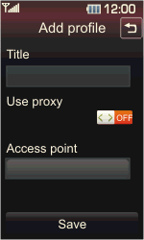
- Under Title, enter myglobeconnect
- Under Use proxy, select ON
- PROXY: 203.177.042.214
- PORT: 8080
- Under Access point, select myglobeconnect
- Select Save.
- Return to the Start screen.
- Start screen.
- Go to the Main menu.
- Select the Utilities tab.
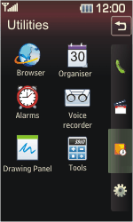
- Select Browser.
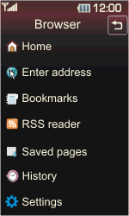
- Select Settings.
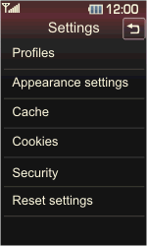
- Select Profiles.
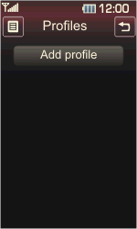
- Select Add profile.
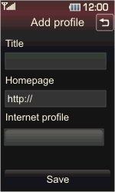
- Under Title, enter myglobeconnect
- Under Homepage, enter http://www.globe.com.ph/globe.asp
- Under Internet profile, select myglobeconnect
- Select Save.
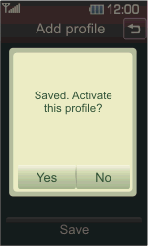
- Select Yes.
- Return to the Start screen.
- Start screen.
- Switch off the LG Cookie and restart it in order to activate the settings.
- You can now start using the internet.

