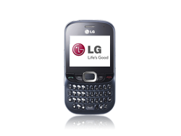
- Start screen.
- Choose the central navigation key.
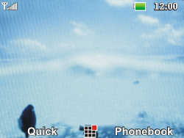
- Choose Settings, and choose the central navigation key.
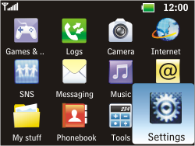
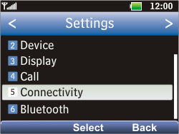
- Choose Connectivity, and then Select.
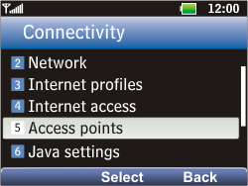
- Choose Access points, and then Select.
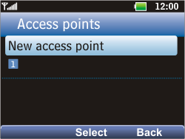
- Choose New access point, and then Select.
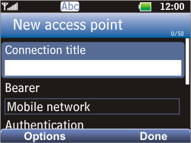
- Under Connection title, enter MYGLOBECONNECT
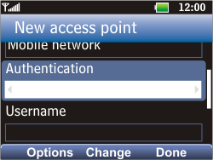
- Under Authentication, choose None.
- Under Username, enter nothing.
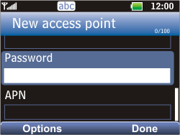
- Scroll down.
- Under Password, enter nothing.
- Under APN, enter www.globe.com.ph
- Choose Done.
- Choose Back.
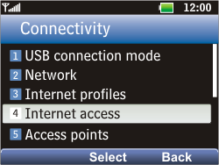
- Choose Internet access, and then Select
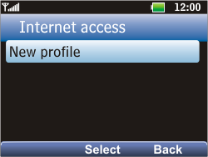
- Choose New profile, and then Select.
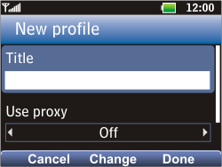
- Under Title, enter MYGLOBECONNECT
- Under Use proxy, choose on
- Under PROXY: 203.177.042.214
- Under PORT: 8080

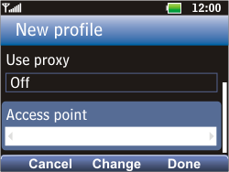
- Scroll down.
- Under Access point, choose MYGLOBECONNECT
- Choose Done.
- Return to the Main menu.
- Choose Settings, and choose the central navigation key.
- Choose Connectivity, and then Select.
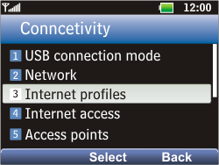
- Choose Internet profiles, and then Select.
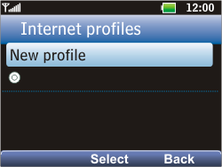
- Choose New profile, and then Select.
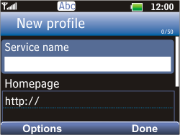
- Under Service name, enter MYGLOBECONNECT
- Under Homepage, enter http://www.globe.com.ph/globe.asp
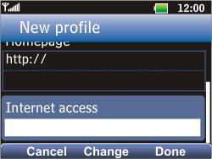
- Under Internet access, choose MYGLOBECONNECT
- Choose Done.
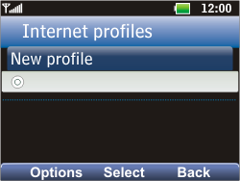
- Choose MYGLOBECONNECT, and then Select.
- Return to the Start screen.
- Start screen.
- Switch off the LG Golf and restart it in order to activate the settings.
- You can now start using the internet.

