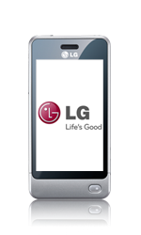
- Start screen.
- Select the menu symbol.
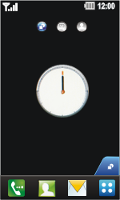
- Under Settings, select Connecti...
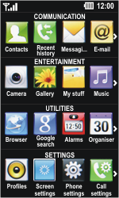
- Select Access points.
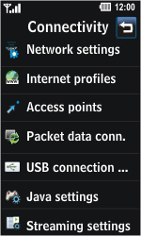
- Select Add access point.
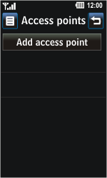
- Under Connection title, enter myglobeconnect.
- Under Bearer, select GPRS.
- Under Authentication, select PAP.
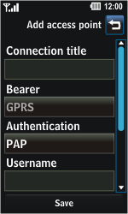
- Under Username, enter nothing.
- Under Password, enter nothing.
- Under APN, enter www.globe.com.ph.
- Select Save
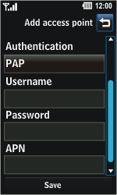
- Select the Back symbol.
- Select Internet profiles.
- Select Add profile.
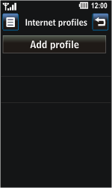
- Under Title, enter myglobeconnect
- Under Use proxy, select ON
- Under Proxy, type 203.177.042.214
- Under port, type 80
- Select Access point, and then www.globe.com.ph
- Select Save.
- Return to the Main menu.
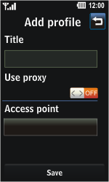
- Under Utilities, select Browser.
- Select Settings.
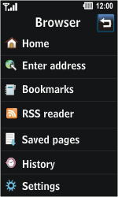
- Select Profiles.
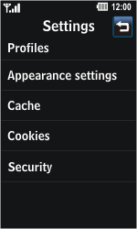
- Select Add profile.
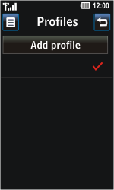
- Under Title, enter myglobeconnect
- Under Homepage, enter http://www.globe.com.ph/globe.asp
- Select Internet profile, and then myglobeconnect.
- Select Save.
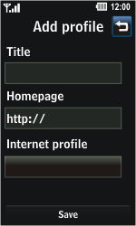
- Select Yes.
- Return to the Start screen.
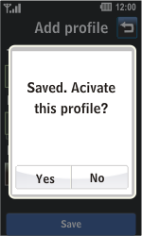
- Start screen.
- Switch off the LG Pop and restart it in order to activate the settings.
- You can now start using the internet.

