
- Start screen.
- Choose Applications.
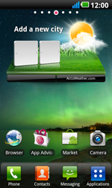
- Scroll down.
- Choose Settings.
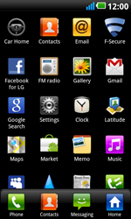
Choose Wireless & networks.
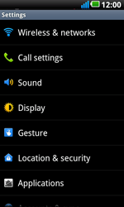
- Scroll down.
- Choose Mobile network settings.
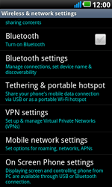
- Choose Data enabled, and check this option.
- Choose Access Point Names.
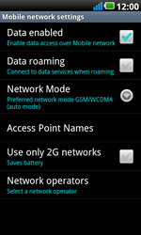
- Remove all current APN settings choosing the menu key, and choosing Delete APN.
- Choose the menu key, and choose New APN.

- Under Name, enter myglobeconnect
- Under APN, enter www.globe.com.ph
- Under Proxy, 203.177.042.214
- PORT: 8080
- Under Username, enter nothing.
- Under Password, enter nothing.
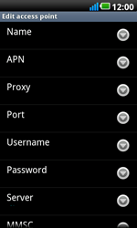
- Scroll down.
- Under MCC, enter 515
- Under MNC, enter 02
- Under Authentication type, choose PAP.
- Under APN type, enter default. (Note: in lower case)
- Choose the menu key.
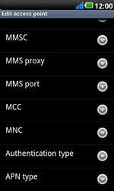
- Choose Save.
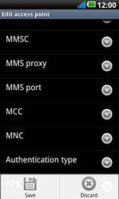
- Choose myglobeconnect and check this option.
- Return to the Main menu.

- Choose Browser.
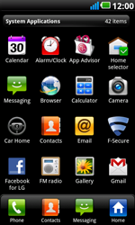
- Choose the menu key, choose More, and thenSettings.
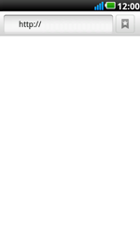
- Scroll down.
- Choose Set home page.
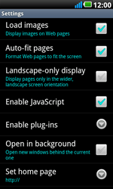
- Enter http://www.globe.com.ph/globe.asp and choose OK.
- Return to the Start screen.
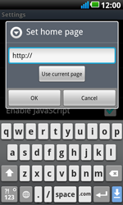
- Start screen.
- Switch off the LG Optimus 2X Speed and restart it in order to activate the settings.
- You can now start using the internet.

